

[https://lessonup.herokuapp.com](https://lessonup.herokuapp.com/)

A web application for parents in the UK - whose first language is not English - to find tutors who can help them understand their childrens’ homework.

Developed using Nodejs, Expressjs, MySQL & Vuejs.

Hosted by Heroku, database hosted by ClearDB.

Translation by Google Cloud Translate API.

Codebase available at: <https://gitlab.doc.gold.ac.uk/ebrad005/lessonup>

By: Edward Bradbury, Hodan Hussein, Imdad Ahmed, Victoria Szydlowska, Lia Farquharson.

**Introduction** **3**

**Initial Design**4

MySQL 4

Javascript (Vuejs library) 4

Node.js 4

Heroku 4

Expressjs 4

Adobe XD 4

UML diagram 5

**Details of implementation** **6**

Database Implementation 6

**Technical Architecture**9

Obstacles/problems and how they were solved 9

Google Cloud Translate API 10

Building the frontend (user interface) 13

Sending HTTP requests and responses between frontend & backend 14

Vue state management & passing data between different components 19

Switching to Vuex state management (a ‘single source of truth’) 23

Hosting and serving the UI (Vue application) 29

Cross Origin Resource Sharing (CORS) 32

Session management, part 1: introduction 33

Session management, part 2: Secure cookies & HTTPS protocol 33

Database 44

Session management, part 3: Passportjs ‘local’ authentication 53

A note about SQL injection attacks 69

Software licencing 70

Testing our software 70

Known bugs 70

**Development Record** **72**

Prototype 72

What did you learn from making and running the prototypes? 72

What problems did you encounter and how did you solve them? 72

What can you say about the lo-fi and hi-fi prototype? 72

ABOUT TESTING 73

**BIBLIOGRAPHY** **76**

# Introduction

We collectively as a team have been developing a single page web application that aims to connect parents in the UK, whose primary language is not English, with volunteer tutors. We produced high and low fidelity prototypes based on secondary research into user interface design for low-literacy users and analysis of tutoring applications already available. Through testing our prototypes with users and stakeholders, we will adjust our designs - based on their feedback - before commencing the build stage.

We have also obtained quantitative data from surveys to the main targeted stakeholders. The majority of the response has been quite positive in terms of design, and other responses have been reliable. The feedback from our participants has also informed us of the strengths of our prototype and areas we needed to improve, thus prompting us to make changes to the coding, so the actual application performs at its best.

* In terms of developing the application, it has been quite challenging at times due to the current situation of COVID, thus making it hard for our group to work together physically.
* Plus, it has been challenging to obtain an extensive range of data for our survey results due to a small number of participants and problems in gaining more responses because of Covid.

# Initial Design

## **Node.js**

* Node.js is a platform built on Mozilla’s JavaScript runtime. Node.js used to build fast network applications. This application will run across distributed devices, and this is the perfect platform to use for it.

## **Express**

* Express is a virtual server that is used to fetch and run the code when you navigate to the lessonup on Heroku. It is also used to handle HTTP requests to our API and send response data back to our frontend UI.

## **MySQL**

* We all decided to create a database within MySQL due to having prior experience using this database.
* We have ensured that we created a MySQL database to make sure our server was effectively running. It is hosted by clear; We had to move all of the backend code to Heroku to make some things work; therefore, we had to use this ClearDB. ClearDB is a MySQL database that a company has set up hosted online to access and use.

## **Vuejs**

* The majority of the group have experience using JavaScript; therefore, JavaScript was the primary coding for our application, and we did it in a Vuesjs library. Vue is a popular JavaScript library used to create dynamic web applications in the front end, and it was best suited for our applicaton because of its flexibility and ease of use.
* Many Vue components were used in our coding to create the application. This was all done in a program called Visual Studios which took in any coding.

## **Heroku**

* Heroku is the container for the code hosted on our virtual server machine. Heroku is the website we use to run our actual application and put it to the test. A couple of times, the application failed to run as we expected, which is why the right changes were made to the coding.

## **Adobe XD**

* High fidelity prototypes for our application were created in Adobe XD. We set up the layout of the application, navigations, actions and tools. We have done this to help decide the most efficient way to have our application function. Besides, it depends on our satisfaction with the prototypes. We decided the right way to code the layout, background and options.
* Also, a couple of mistakes have been resolved due to the feedback we got from our surveys.

## **UML diagram**

The UML diagram was an efficient way of allowing our group to understand the overall pathway of how the application will work. Using UML diagrams has allowed the group to decrease the amount of development time needed to produce the overall application as we indicated how the application would work. Also, it was clear to follow to ensure everything was in the appropriate order due to it having visual elements.

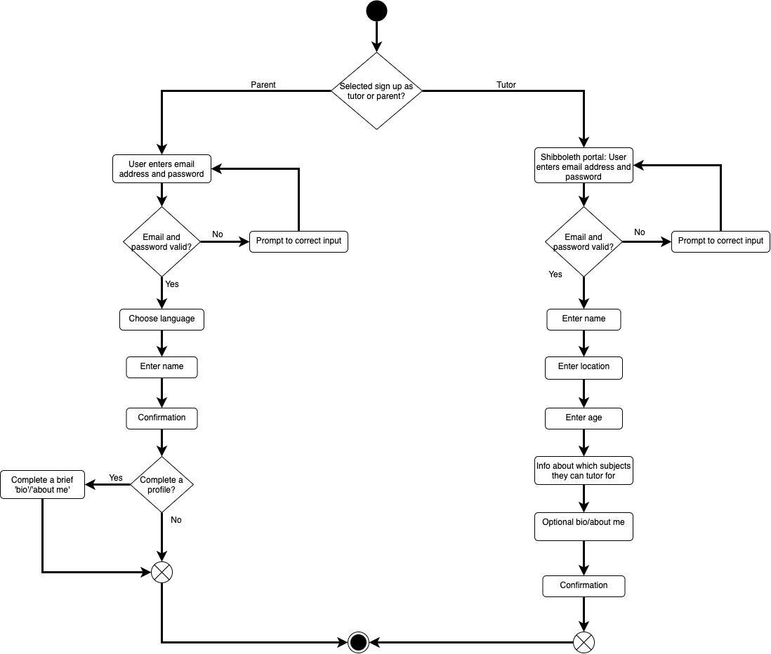

# Details of implementation

## **Database Implementation**

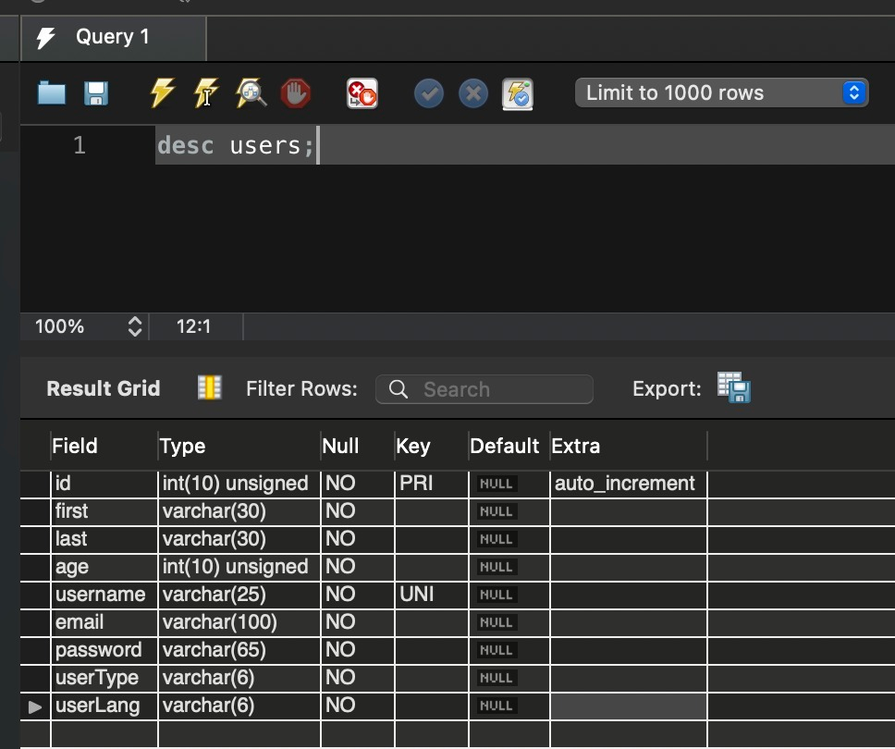

Figure 1 - Database 'users' table

The primary key is id, which is an auto-incrementing int.

The username column has a constraint that values entered into it must be unique (so you cannot create more than one record with the same username).

All columns have a 'not null' constraint - meaning if you try to enter a new record without a value for any column, it will be rejected by the database.

There is logic in the JS server code to check whether the username sent with a registration form is already associated with a record in the database and send a message to the frontend application indicating that they cannot use that username.

There is also logic in the server code to send an error message back to the frontend if any fields (columns) are missing data. There is logic in the frontend application to prevent registration forms from being submitted with any missing data.

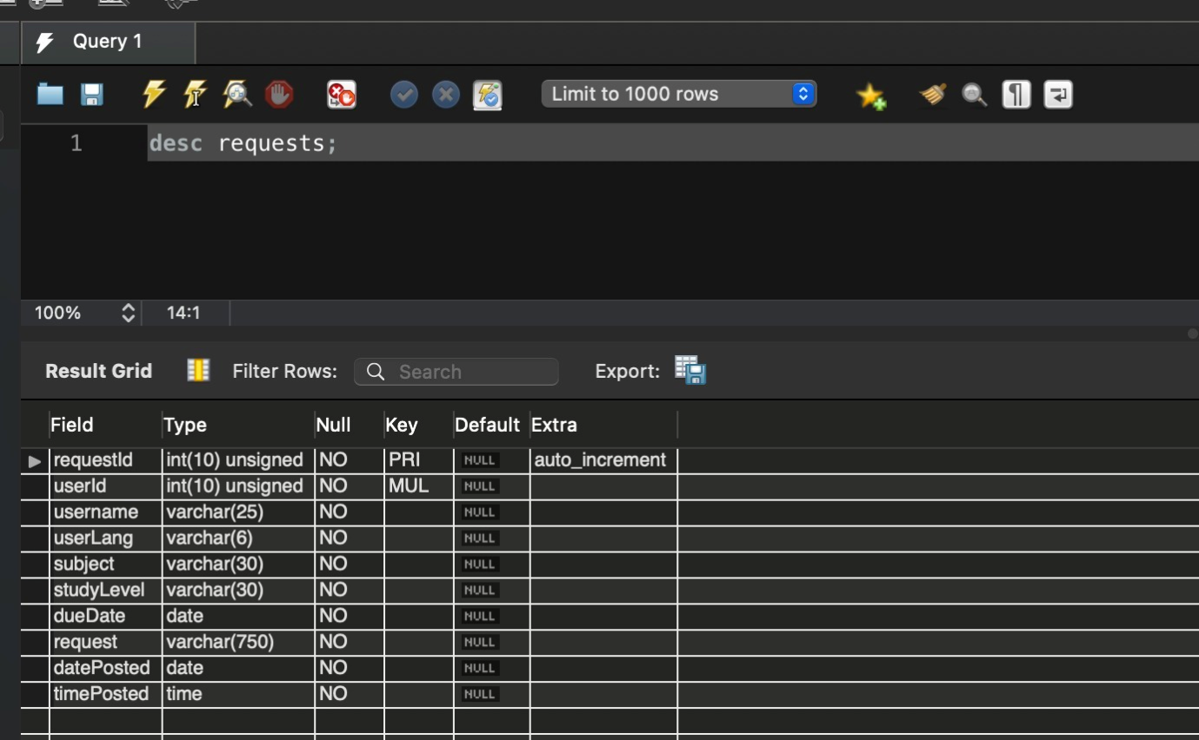

Figure 2 - Requests table

Requests table (i.e., people posting requests for help with homework):

RequestId is the primary key autoincrement. Also, unsigned means cannot be negative, but it is not essential since they are auto-generated from 1.

All columns have a 'not null' constraint with accompanying logic in frontend and backend JS code to prevent even trying to create a record with missing values.

UserId is a foreign key that references users.id. One user could create multiple requests for help at different times or different assignments/help a different one of their children.

The messages table also references requestId to retrieve messages that a given user has either sent or received, which relate to a given request object.

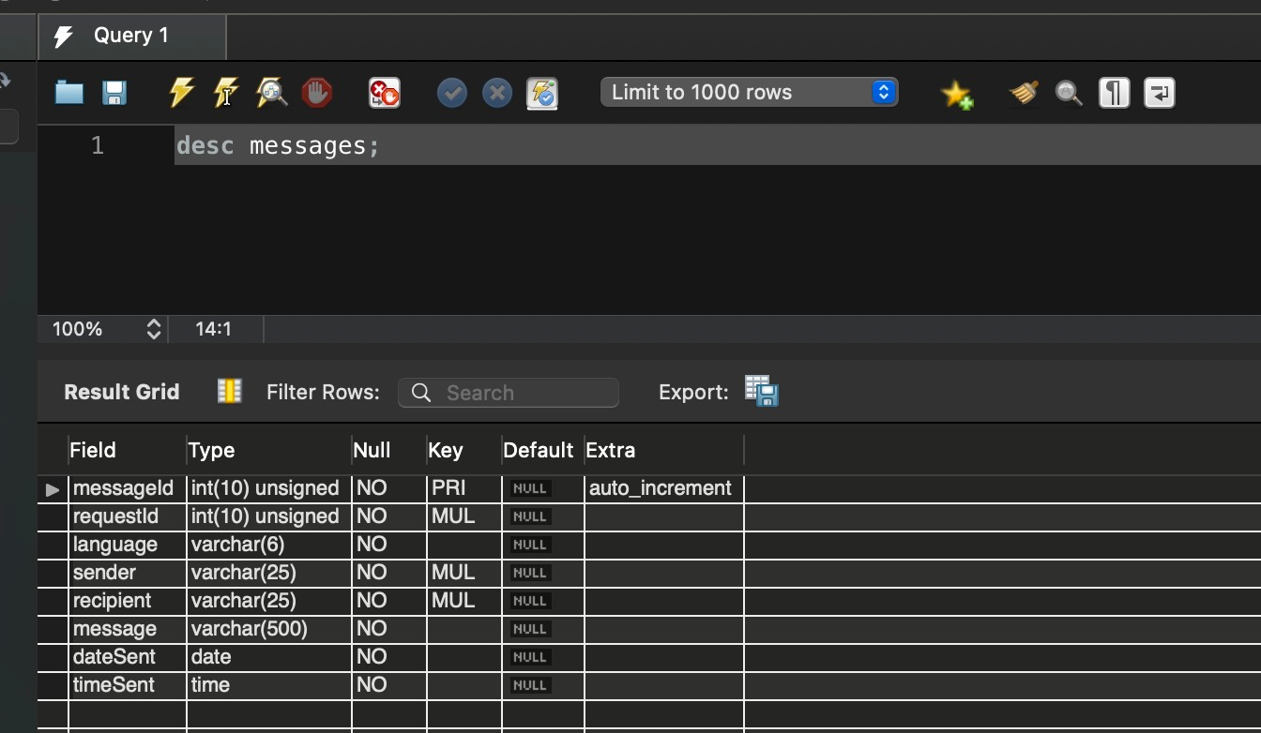

Figure 3 - Messages table

The primary key is messageId, an unsigned auto-incrementing int.

RequestId is which request to help the message relates. is a foreign key which references requests.requestId.

Language is the language of the user who sent the message.

Sender & recipient. Also, there are foreign keys that reference the username column in users. MySQL allows username not to be a foreign key despite users because it is constrained to unique values.

Date & time.

The message is the actual text of the message that the sender wrote.

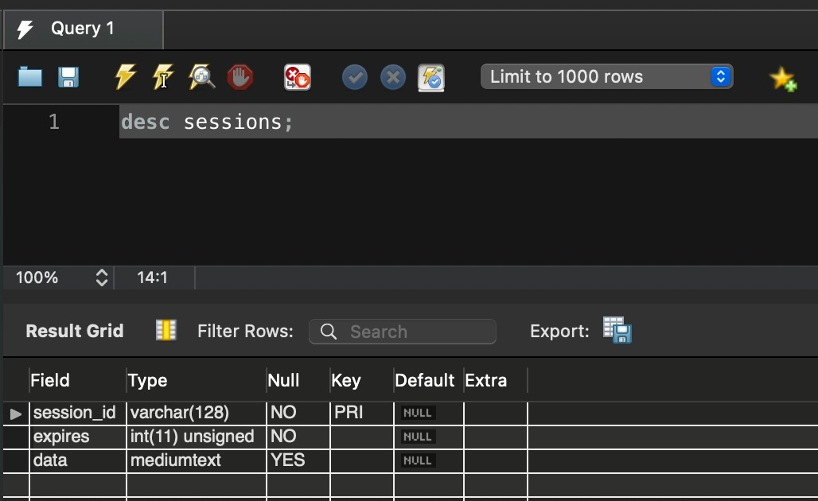

Figure 4 - Sessions table

It is created by the 'express-session' middleware, using 'express-mysql-session' middleware (following screenshot) on top of express-session.

This automatically records session data in the database whenever a new user session starts. Somebody registers/logs into the application for the first time or returns to it in their browser more than 24 hours after they last logged in, or if they had logged out at the end of the last time, they used it.

Data in this table is used to create cookies and do other activities around 'session management'. For instance, keeping users logged in for 24 hours, so if they navigate away from the application (close the tab or go to a different website, when they come back, they don't have to login again. If they are logged in and using the application and open part of the application in a new tab, they don't have to login again to the new tab.

# Technical Architecture

We have a Vuejs application for the frontend (the user interface), i.e. what the user sees and interacts with in their web browser. We also have a separate API (written in Nodejs & Expressjs) to handle database operations. The database operations are things like registration, login authentication, creating/deleting requests for help & messages, retrieving all of the requests & messages.

Besides database operations, the API also retrieves the list of languages that Google Translate supports and sends that list to the frontend Vue application (which uses it for the dropdown language selector) and the API handles translation requests from the Vue frontend. It receives HTTP requests with text to translate & the language to translate it into, it sends a request to Google Cloud Translate API and sends the results back to the frontend.

Originally, the plan was that our Express API would be hosted on a virtual machine on Goldsmiths’ Department of Computing. The intention was that one Express virtual server (one index.js or app.js file) would serve both the API and also the user interface (the things the user sees and interacts with in their browser).

Ultimately, what we’ve ended up with is the UI (the Vue application) and the API being completely separated and both hosted on herokuapp.com - none of the code our software project uses is now hosted on Goldsmiths DoC. The rationale for this will be discussed later.

## **Obstacles/problems and how they were solved**

## **Google Cloud Translate API**

<https://cloud.google.com/translate/docs/reference/rest/?apix=true>

We decided to use Google Cloud Translate API for the translation for 2 reasons. First, it has one of the widest ranges of supported languages. Second, it has a reasonably good reputation for accuracy of its translations (still not great, but better than reviews of most other translation APIs) (Purkaystha, 2019; *Top 9 Best Translation APIs (2021) [23+ Reviewed]*, 2021).

Plus - being owned by the world’s largest search engine and one of the largest tech companies (which has its operating systems installed on half the world’s smartphones, plus many tablets and laptops) - we reasoned that Google Translate is likely to evolve and improve at a faster rate than other translation APIs. Think how much data Google must hold - and analyse - about how people use language and communicate!

In all likelihood, the Google Cloud Translate operations probably should be sent directly from the frontend Vue application, rather than going to our Express API, then Google Translate, back to our Express API and back to the frontend from there. Waiting for that extra step must slow down the frontend application a little, but any performance difference isn’t very noticeable (or at least, it isn’t on my home broadband).

The only real reason for the Google Translate operations being done from our Express API is that working with Google Cloud Translate API was the first thing we figured out for this project. We wanted to ensure we understood how to use the Google Translate API before anything else. It seemed (based on what we understood of web development from our Data & The Web module) the simplest way to experiment with the Google Cloud Translate API would be to write a very basic Express application to send HTTP requests to and receive responses from Google Cloud Translate.

So the first thing that we did was write an app.js file to create a very basic Express application, and we wrote a routes/main.js file with a /getlanguages route and a /translate route. It looked like this:

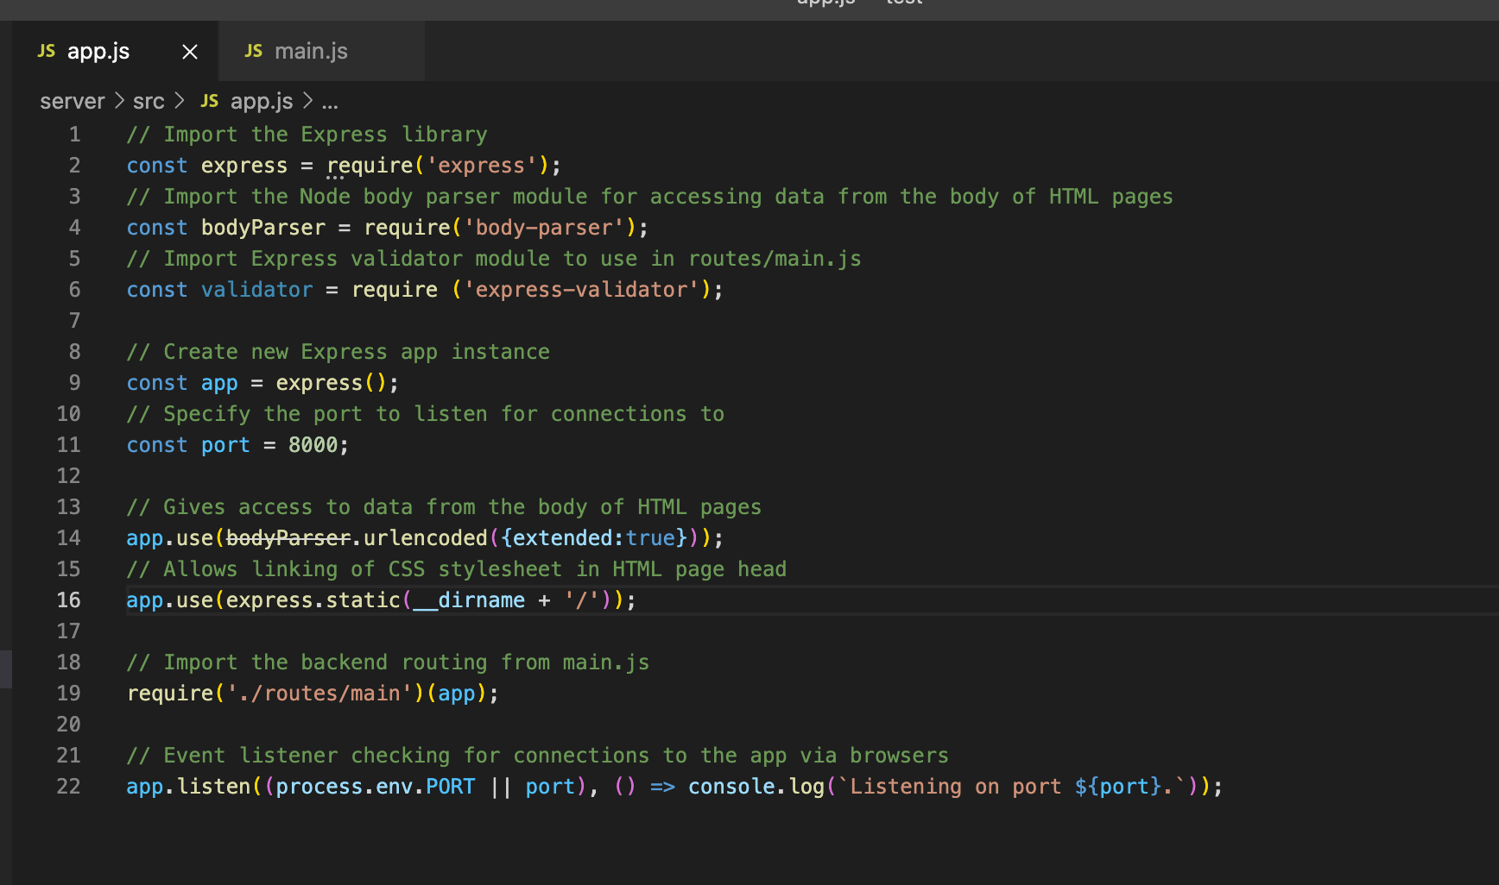

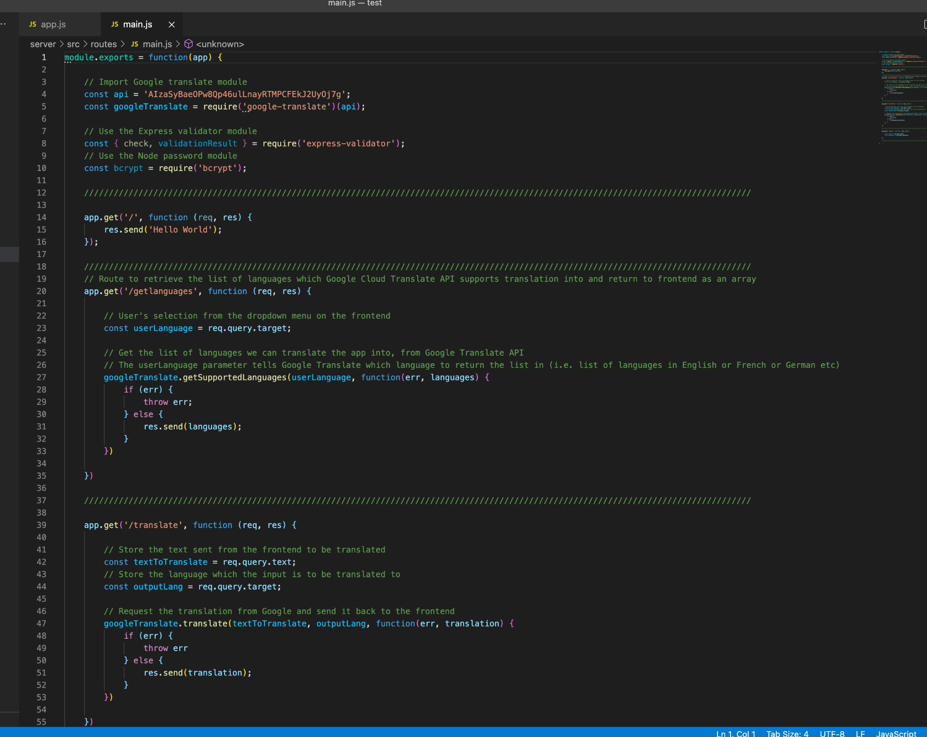

Then we could test the responses those routes returned from Google Translate like so:

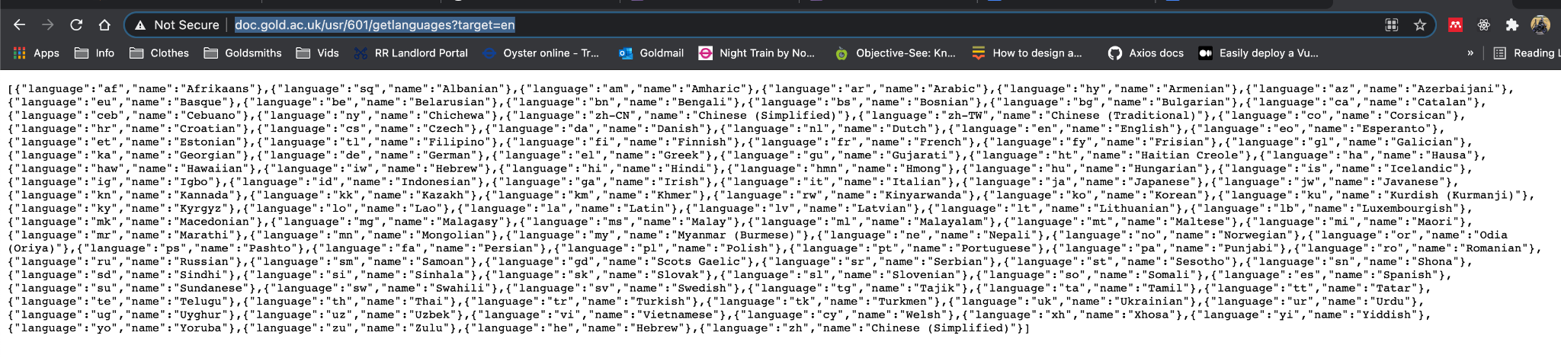

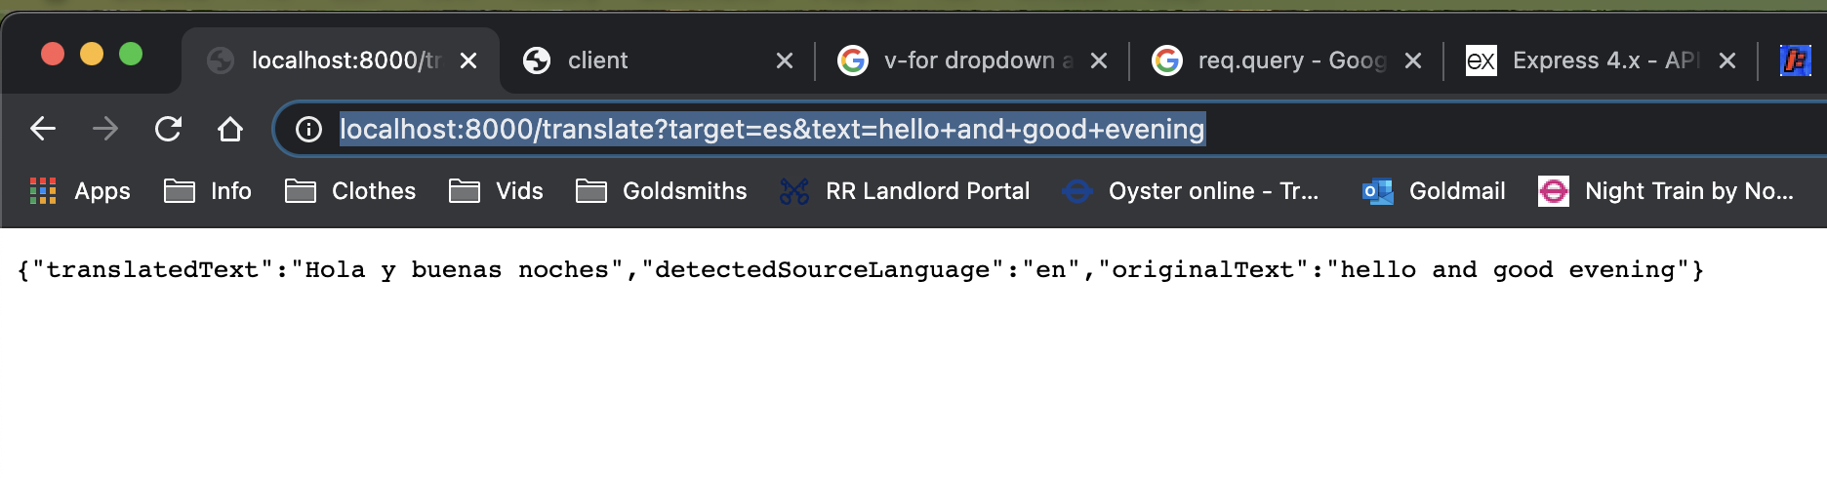Having established that those routes worked and what format the output would be in, we also knew that when we started building a frontend, it would be able to send requests to those routes and they would send back data in these particular formats (JSON objects with particular properties).

Now returning to our earlier assertion about how the translation requests should probably really be sent directly to Google Translate from the Vue UI, rather than being routed through our backend API… Translation was the first thing we figured out and having figured out that it worked from the backend, we considered it best not to fix what’s not broken.

## **Building the frontend (user interface)**

Eventually our Express API would perform database operations like creating user records, checking login credentials against user records (for login), creating requests for help & messages, retrieving the requests & messages, deleting those etc.

That meant we needed a user interface - some way for users to interact with that backend API. We could probably have just used static HTML files or EJS templates, but it wouldn’t have been so responsive. We might have needed multiple templates for each page/component (to reflect different states) and very long logic in the routes/main.js file to determine which templates to display and which data to pass them to render. It would have been quite difficult for anybody looking at the code to understand what it was doing. There would’ve been a lot of reloading & redirecting things in the user’s browser, which can be slow and resource intensive.

We decided as a group to use a Javascript design framework to write our frontend. We discussed using either Reactjs or Vuejs. Those frameworks make it relatively easy to change/update the content which is rendered in the browser, without having to either reload a whole page/template or redirect to a different page/template just to show minor changes (Freed, 2016). So there are performance advantages to using reactive JS frameworks - the application runs faster in the user’s browser than it would if we had to keep re-rendering static HTML or EJS templates to update very small parts of the content displayed. That’s good for impatient users. Also not having to do so much reloading/rendering of markup means that the code requires less processing power on the host server (Maniatis, 2018), so we’re less likely to incur charges/costs from our hosts.

Ultimately we decided to use Vuejs rather than Reactjs (or Angular, which we didn’t even really consider). The reasons being that Vue gave the impression of being more accessible from the perspective of developers needing to learn a framework which is completely new to them, in a short space of time. Vuejs’ ‘single file components’ (all of the markup, JS and CSS for a given component encapsulated in its own separate file) also appealed to us on the grounds of making ‘separation of concerns’ pretty straightforward.

We decided not to use the most recent version of Vuejs (v3), but to use the last release of the previous version, v2.9.6. The rationale was that an older version might have wider browser support, although that was an assumption and probably not one that bears scrutiny. Having used an older version of Vue also made things interesting when trying to solve problems based on things we read on StackOverflow, Vue’s own forums and Vue’s documentation. There are differences in features and functionality between Vue v2 and v3, so I’ve had to always check that I was viewing Vue’s own documentation for v2 and had to figure out how to adapt solutions (e.g. from forums) to work in v2.

We set up the Vuejs application via Vue CLI, opting to implement the webpack template, with the Vue router option installed. We did this by following this YouTube tutorial video titled [*Full Stack Web App Using Vue.js & Express.js, part 1*](https://youtu.be/Fa4cRMaTDUI)*:* (skip to 8:25 and watch til about 15:15) (Seibert, 2017).

**CSS  and HTML**

There are a lot of divs in code to make sure css is applied to right parts of code but we also used semantic tags to make sure app is accessible for everyone, SEO (browser searching) and code cleanliness.

There is quite a lot of flexbox used in the app for proper items aligning and responsiveness. There are mostly used percentages or vw, vh so app is responsive and elements are always displayed in the correct way. We decided to change position of the navbar compared to prototype. Now it is positioned above the image (not inside the background image) just to make it stands out from the rest, is contrastive and visible. Images and icons are downloaded from prototype and saved as assets folder in app directory.

Few things in the app that would need implementing in the future- we would add also more complex elements from prototype which unfortunately seemed a little to complex to implement. App uses images from its inside folder (assets) instead of any external links. It is making app works much faster with saving time on uploading images from external sources. It also makes sure if for some reason it would get deleted our app still has access to it.

## **Sending HTTP requests and responses between frontend & backend**

As previously mentioned, the UI (the Vue frontend application) needed to send HTTP requests to our Express API and receive responses from it. The HTTP requests from the frontend are things like authenticating login credentials, registration form data processing, posting a request for help or a message object. Responses are mostly success or failure messages, to tell the frontend what to do next.

Having set up a basic Vuejs application by following the video cited in the previous section of this document, the same video (Seibert, 2017) (36:50 to 54ish) also taught us about an API called [Axios](https://github.com/axios/axios) which can be used to handle HTTP requests and responses in a Vuejs application. So we configured and implemented Axios in our UI in a very similar way to that video:

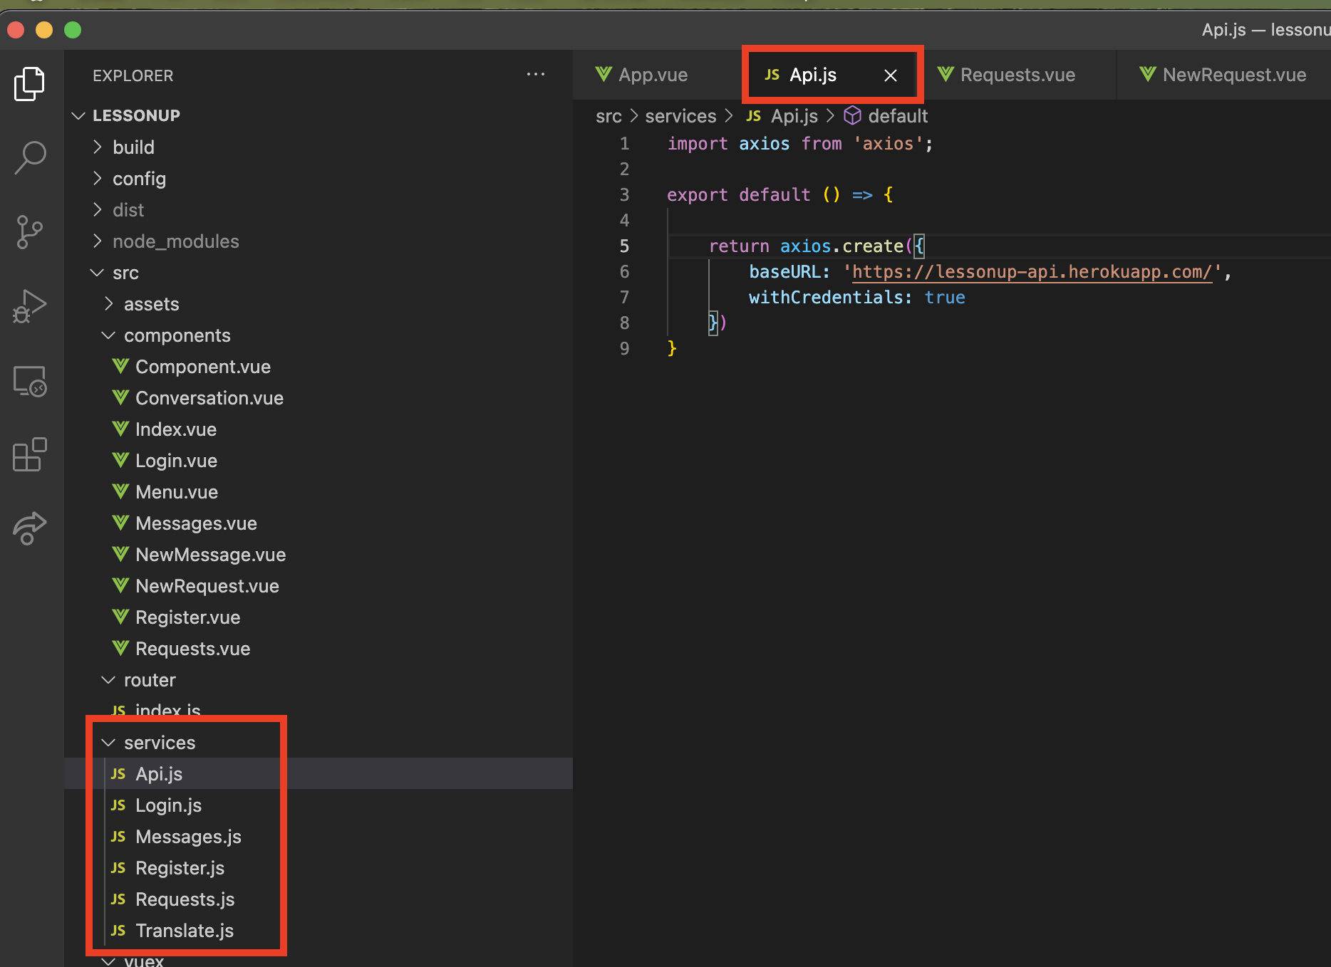

There’s one instance of Axios, in a file called Api.js. Api (i.e. the Axios instance) which is then imported in other .js files in src/services, where each of those service files has methods for sending different types of HTTP requests to routes in our Express API.

HTTP requests which deal with similar things are grouped in separate files, e.g. requests relating to Google Translate are in Translate.js:

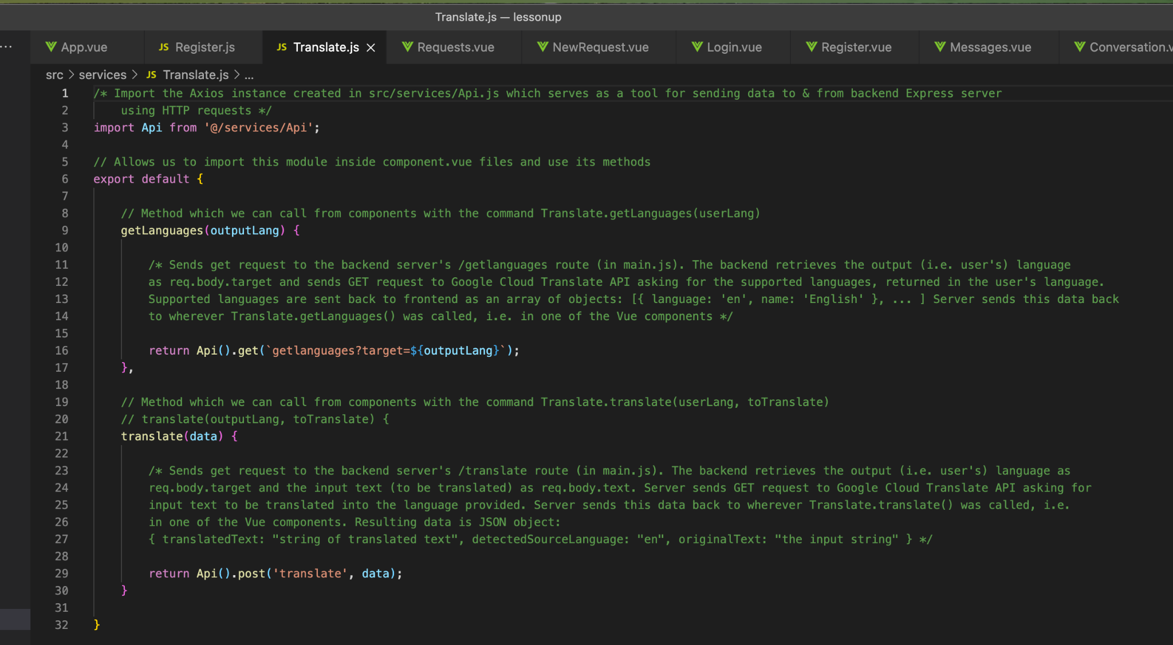

Requests relating to user registration are in Register.js:

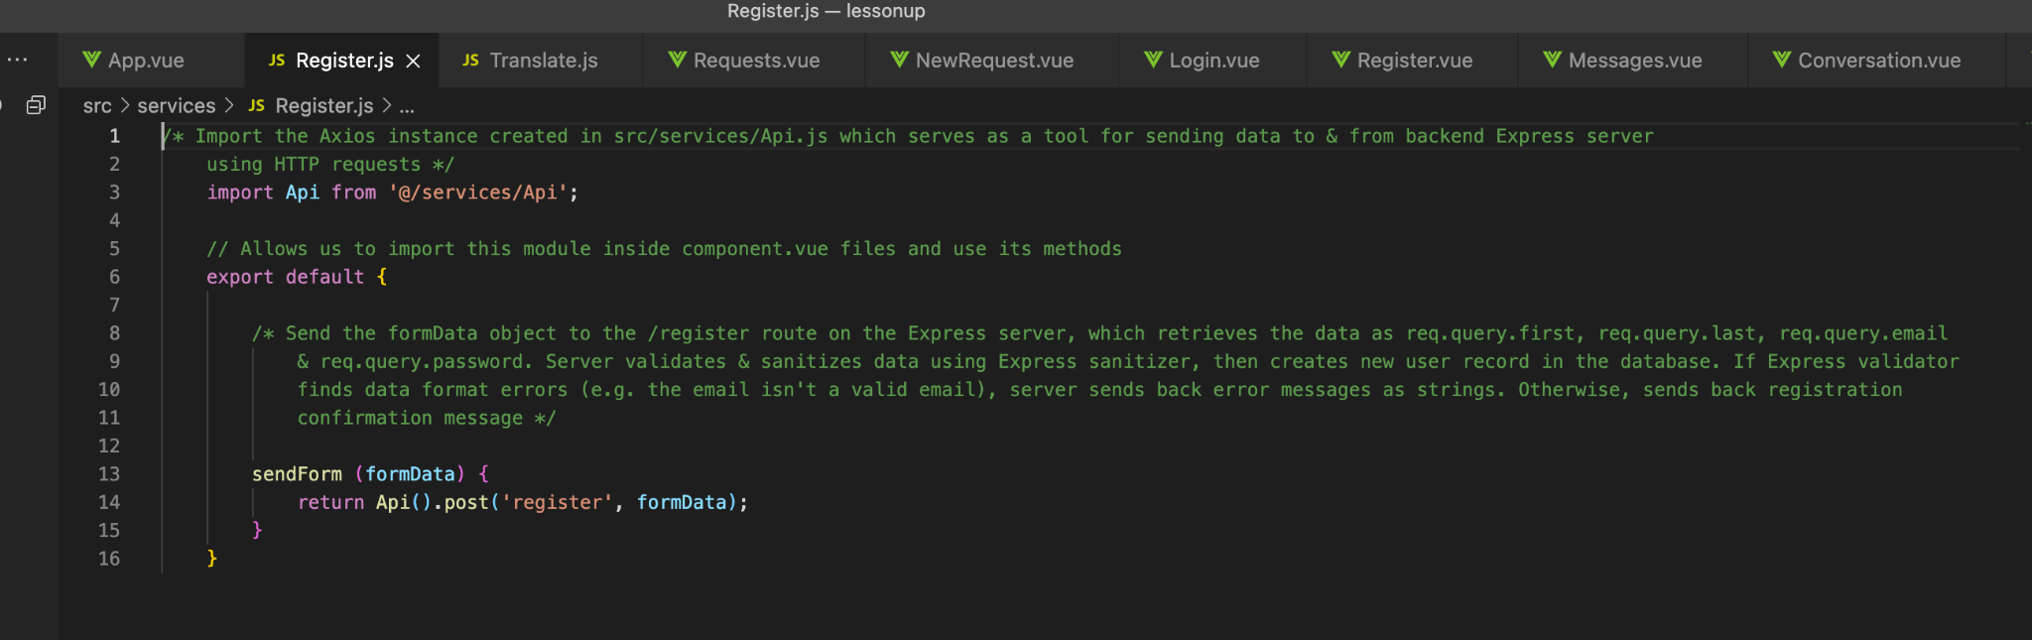

Login requests are in Login.js:

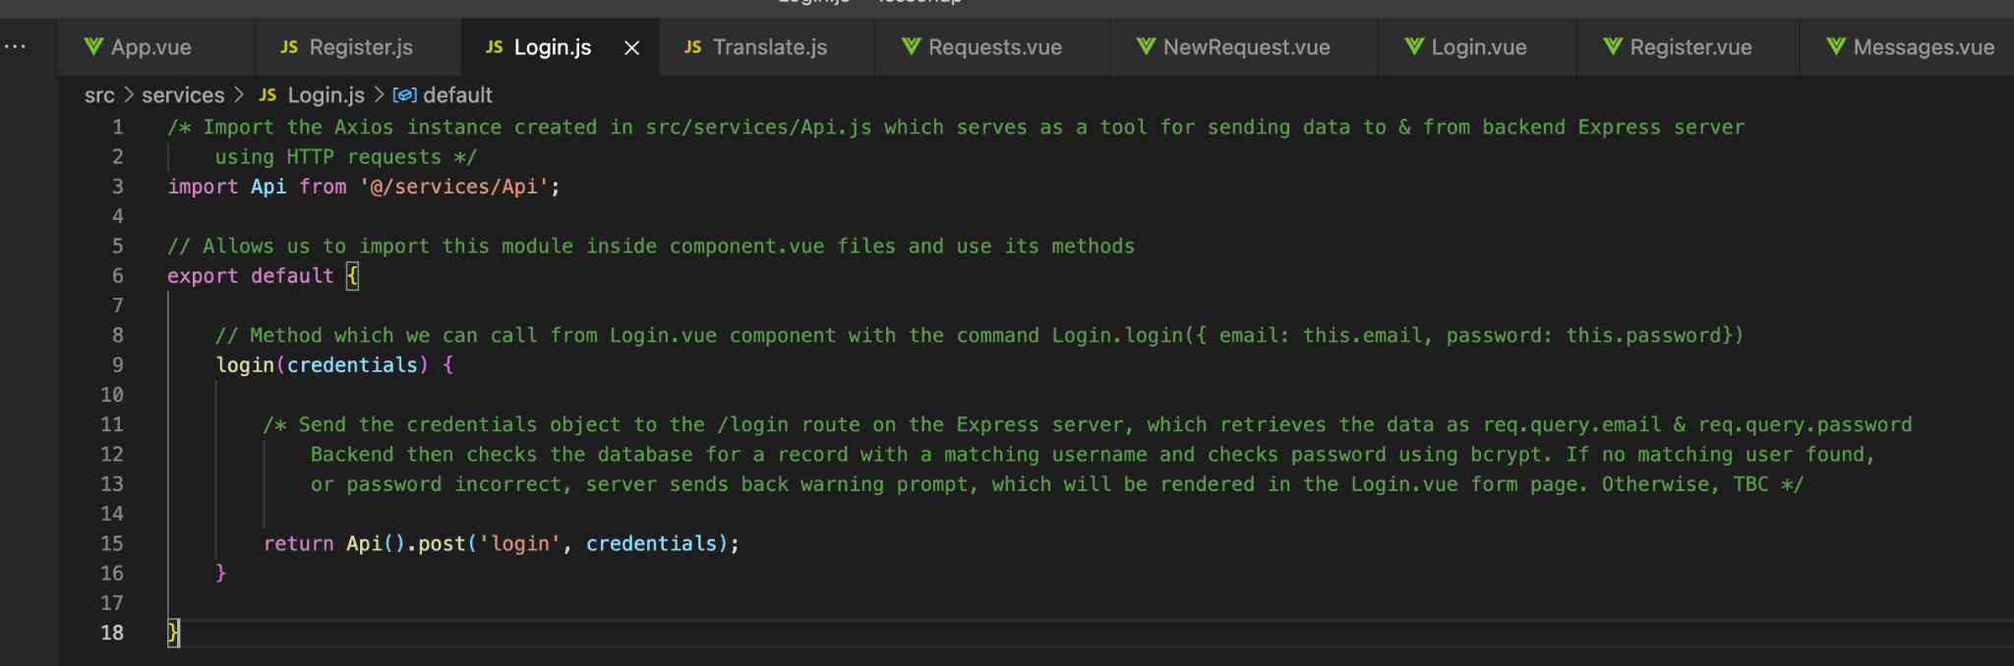

Parents’ requests for help with homework are in Requests.js:

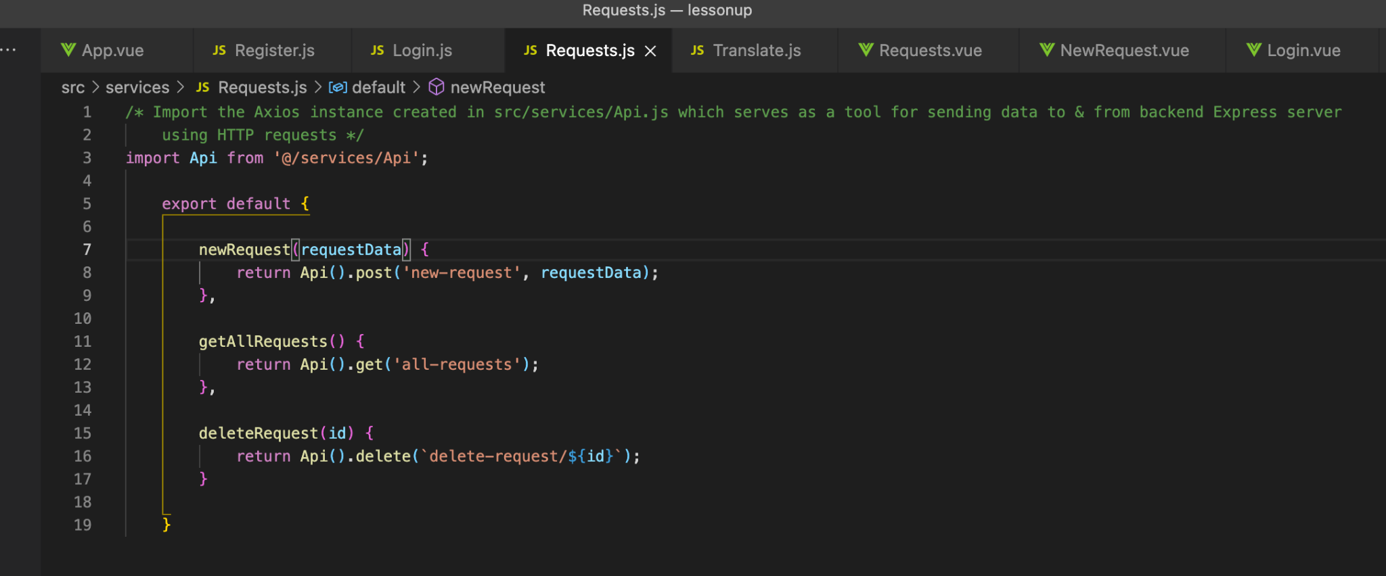

Messages.js:

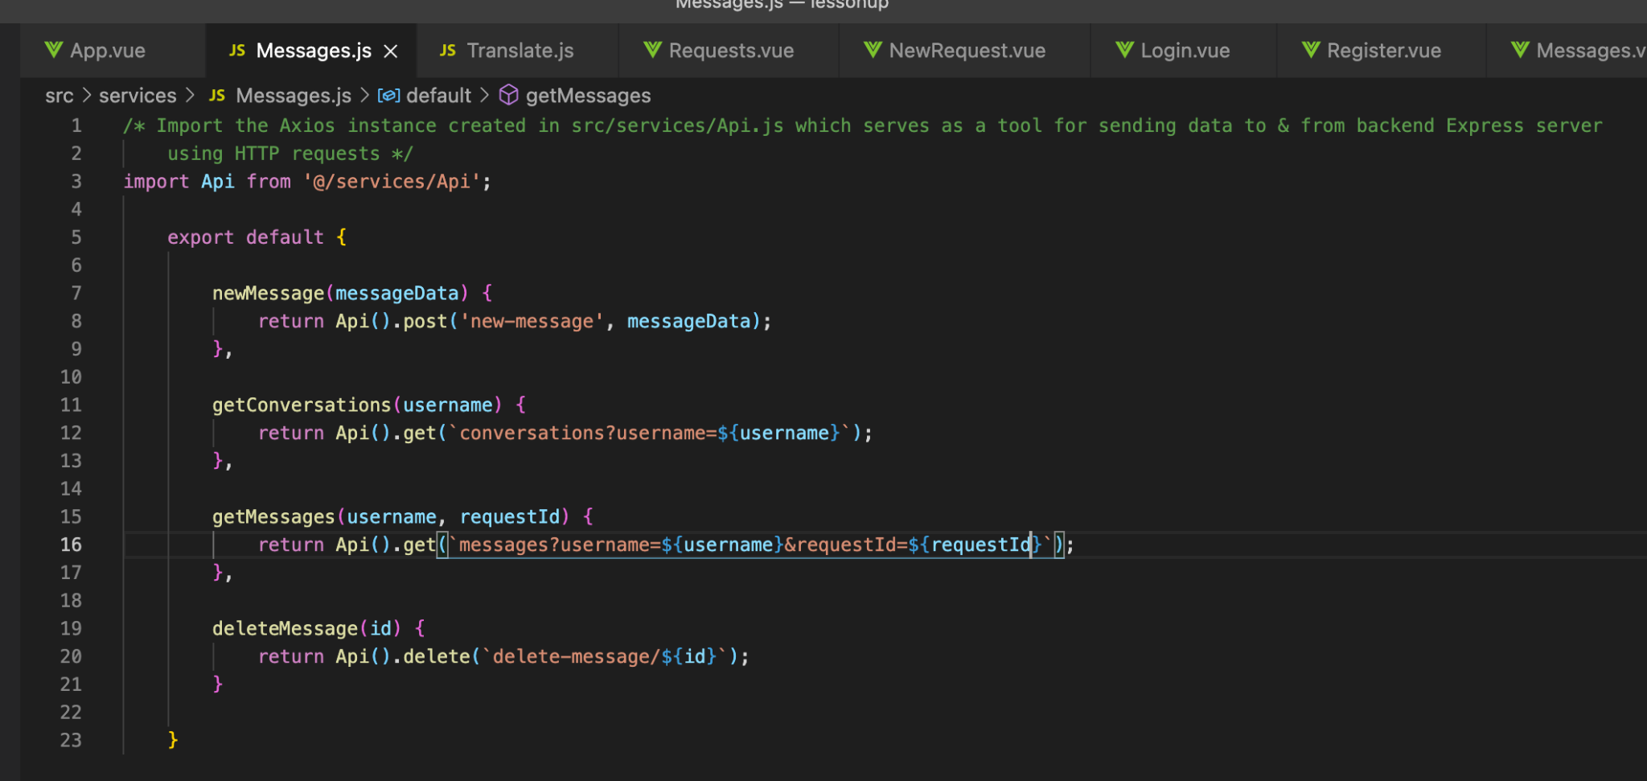

Then those .js files in src/services, with their methods for HTTP request handling, are imported in the .vue components so their methods can be implemented:

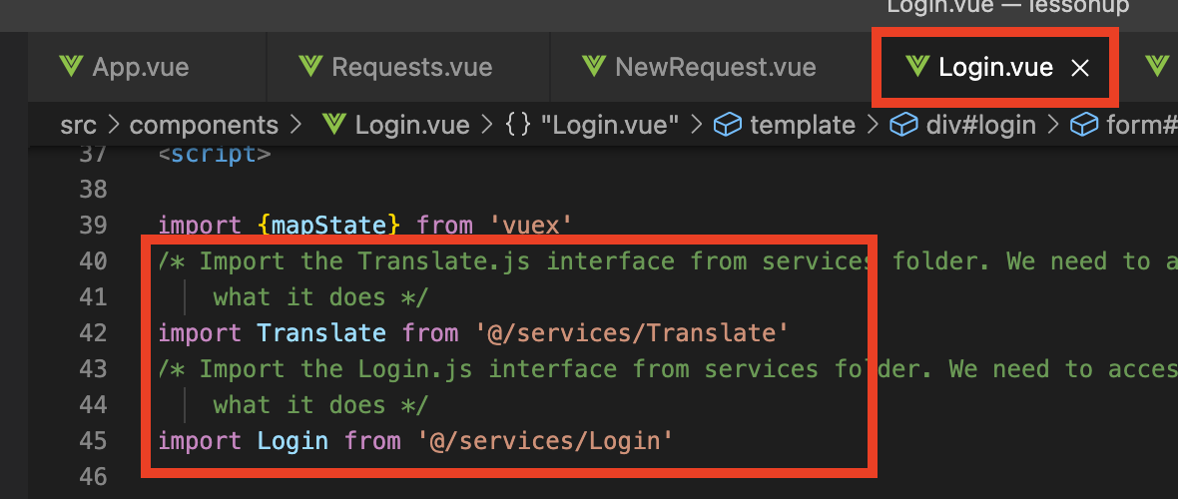

Implementing methods from Translate.js & Login.js:

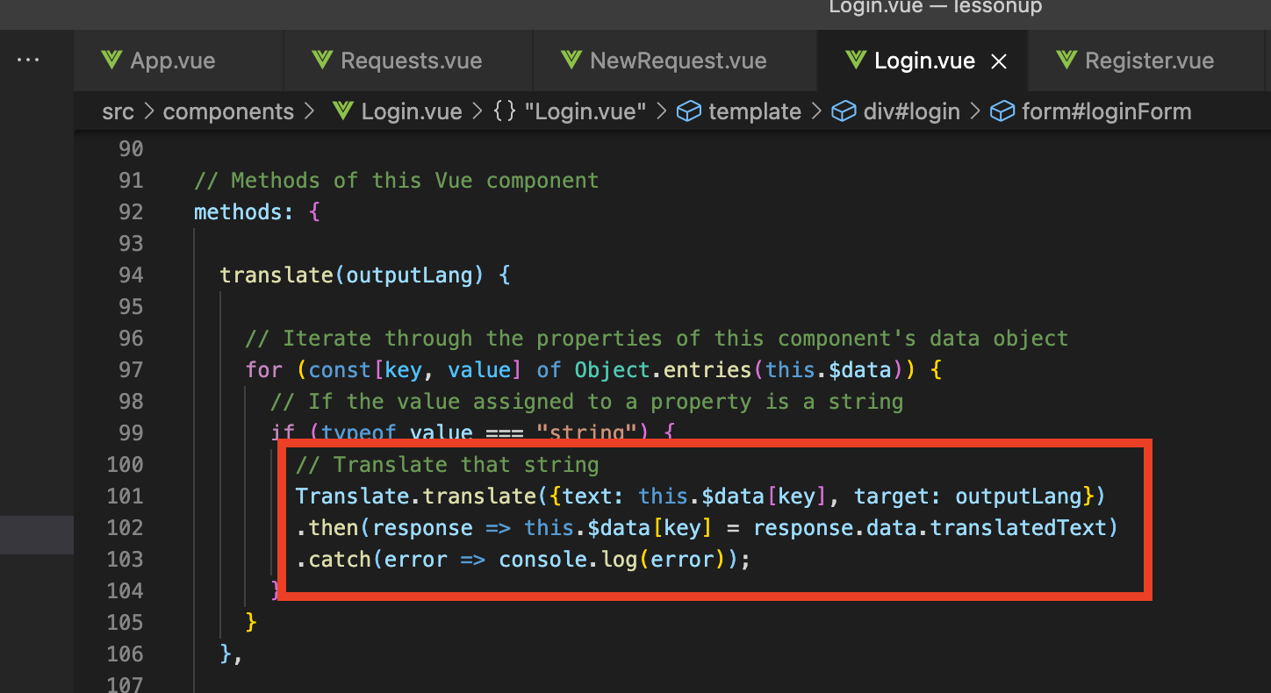

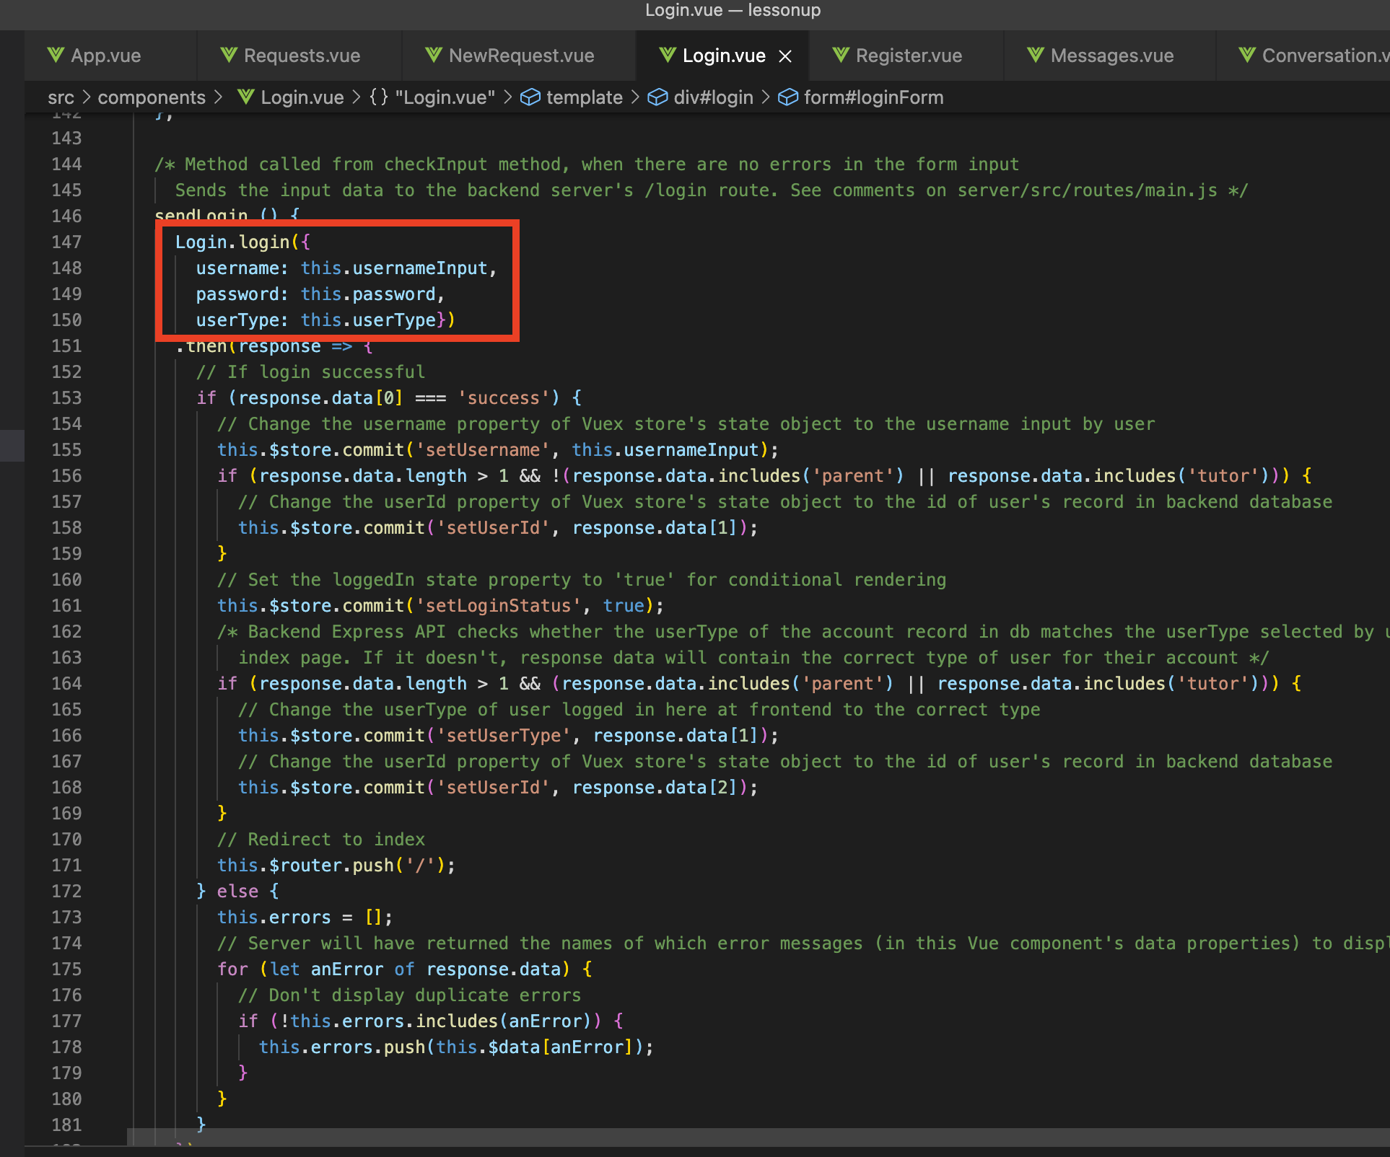

## **Vue state management & passing data between different components**

From an early stage in the project (when we only had a few components - App.vue, Index.vue and Register.vue), it was necessary - for managing the application’s state - to pass the userLang between components. The user’s chosen language must be available to all components, so they can automatically translate text displayed:

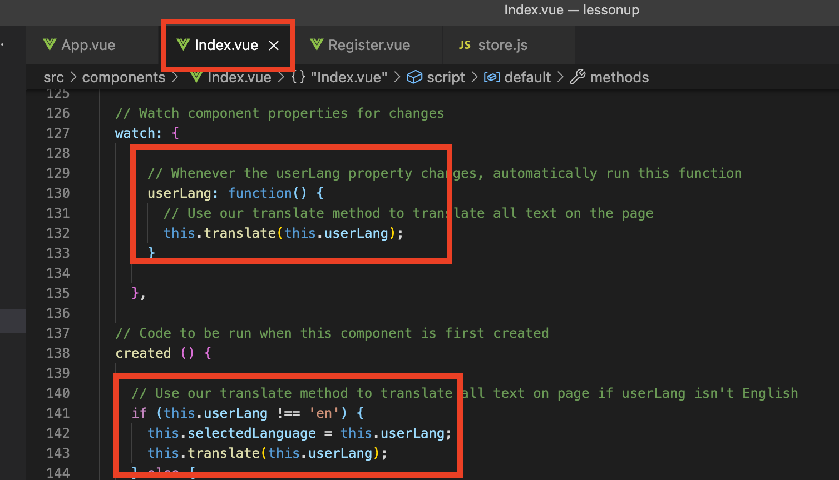

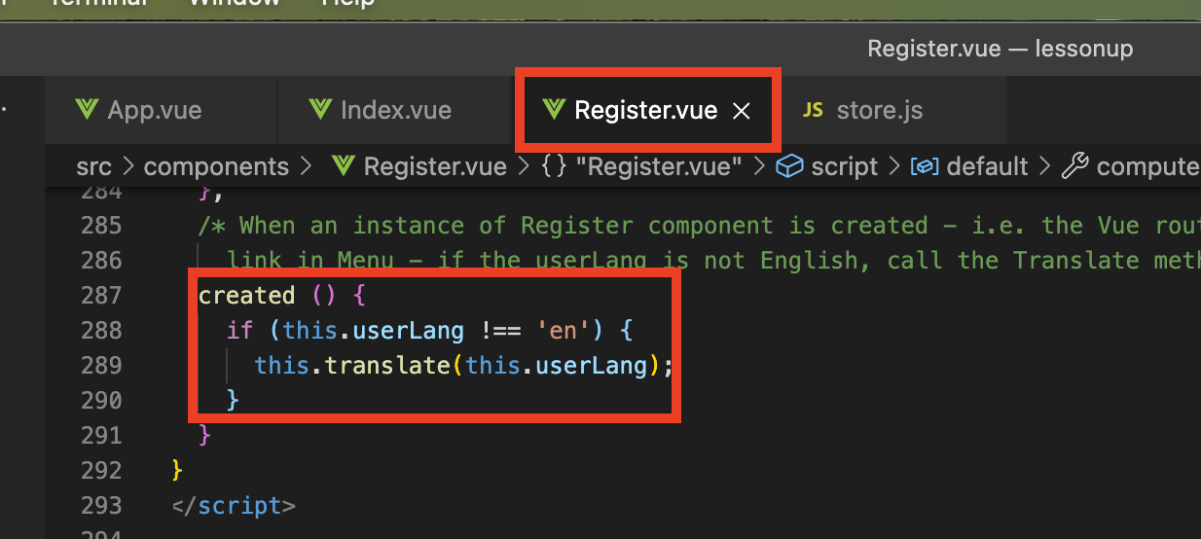

userLang was a data property of the App.vue component:

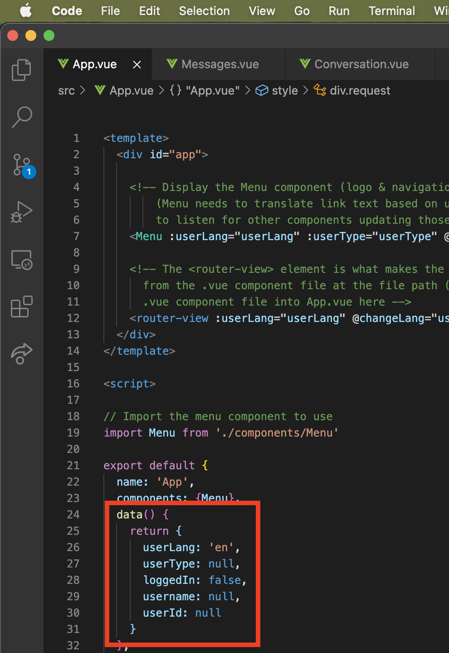

And it needed to be available to the child components (all the other .vue files, like Index.vue, Register.vue, Login.vue etc).

So we were passing that property of App.vue to the child components as a ‘prop’, which is what :userLang=”userLang” in line 12 of the screenshot above is doing. It says that whichever .vue component is instantiated inside that <router-view> tag should use the value of the userLang property of App.vue (at the time the child component was created) as its own userLang property.

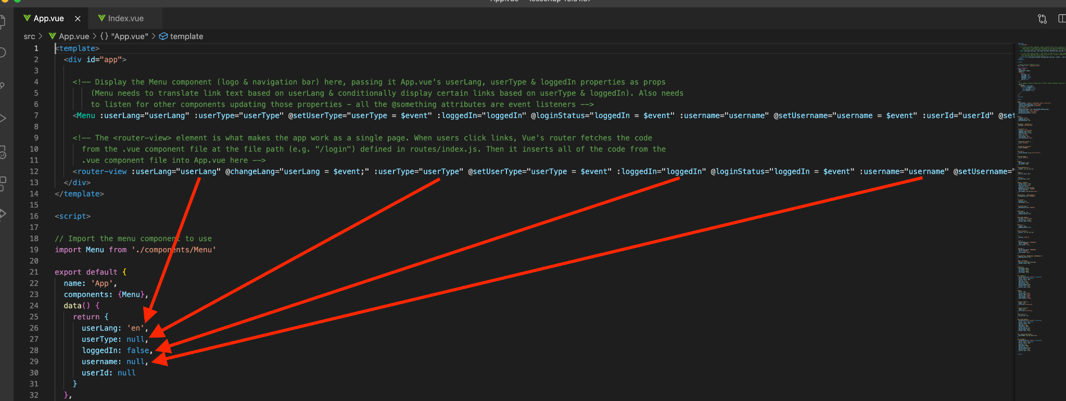

Telling Index.vue which props it should expect to receive from its parent (App.vue):  
  
(Now Index.vue, in addition to properties defined in its data object, also has the properties named in props, which have the same values as those same properties in App.vue had at the time Index.vue was created in the <router-view> in App.vue)

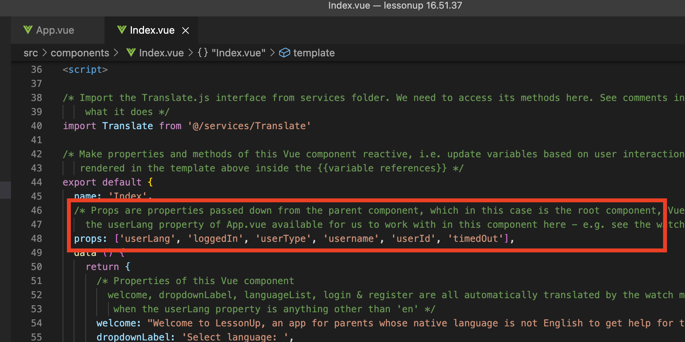

For state management of the application, some of App.vue’s data properties needed to be updated from child components. E.g. Index.vue has the language selection dropdown, so we needed to update the value of userLang at root level (i.e. in App.vue) from Index.vue. Likewise, Login.vue needed to be able to update loggedIn, username & userId in App.vue, and Register.vue also needed to update those properties upon successful registration. Index.vue shows and hides certain sections depending on the values of loggedIn & userType.

We were accomplishing this by adding event listeners to the child component’s instantiation in the parent component, e.g:  
  
(the <router-view> tag in App.vue is where the components Index.vue, Requests.vue & Messages.vue are instantiated.  
  
It has listeners which are listening for events such as ‘changeLang’, ‘setUserType’ & ‘loginStatus’. The instruction “propertyName = $event” set on those listeners says to update the property name with the value of the event ‘payload’.)

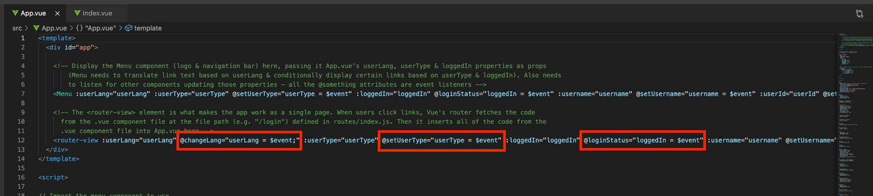

Index.vue emitting a ‘changeLang’ event with the new language - which userLang in App.vue should be set to - as its payload:

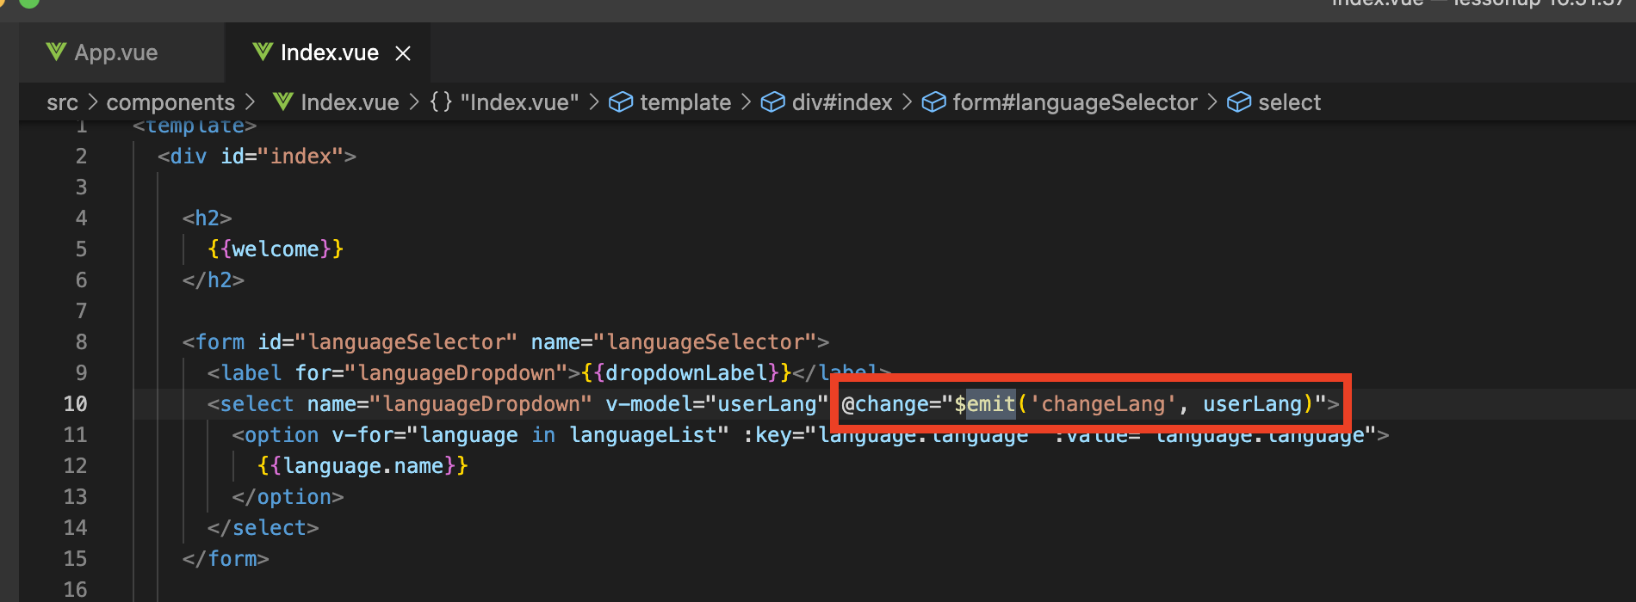

Login.vue emitting loginStatus, setUsername & setUserId events:  
  
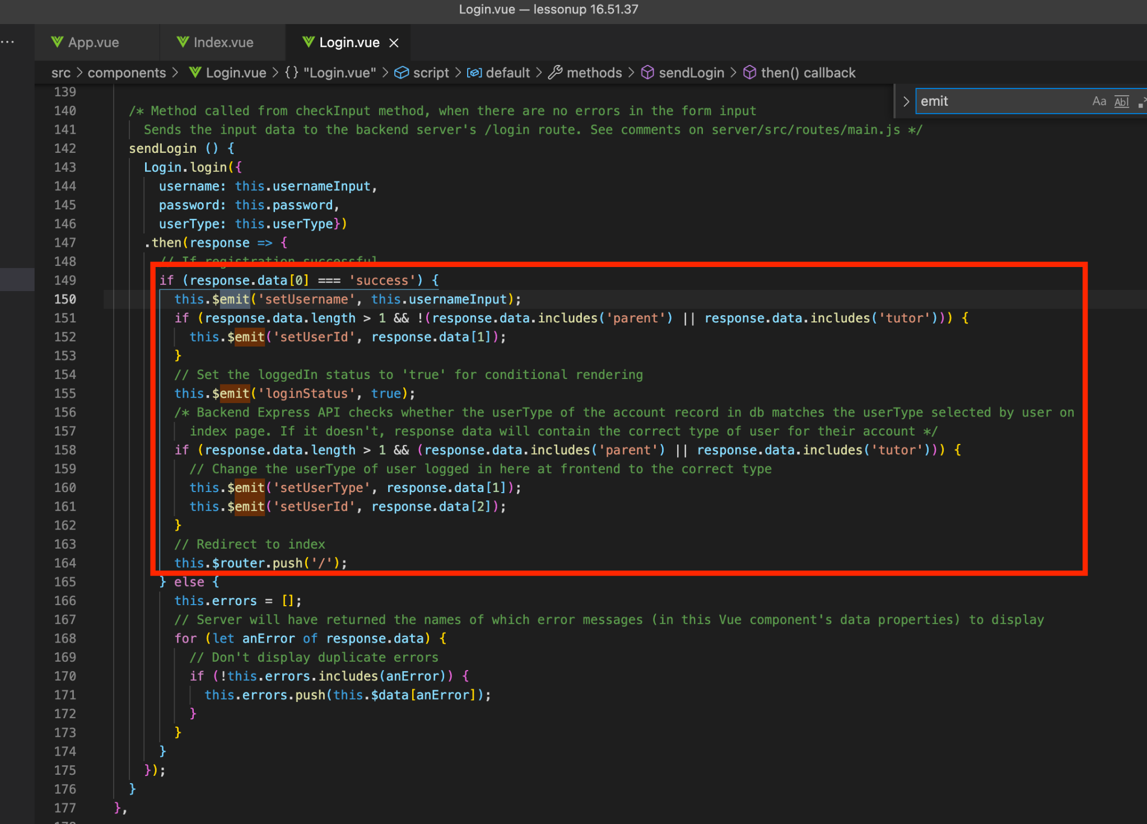

The event listeners in App.vue catch those events and update the relevant properties of App.vue (loggedIn, userType & userId are updated).

## **Switching to Vuex state management (a ‘single source of truth’)**

Using props and events to update the properties in App.vue was ok when we only had a handful of components, but started to become convoluted and confusing as we added more components, some of which have embedded child components.

For example, Messages.vue has Conversation.vue as a child component, which in turn has NewMessage.vue as a child:

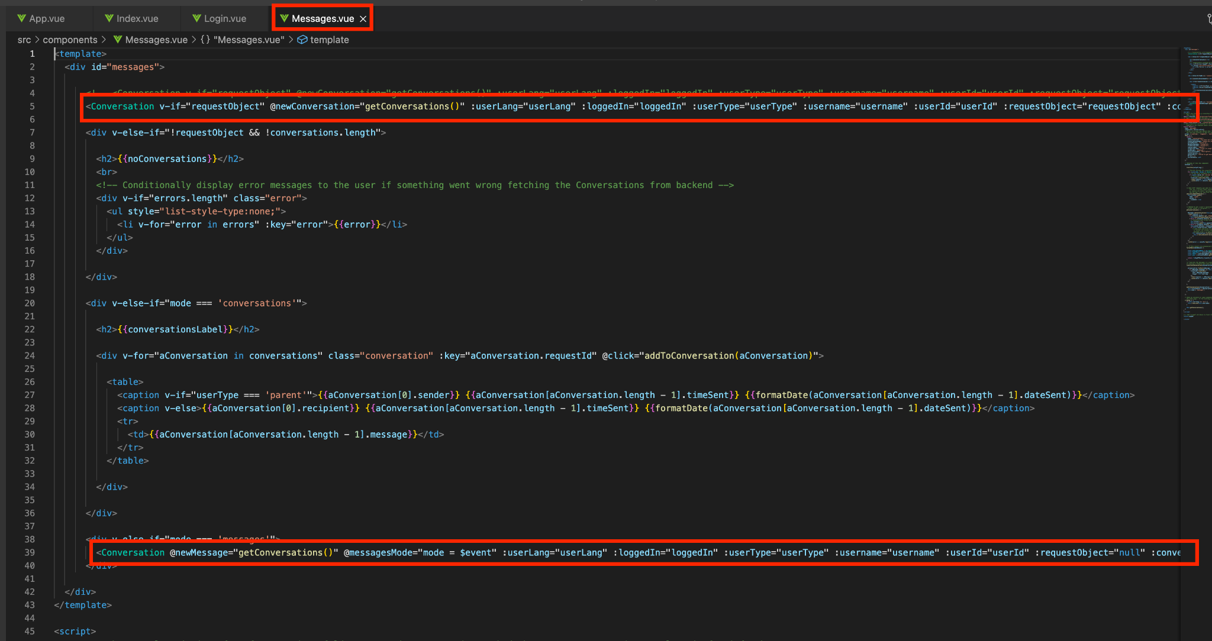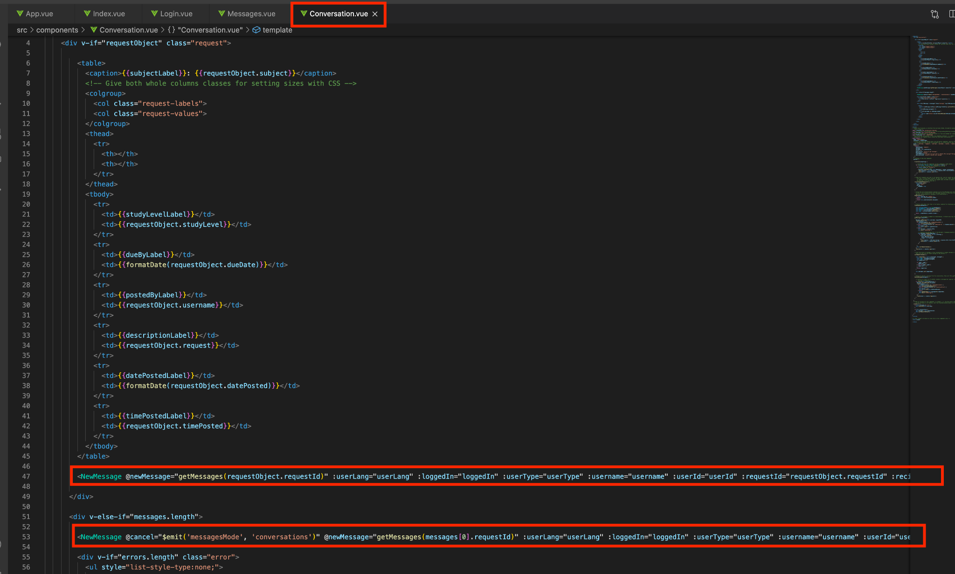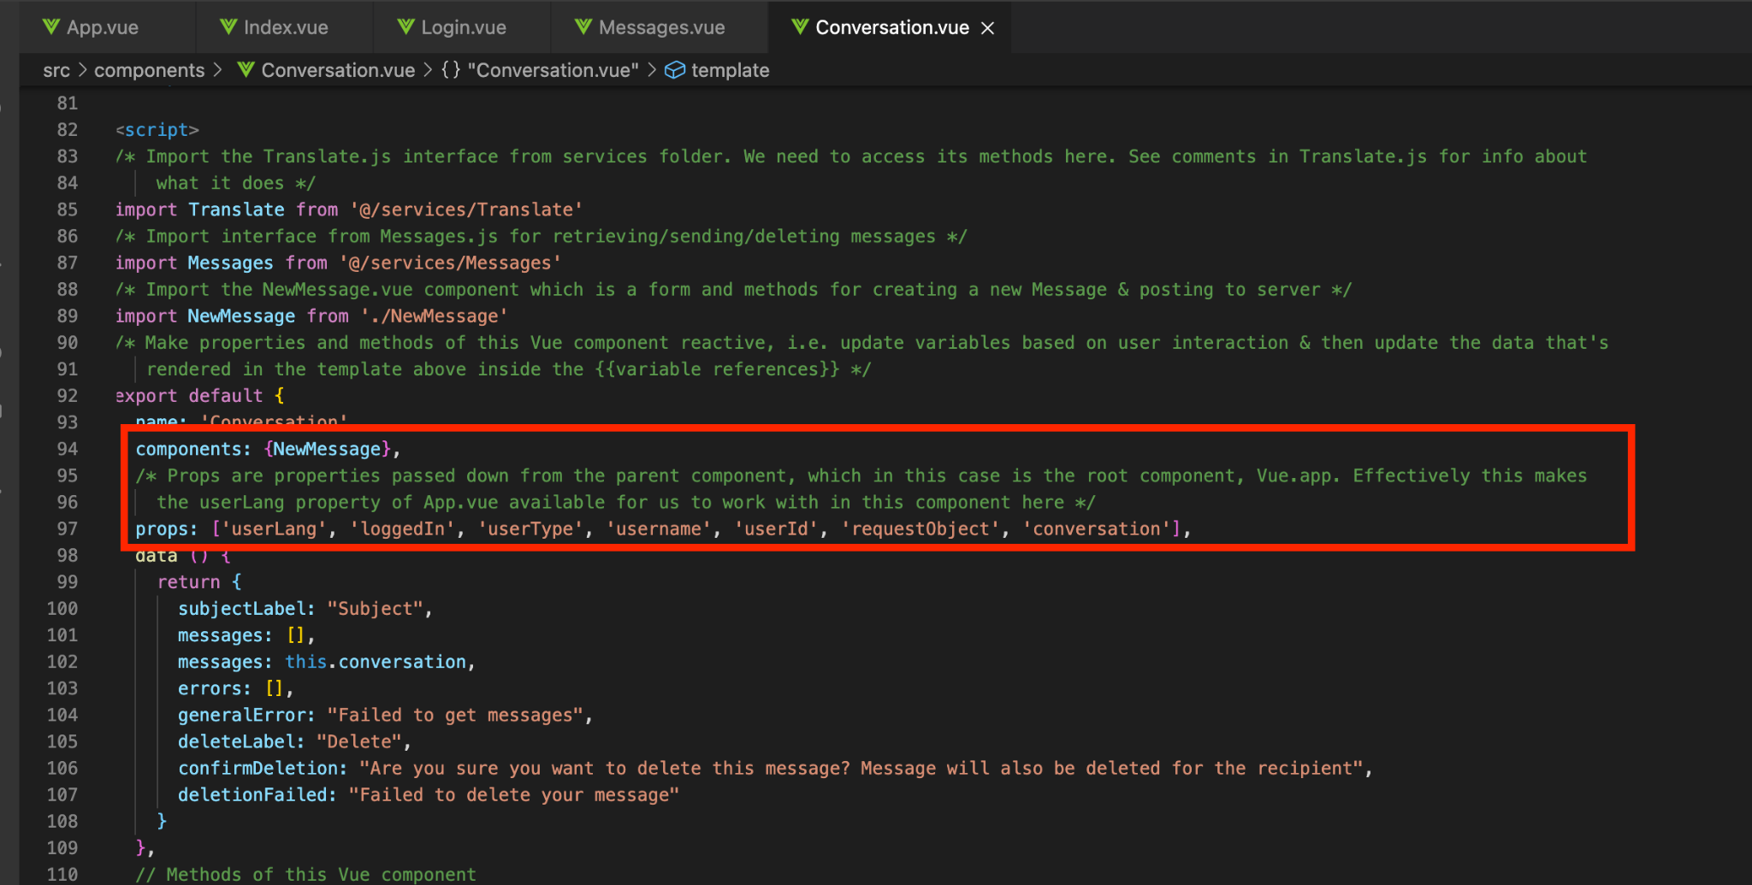

Props and event listeners everywhere - not great for readability of our code. It also meant we sometimes had to emit the same event from several components, up the chain of inheritance. That sometimes made it difficult to determine why an update had not reached the property at its root component.

The application did appear to function as expected using props and events. It was only when we began researching how to persist the application’s state - on refresh or new tab/window or returning to the address after having navigated away - that we discovered Vuex. Googling terms such as “Vuejs persist state on refresh” led us to two particularly useful articles (Eschweiler, 2017; Anumadu, 2020). From those, we were able to configure a Vuex state store and attach it to the root App.vue, thereby making the state’s properties available to all components.

Thankfully, it was relatively straightforward to implement the Vuex store and we were able to discard the majority of the props & event listeners. Components which have child components embedded within them, such as Conversations & Requests, still need to use some props. Those have remained as props to keep that data localised.

src/vuex/store.js file:

(Defines the state object with initial values, plus ‘mutations’ (methods for updating the properties, which are used in the methods of our .vue components))

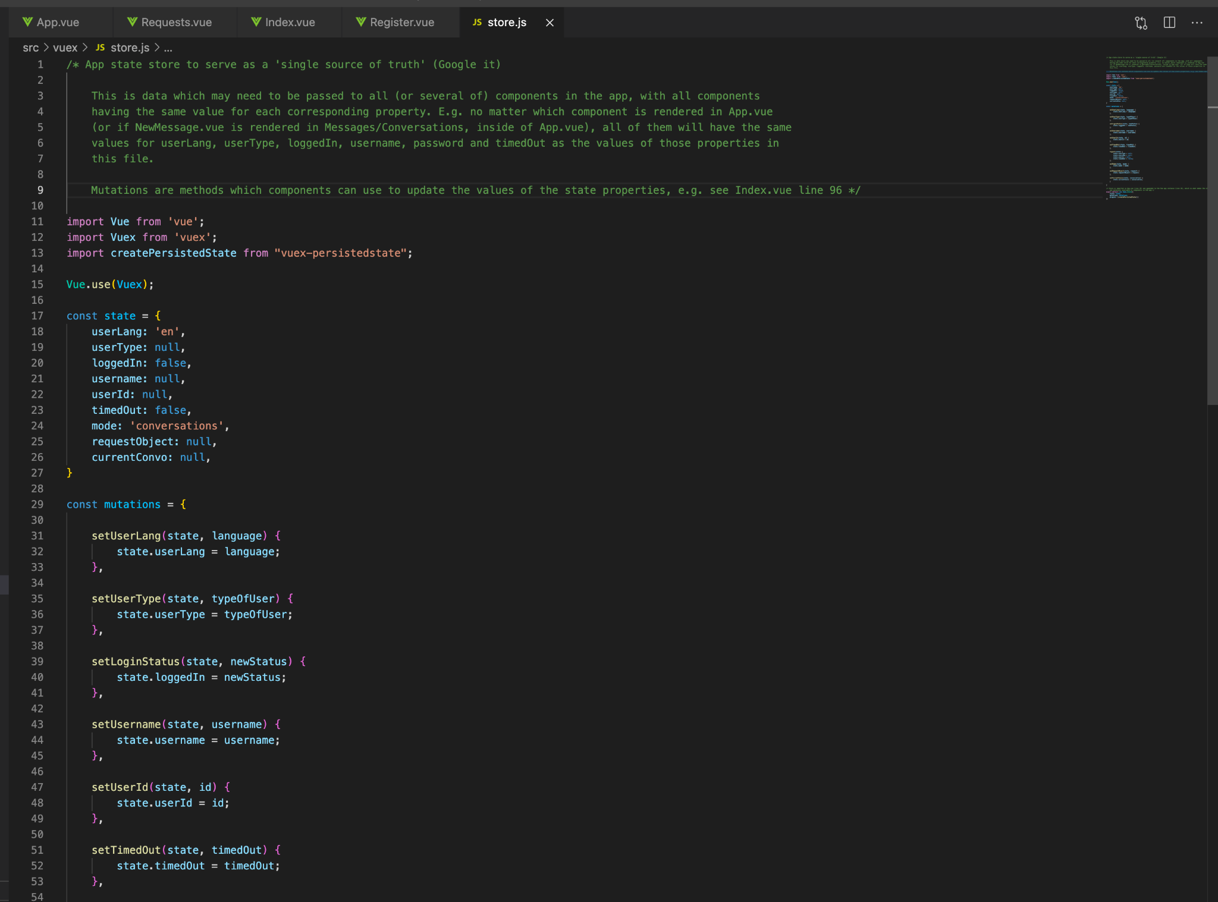

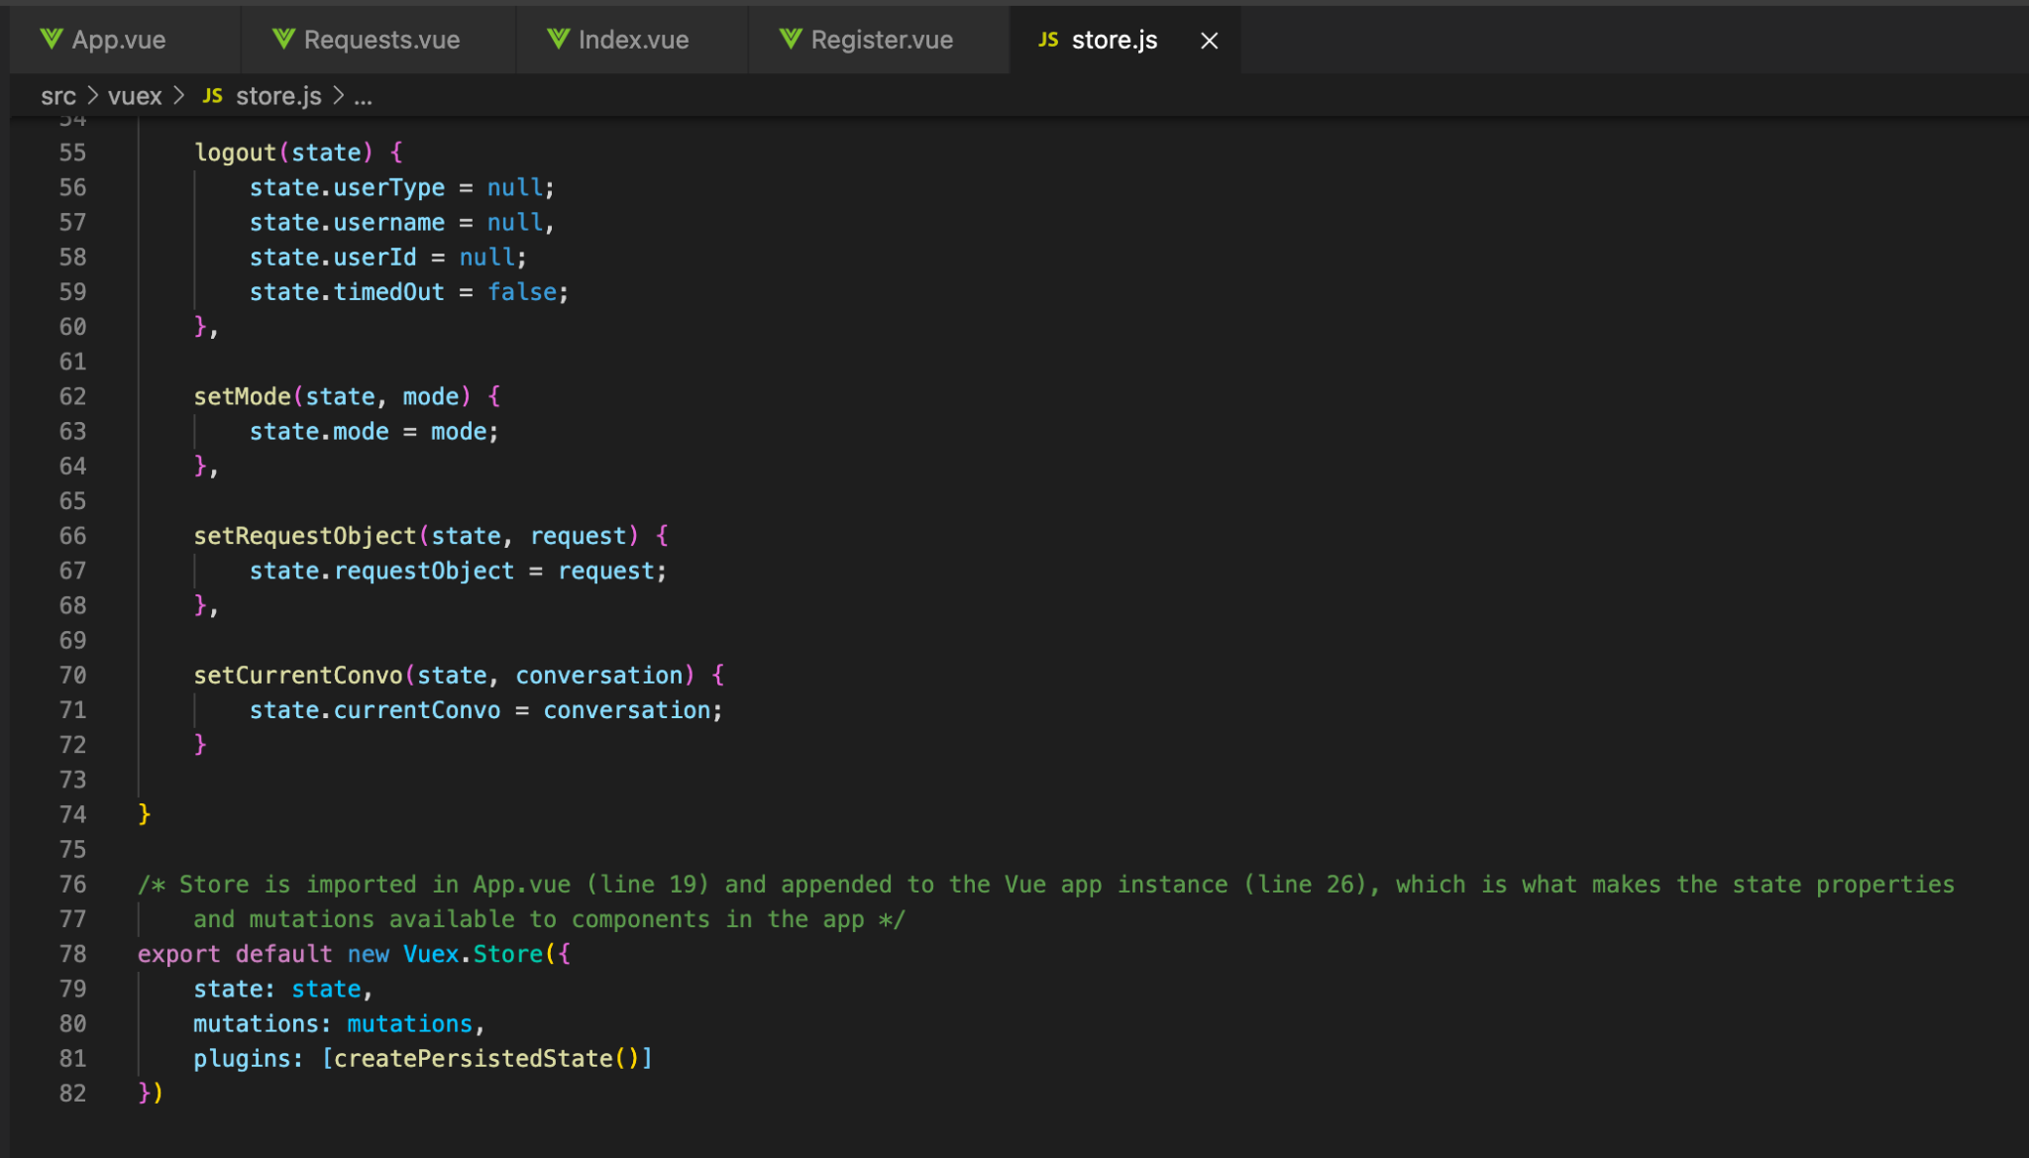

^^ Creates a new instance of Vuex Store and exports it for use elsewhere ^^

Importing the Vuex state store into App.js and attaching it to the Vue application instance:

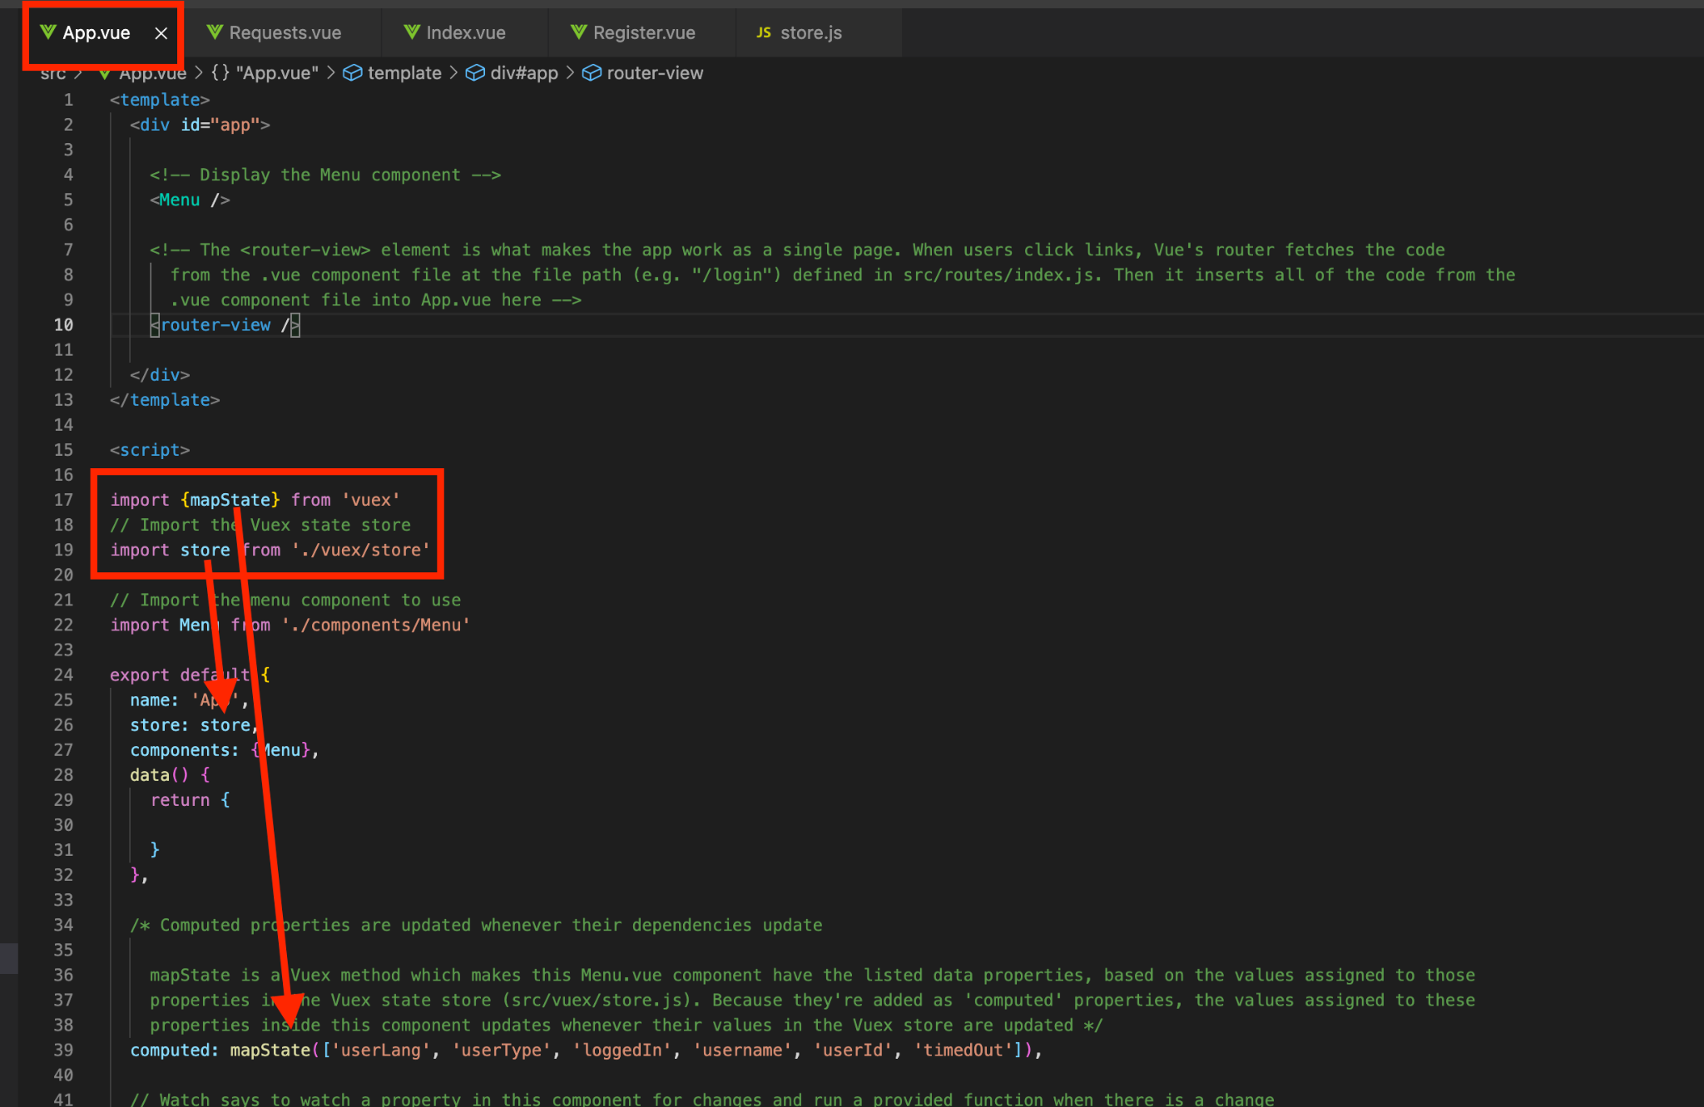

In Vuejs, computed properties are automatically re-computed whenever their dependencies change. mapState is a Vuex method, which basically says ‘retrieve the values of the state properties with these names from the store and attach them as properties here’. Since we added them as computed properties, if the values of the properties in the store change, the computed properties with those names in App.vue will be automatically re-computed.

Now, rather than having to emit the same event multiple times, up the chain of inheritance, we can ‘commit’ (Vuex syntax) a ‘mutation’ to a property of the state object. This can be performed from anywhere in the application and need only happen once for the change to take effect.

For example: upon receiving a success response from the backend API, the sendLogin() method in Login.vue ‘commits’ the ‘mutations’ *setUsername*, *setUserId*, *setLoginStatus*, and (if the usertype associated with their record in the backed database is different than the userType they selected on the homepage) *setUserType*. The values of those properties of the state object in src/vuex/store.js are updated with the values passed from the sendLogin() method in Login.vue. Since all components have these as computed properties and since computed properties are re-computed when their dependencies update, the computed properties in all components will reflect the new values.

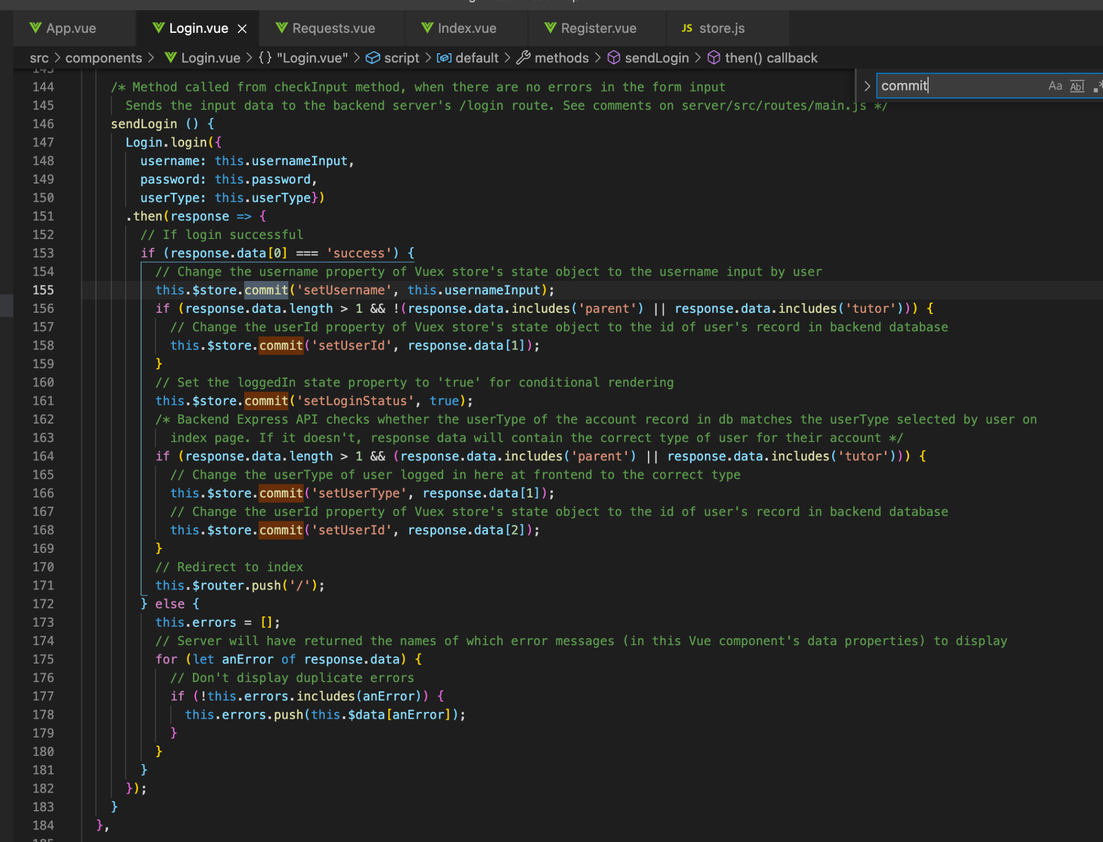

This has made the markup in the component files much tidier and more easily readable, without props and event listeners or event emissions all over the screen.

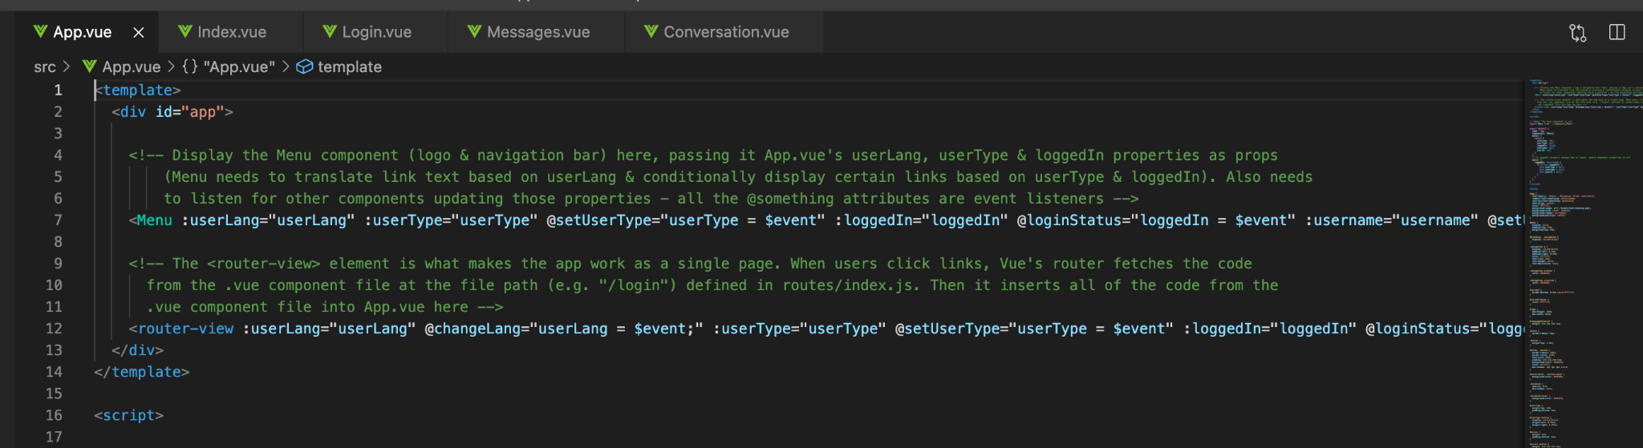

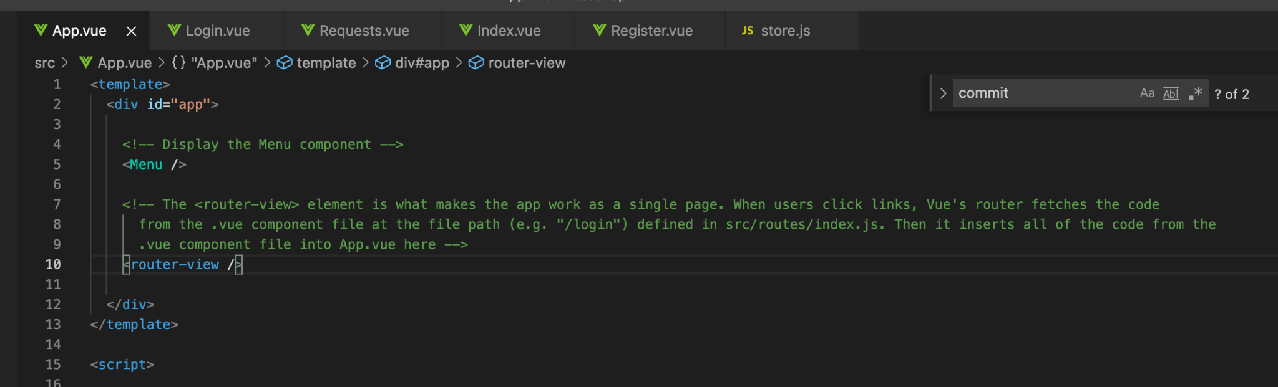

Let’s return to our original reason for implementing the Vuex state store - i.e. to enable state to be persisted on refresh etc. Implementing state persistence was as simple as adding two lines to the src/vuex/store.js file:

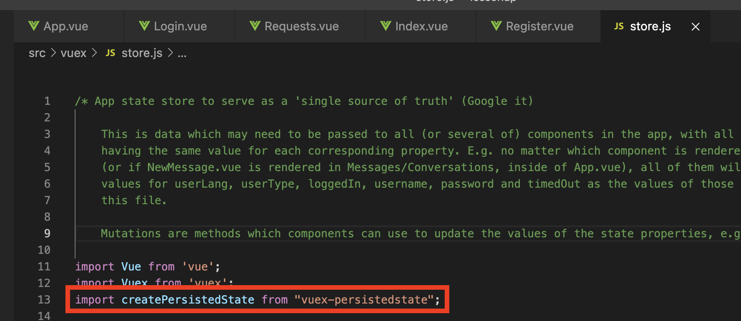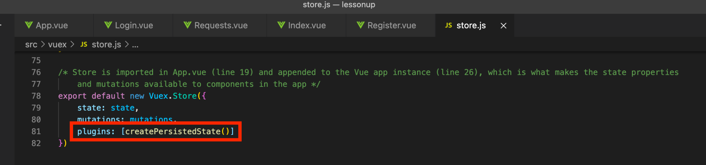

The vuex-persistedstate module saves a copy of the state object (contained in src/vuex/store.js) to the user’s browser’s localstorage. The properties of the state object in that file will have been updated based on user interactions with the vue components rendered in their browser. Hence, the copy saved in their browser’s localstorage reflects the state of the application when the user last interacted with it.

Now, if the user refreshes the page, opens a link from the application in a new browser tab/window, or navigates away from the application and returns; if their login session at the backend API hasn’t expired (it’s been less than 24 hours since last accessing the application), the application is rendered in its correct state. This is because Vue will have checked localstorage to see whether it contained a state object and if so, retrieved it and used its values.

## **Hosting and serving the UI (Vue application)**

We stated earlier in this document that - at the outset of the project - we intended to have both the UI and our API both hosted on a virtual machine on Goldsmiths DoC server and served by one Express server.

Our attempts to figure out the logistics of having one virtual machine run UI on one port and the API on a different port, whilst communicating with one another, was expending more time than it really warranted. We tried building the Vue application with the command ‘npm run build’, then copying the *dist* (containing all of the static files) directory to a views directory in the API’s file tree, requiring the views directory into Express, configuring Cross Origin Resource Sharing in Express to accept HTTP requests from a different port…

We never quite resolved how to tie it all together. It seemed the simplest solution to this quandary was to host the frontend and backend separately. Having spent a little time in January researching hosting solutions for web apps, we had seen Heroku recommended on various forums and blogs. People recommended it because it can be free to use (although one of our Heroku dynos is a paid one) and requires very little setup or configuration. With that in mind, we set about Googling terms such as “how to deploy a Vue app to Heroku”. Those searches led us to an article titled *Easily deploy a Vue + Webpack app to Heroku in 5 Steps* (Manning, 2017). We easily followed the steps in the article and deployed our Vue UI to Heroku at <https://lessonup.herokuapp.com/#/>.

Deploying the UI to Heroku necessitated creating an Expressjs virtual server file in the root directory of the codebase, to serve the application:

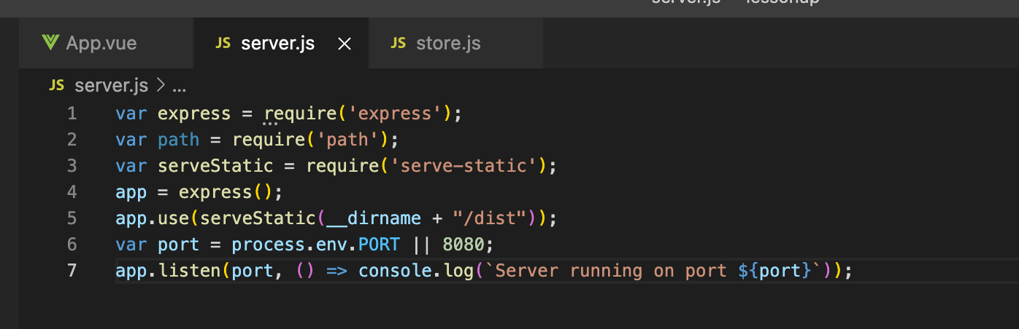

(Requiring in the *path* module was redundant and may as well be removed. In fact the path module itself seems rather redundant - why does anybody need to import a library to join parts of a file path, which can easily be joined using template literals or string concatenation?)

The *dist* directory is created when ‘npm run build’ is executed and contains the static files output by the build process. When the codebase is pushed to Heroku using Heroku Git - with the command ‘git push heroku master’ - Heroku automatically executes the command ‘npm run build’ and then ‘npm start’. The start script is configured - in package.json - to execute the command ‘node server.js’.

The process.env.PORT variable is set by Heroku and varies; see the section titled ‘web servers’ in the [*Runtime Principles*](https://devcenter.heroku.com/articles/runtime-principles) article on Heroku’s developer center. Heroku actually advises developers that we should use the PORT environment variable, rather than explicitly specifying a port ourselves (Heroku Dev Center, 2019a).

Heroku logs showing different ports logged by the callback on line 7 of the screenshot above:

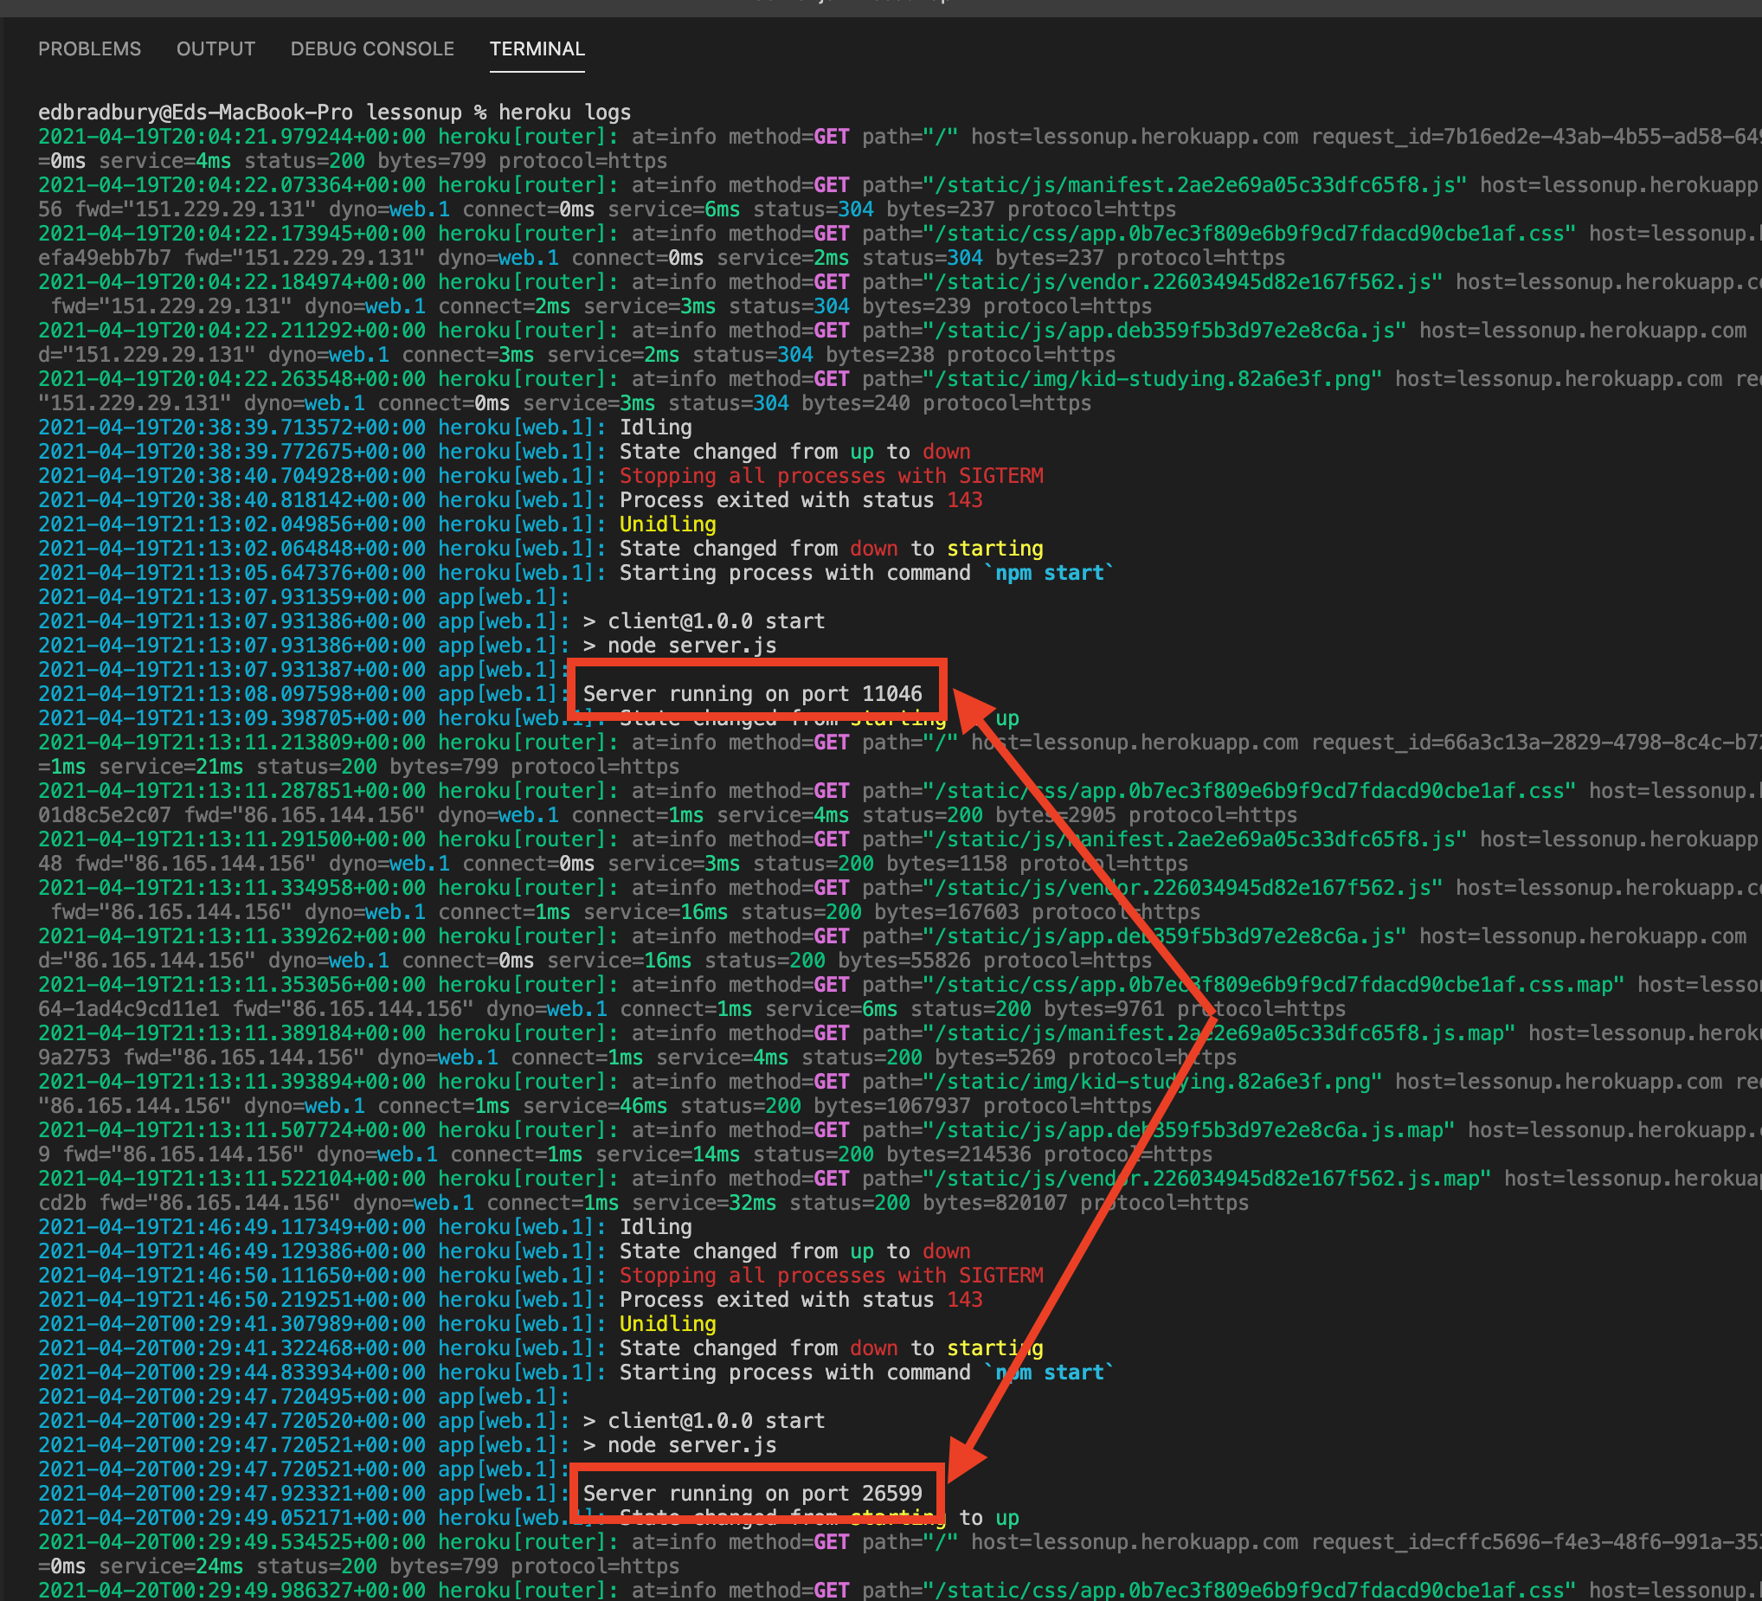

Heroku actually does some kind of magic whereby plain HTTP requests are proxied to port 80 and HTTPS requests are proxied to port 443.

You can see (from the screenshot above) that the ‘dyno’ (like a container on a virtual machine, with a runtime environment) (Heroku Dev Center, 2020a) which holds our codebase idles after a period of inactivity. Consequently, when nobody has access the application at <https://lessonup.herokuapp.com/#/> for a while, it can be a little slow for the page to load in a browser, due to the dyno restarting. That’s due to it being hosted on a free dyno; Heroku’s paid-for dynos do not idle. If this were a real world, professional software development project, we would ensure we are using a dyno which doesn’t idle, hence reducing loading times in browsers. However, if it were a professional development project, we probably would not be using Heroku hosting anyhow.

## **Cross Origin Resource Sharing (CORS)**

Cross Origin Resource Sharing (CORS) is a security procedure used by web servers to determine whether they should accept HTTP requests - requesting resources from the server - from other domains, outside of the one the server is hosted at (Mozilla Developer Network, no date; Wikipedia, no date).

Having moved the frontend UI to Heroku, our backend API was still hosted at <http://doc.gold.ac.uk/usr/601/>. Hence, the UI was sending requests from <https://lessonup.herokuapp.com/#/> (the requesting ‘origin’) to endpoints at <http://doc.gold.ac.uk/usr/601/> (the resource host). Clearly, these are different domains. So it was necessary to configure our Express API to allow CORS for requests from <https://lessonup.herokuapp.com/#/>. Otherwise, the UI would not have been able to check login credentials, register users, post/delete/retrieve messages or requests for help.

Expressjs has a [CORS middleware](https://expressjs.com/en/resources/middleware/cors.html), which we were able to configure to accept HTTP GET, POST and DELETE requests from <https://lessonup.herokuapp.com/#/> as follows:

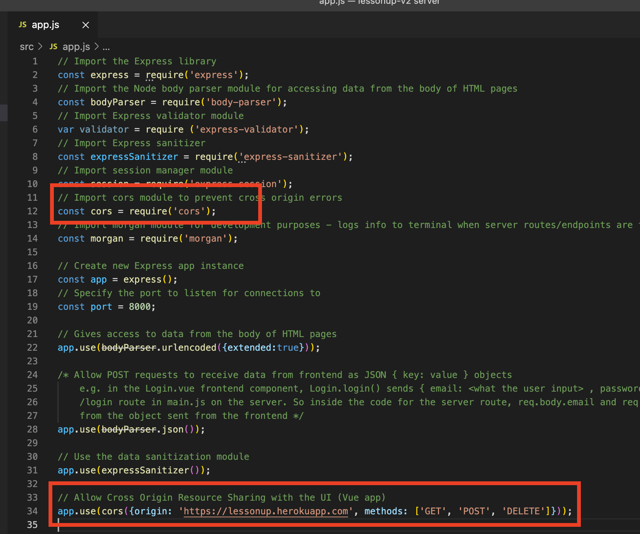

Later in the project, when we implemented session management, it became necessary to add further configuration to the Express CORS middleware. That will be discussed in the ‘secure cookies’ and ‘session management’ sections below.

## **Session management, part 1: introduction**

Once we had built the majority of the functionality for the UI and our API functioned as expected, we turned our attention to session management. We had used the express-session module for access control in some of our lab assignments for the Data & The Web module, so had a very vague idea about session management. This was not sufficient to serve the session management and authentication needs of our software project.

Whilst still not something that we have a particularly strong understanding of, we got the impression that session management is something which needed to be implemented at the backend, in our API. Typing terms such as “Node and Express session management” into Google led us to read a range of forums and blogs, which had the effect of confusing us, rather than really being much help. So we tried searching for tutorials on YouTube, using similar search terms. This led us to an incredibly helpful series of YouTube videos, titled *Passport JS User Authentication (Node + Passport + Express + Angular)* (Gollwitzer, 2020). He explains HTTP headers, cookies, Express middleware, the express-session module and authentication techniques using the Passportjs framework.

## **Session management, part 2: Secure cookies & HTTPS protocol**

From watching the first six videos in the series (Gollwitzer, 2020), we came to understand session management as partly based on storing cookies in a user’s browser. We got the impression that by setting a cookie in a user’s browser, that cookie will be attached with any subsequent requests from that given user’s browser to our API. The cookie is included in the HTTP response, sent from our API when a request to either our /login or our /register route triggers a successful response, i.e. the login or registration operation was successful. The user’s browser should set the cookie if the response to its HTTP request includes the *Set-Cookie* header. Once the cookie is set in the user’s browser, it’s included in the headers of subsequent HTTP requests to our API.

We wanted the user’s browser to set the cookie and send it with its HTTP requests to our API, for reasons which will be detailed and discussed in the next section. Before that explanation becomes necessary, we first had to overcome the various obstacles which hindered our ability to even set the cookie.

Our UI relies on CORS (see the section above titled Cross Origin Resource Sharing), since it’s hosted at one address and needs to access data from our API, which is hosted at a different address. Therefore, in order to set cookies, we needed our API to include ‘Access-Control-Allow-Credentials’ headers in its responses and we needed our UI to include the same header in its requests to the API.

So we added the credentials configuration option to our Express CORS middleware (in the API):

(Telling the API that it should reject requests which do not have the relevant header)

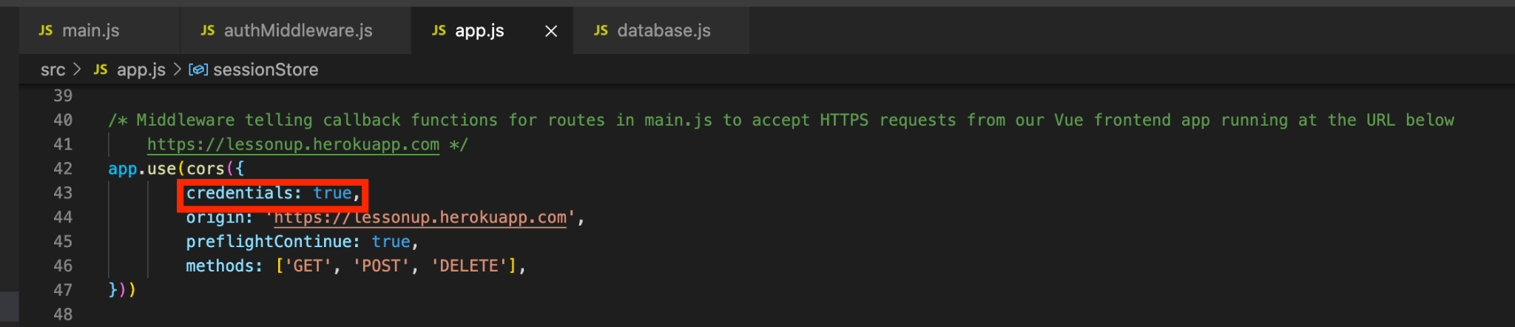

And we had to tell our Axios instance (which if you read the earlier sections of this document, should not require explanation) in the UI to include credentials with its HTTP requests:

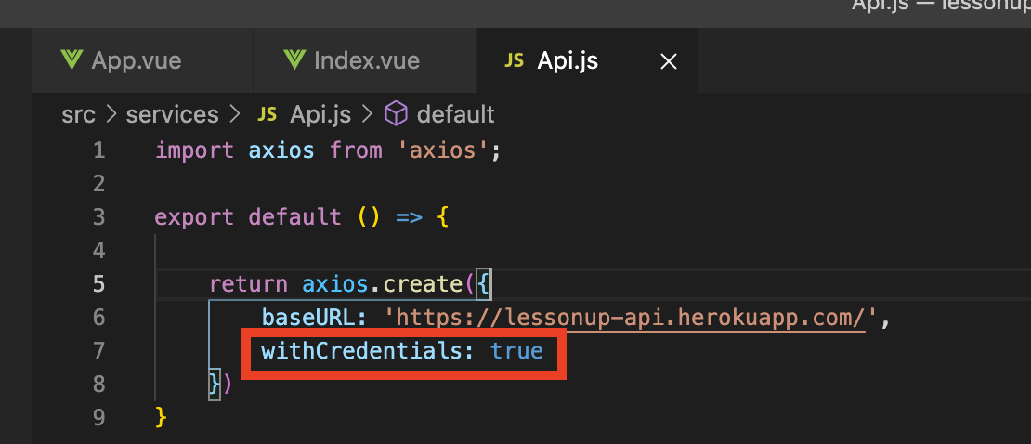

The express-session middleware in our API creates the cookie:

(Which has the sameSite: ‘none’ property to inform the browser that the cookie is not required to have been set by the same origin - address - which sent the HTTP request, with which the cookie is attached.)

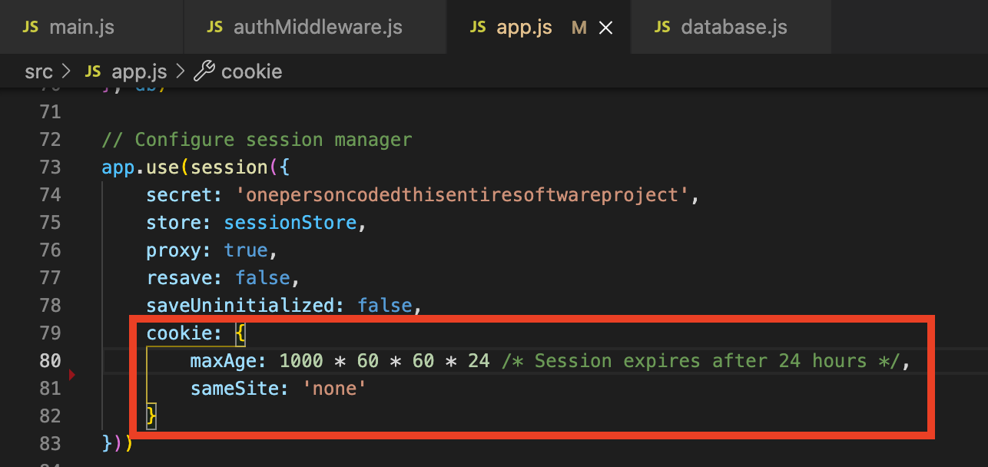

At this point, it emerged that browsers typically refuse to set cookies - at least, ones received in a *Set-Cookie* header in a HTTP response from a different origin - unless the cookie is designated as *secure*. Using the developer tools in Google Chrome, we could see that the browser was receiving the *Set-Cookie* header (we could even see the cookie sent), but it was warning that the cookie wasn’t secure and so Chrome did not include the cookie in subsequent request headers.

We tried giving the cookie a secure property:

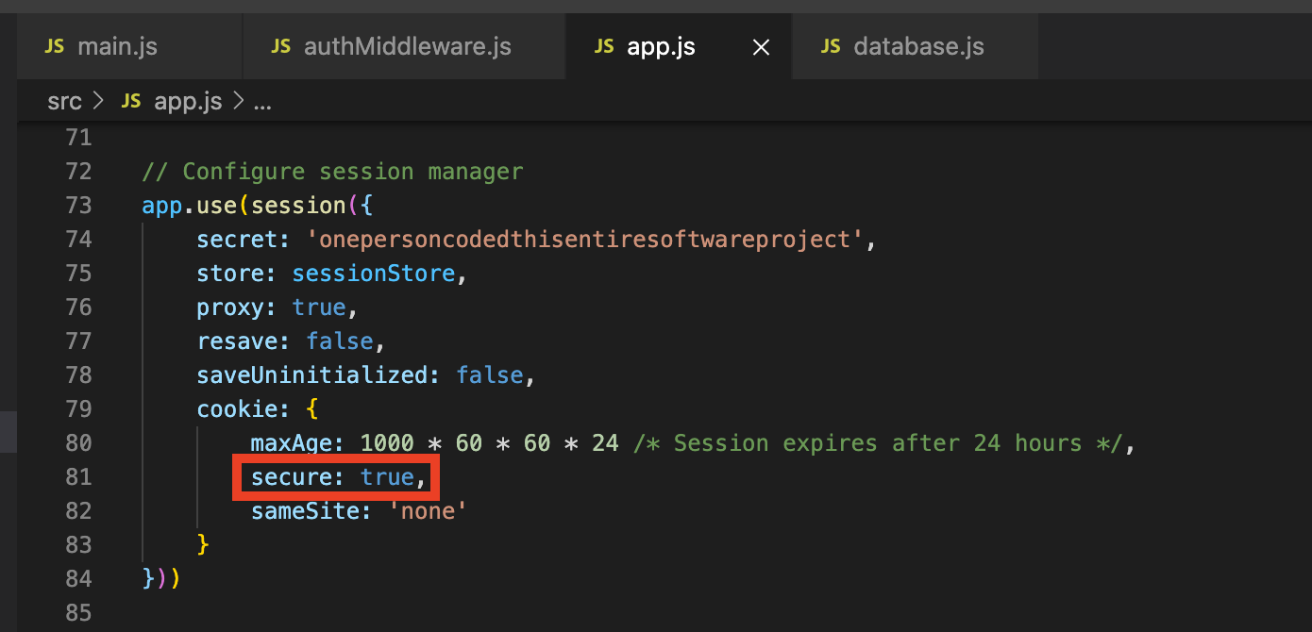

That made no difference to anything.

Reading [some documents](https://developer.mozilla.org/en-US/docs/Web/HTTP/Headers/Set-Cookie) on Mozilla Developer Network, we discovered that for a browser to set a secure cookie, the origin requesting that the cookie is set - in this case, our API - must have sent its set-cookie header using HTTPS protocol. Our API was hosted at <http://doc.gold.ac.uk/usr/601/> and sending its responses via plain old HTTP, without the secure layer. This prompted us to begin researching how to ensure an Express server sends its responses via HTTPS. Which, it transpires, is confusing to say the least.

First, we tried reconfiguring our Express instance to use the https module from npm:

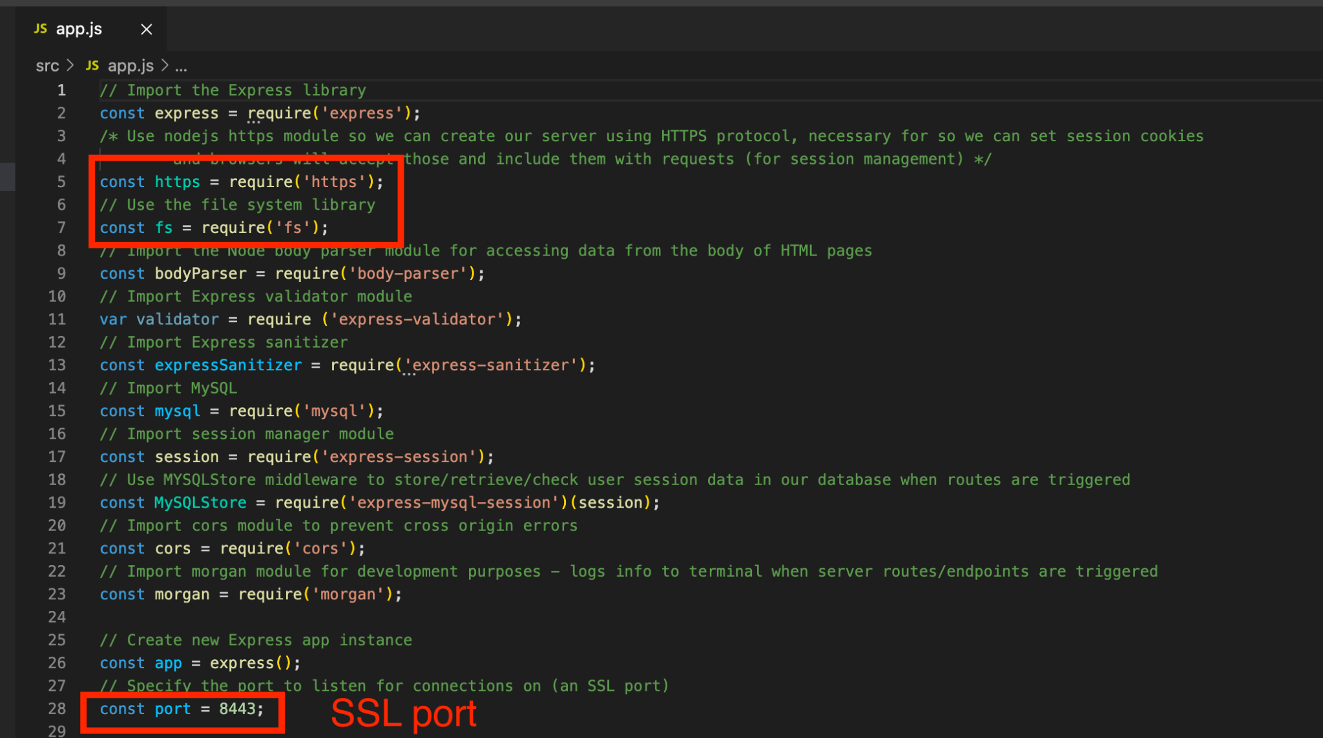

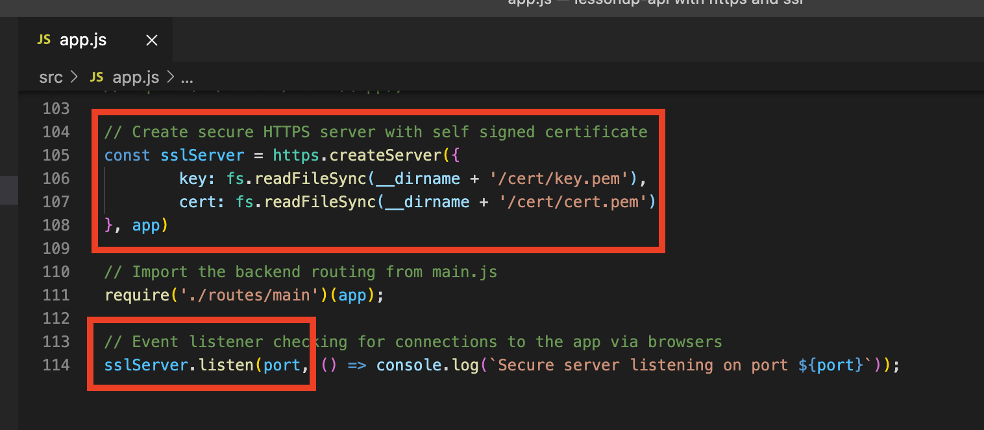

Somebody spent the majority of an afternoon following some exceptionally long-winded instructions (Arul, no date) to update the outdated version of openssl which came pre-installed on our DoC virtual machine.

This was so that the person in question could create a self-signed SSL certificate (which you can see is used in the *https.createServer* command in the screenshot above, certificate contents below):

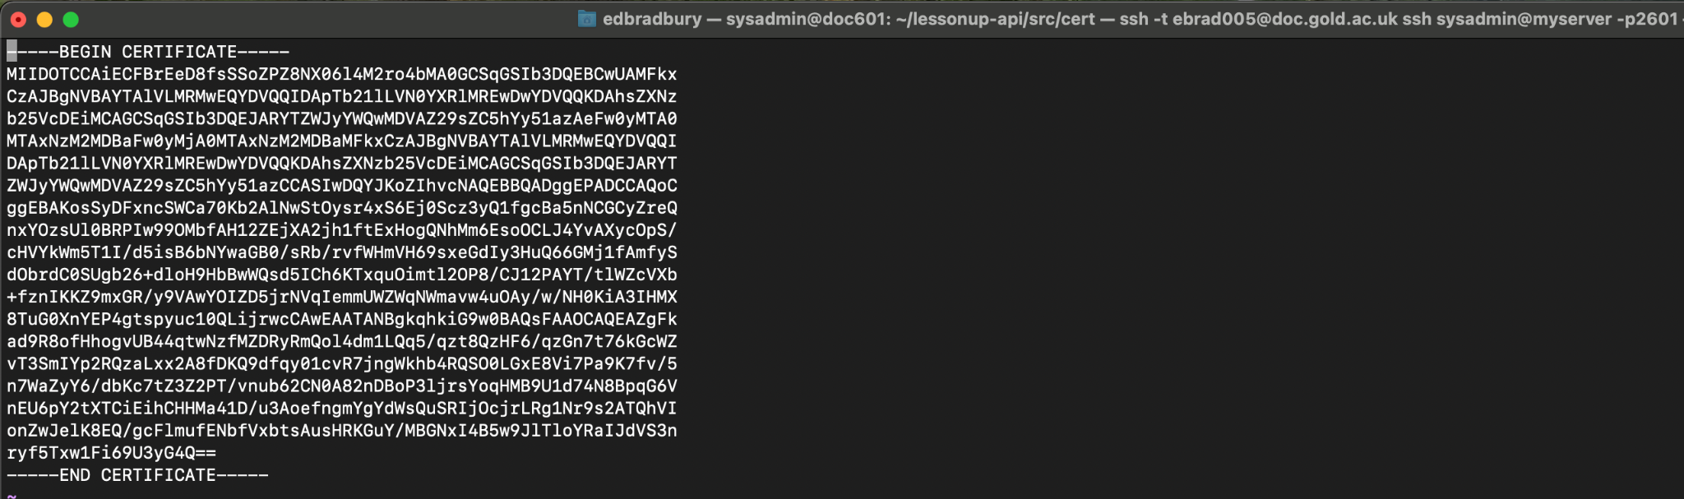

Only, for reasons that we never managed to understand, this whole exercise had been a waste of time and did not achieve the intended effect of forcing our Express API to send responses by HTTPS. We wondered whether it was something to do with doc.gold.ac.uk already having SSL certification, which presumably was clashing with (or overriding) what we had tried to implement on our virtual machine.

Regardless, enough time had been wasted. Since we already had some experience of deploying applications to Heroku hosting, we began researching whether we could host our API on Heroku with a SSL. We read that [all Heroku paid dynos include SSL](https://devcenter.heroku.com/articles/ssl) (Heroku Dev Center, 2021b) and by default, Heroku automatically manages the SSL certificates (Heroku Dev Center, 2021a). So the logically obvious solution here was to migrate our API from the virtual machine on DoC to a paid Heroku dyno. That way, we could guarantee that the origin requesting cookies be set (our API) was requesting that over HTTPS.

Migrating our API to Heroku meant we obviously needed a new Heroku dyno to hold the codebase, so the first step was to create a new dyno:

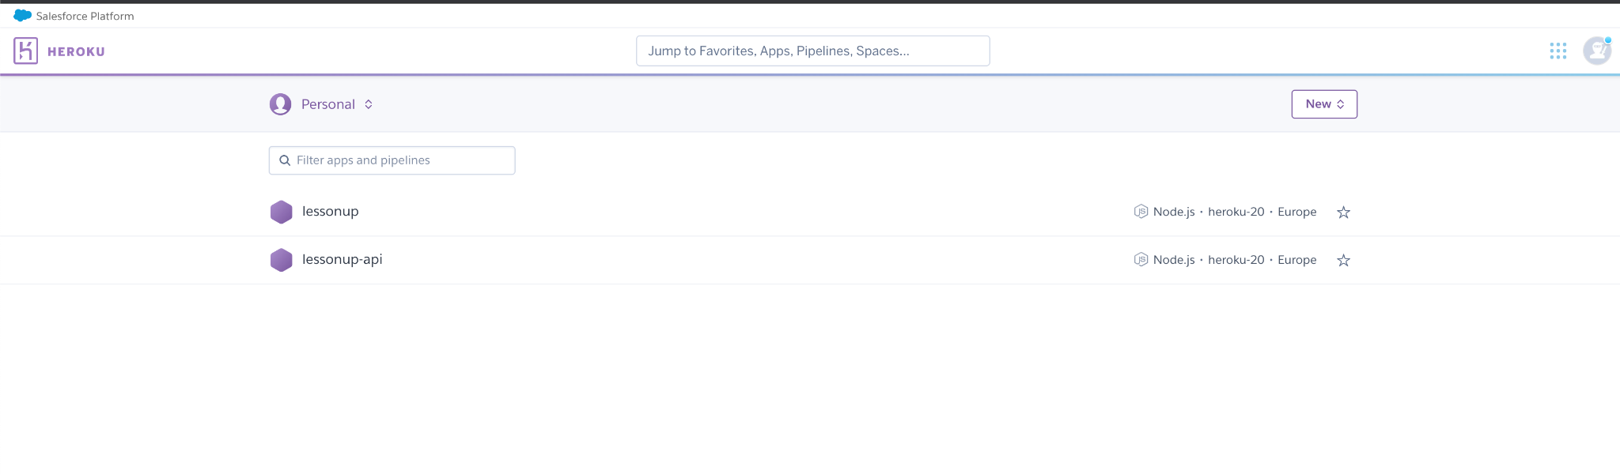

To which we added the Nodejs buildpack:

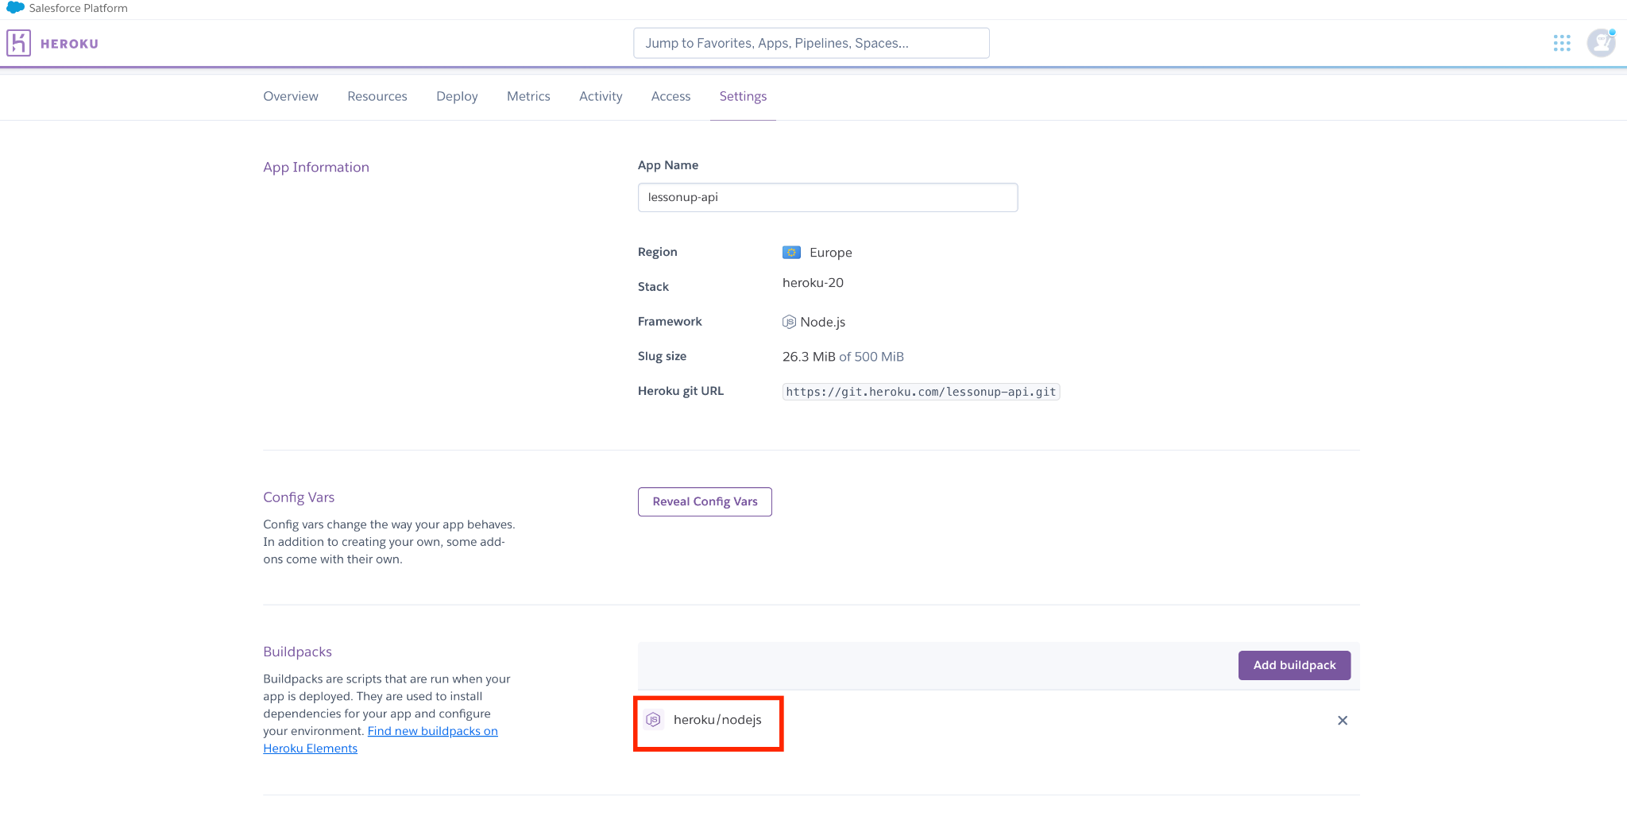

Then pushed the most recent codebase from our DoC virtual machine to GitLab, so we could clone the files to a group member’s local computer:

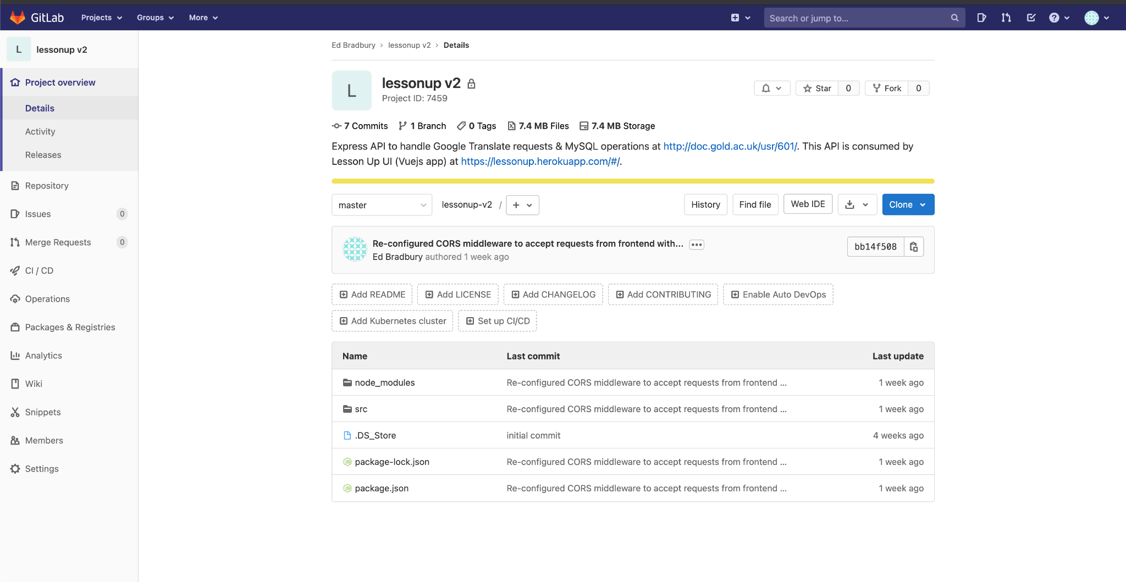

Now we could follow this Heroku guide to [*Preparing a Codebase for Heroku Deployment*](https://devcenter.heroku.com/articles/preparing-a-codebase-for-heroku-deployment).

We had been deploying the UI to Heroku using Heroku Git, so it made sense to do the same for this API. Which meant we needed to add a Heroku Git remote to the API:

(Screenshot from [here](https://devcenter.heroku.com/articles/git#creating-a-heroku-remote))

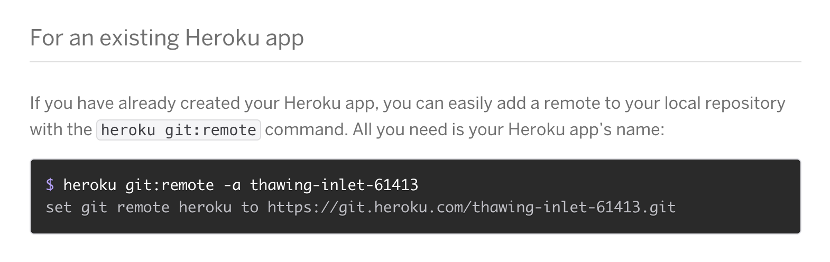

A *Procfile* (kind of a configuration file telling Heroku how to start running the code when it’s deployed) was created in the project’s root directory:

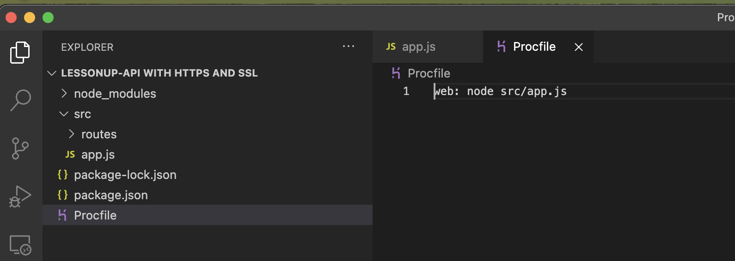

Attempting to gain some understanding of how we could ensure our API on Heroku sends responses via HTTPS, we read about Heroku’s [*Automatic Certificate Management*](https://devcenter.heroku.com/articles/automated-certificate-management). The section titled ‘listening on the correct port’ in their *Preparing a Codebase for Deployment to Heroku* document states: “On your local machine, your app’s web server can listen on any open, unreserved port. On Heroku, however, it must listen on a *specific* port. This specific port is indicated by the PORT environment variable”. We read these Heroku documents [*Understanding SSL On Heroku*](https://devcenter.heroku.com/articles/understanding-ssl-on-heroku) (Heroku Dev Center, 2019b) and [*HTTP Routing*](https://devcenter.heroku.com/articles/http-routing)(Heroku Dev Center, 2020b)*.* Eventually, the answer to [this question](https://stackoverflow.com/questions/25148507/https-ssl-on-heroku-node-express) on StackOverflow helped to clarify how we should proceed.

Based on that answer on StackOverflow, it seemed we needed to refactor part of our API’s app.js file from this:

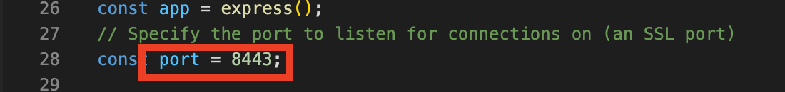

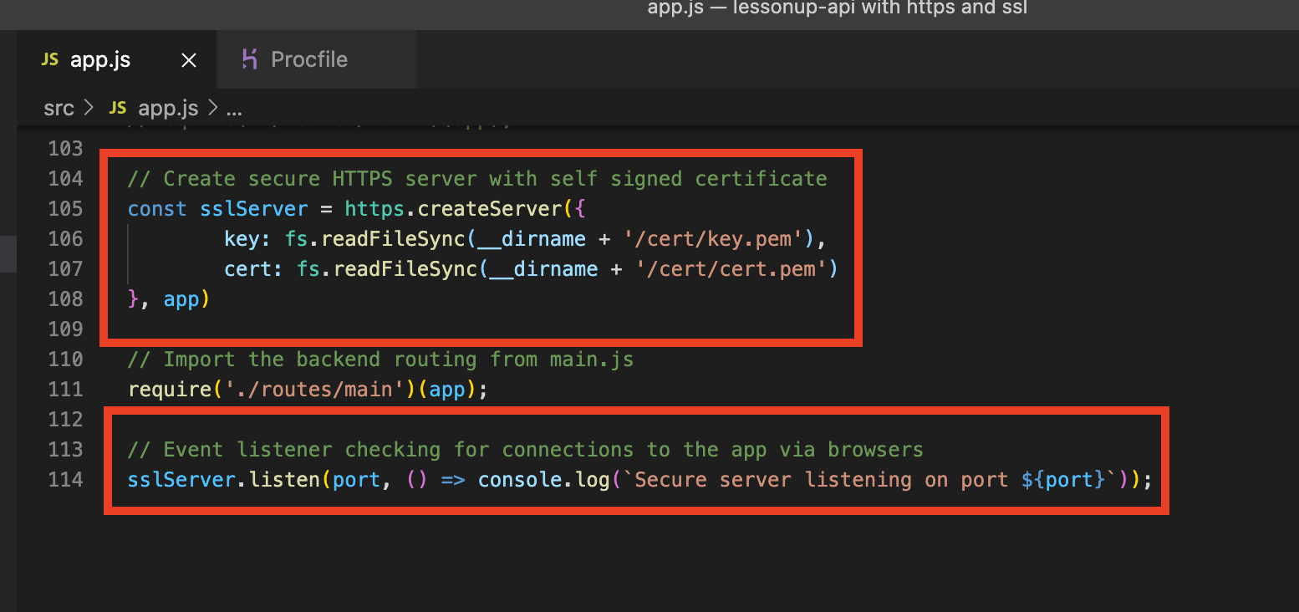

Where the port variable was explicitly defined as an SSL port and the server created as a HTTPS server with a self signed certificate.

Refactored to this:

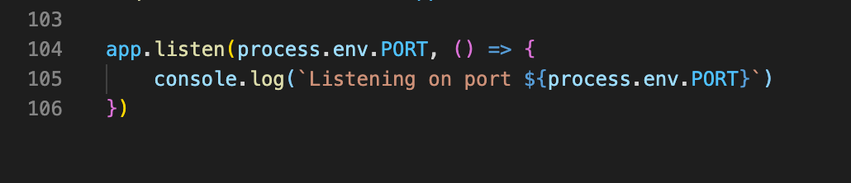

With this additional Express configuration, since Heroku’s SSL terminates before requests reach our dyno and the requests are proxied, from the load balancer, by Heroku’s router (Heroku Dev Center, 2020b), to our dyno:

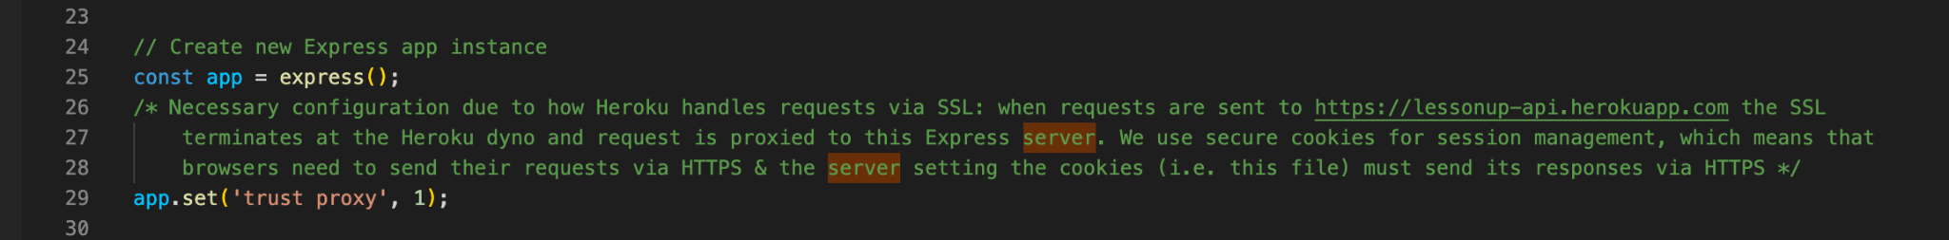

The codebase was then ready to be deployed via Heroku Git, using similar commands to those we had used to deploy the UI:

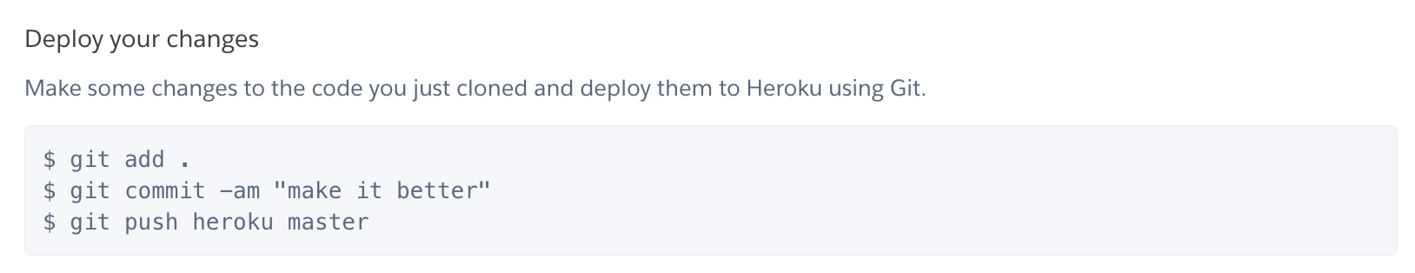

Since the Heroku documentation states that “[The Heroku SSL feature is included for free on any app that uses paid dynos](https://devcenter.heroku.com/articles/ssl)” (Heroku Dev Center, 2021b), the last step to ensuring our API would send its responses via HTTPS was to upgrade the lessonup-api dyno from a free one to a paid one:

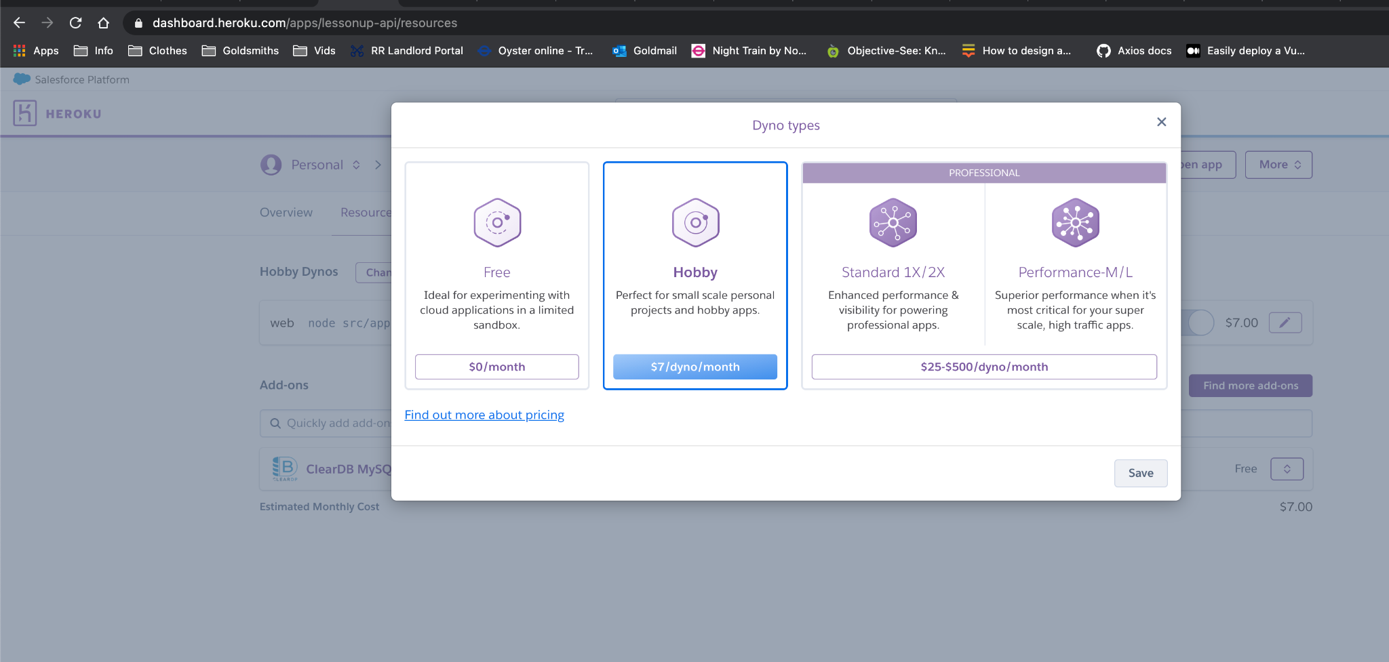

Which, sure enough, appeared to have automatically added SSL to the dyno:

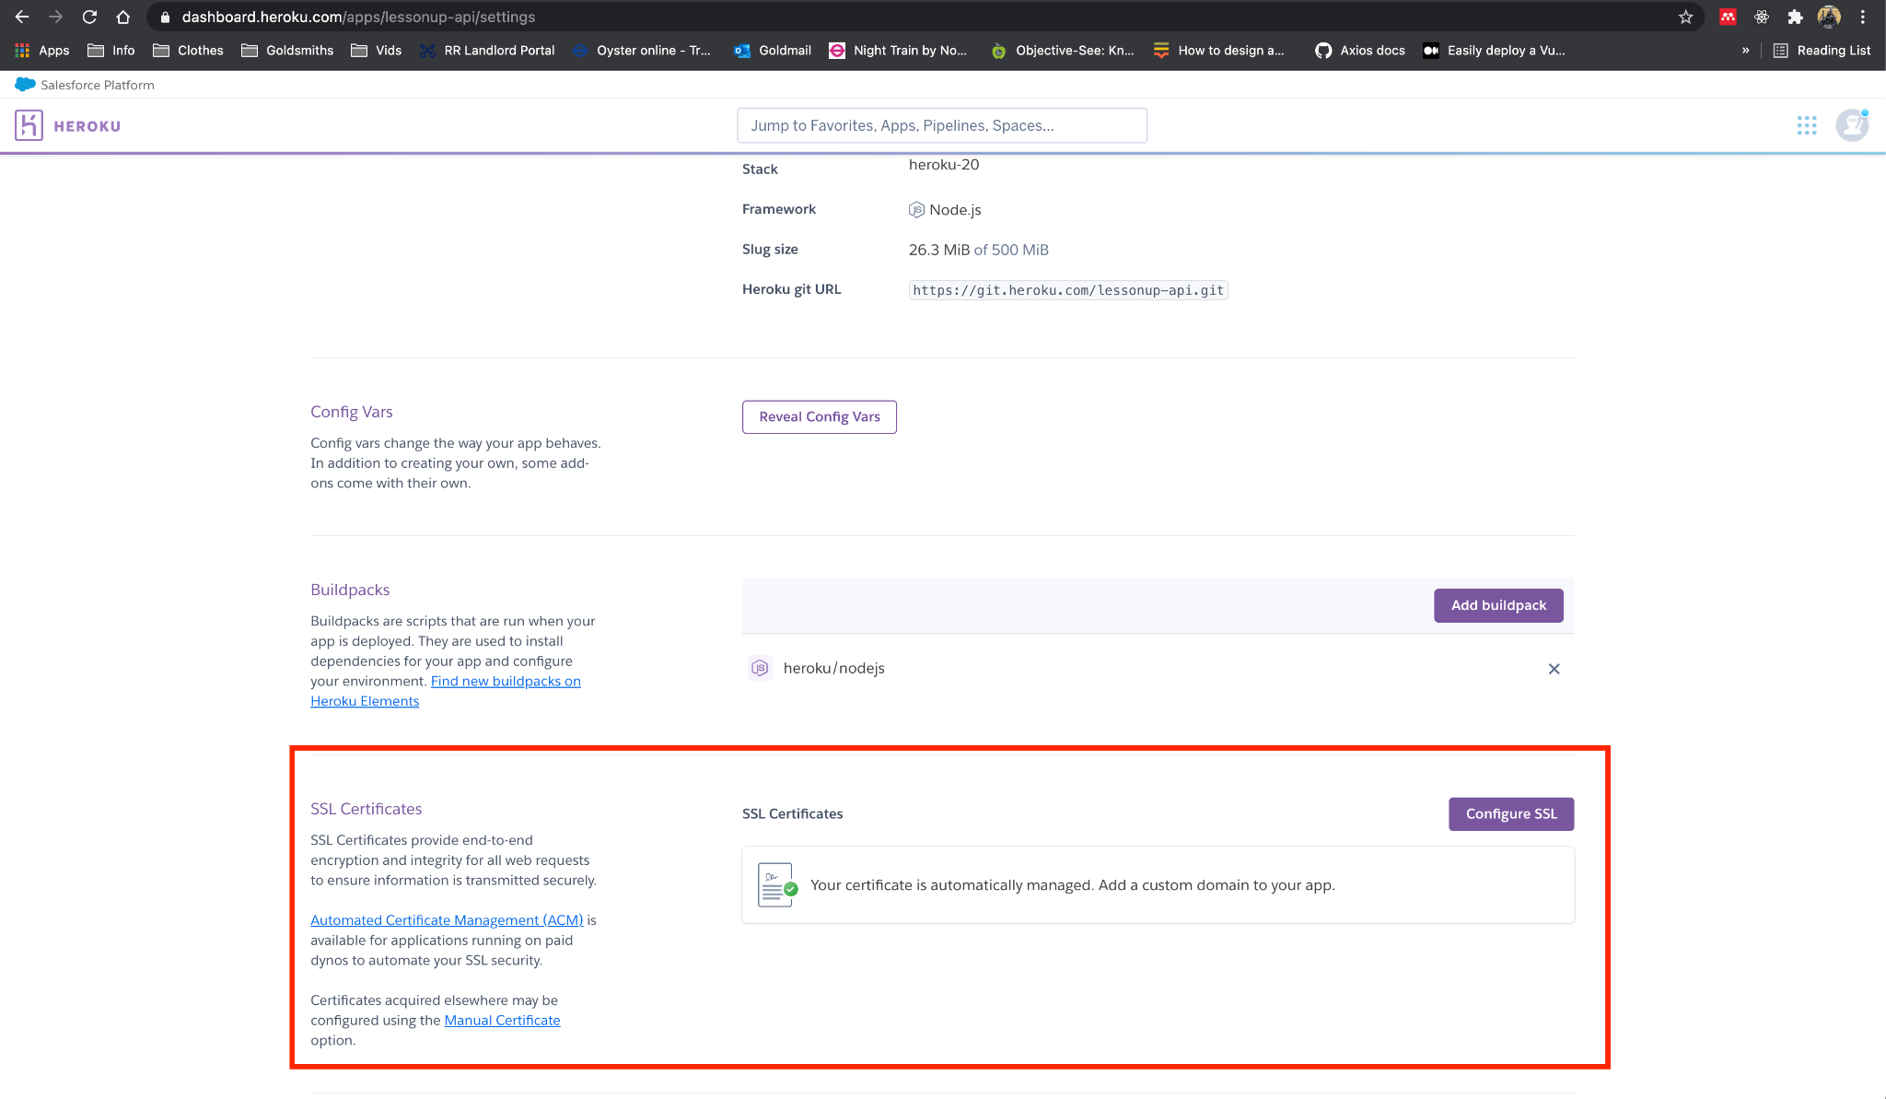

And finally, after considerable time and effort expenditure, we could successfully set cookies:

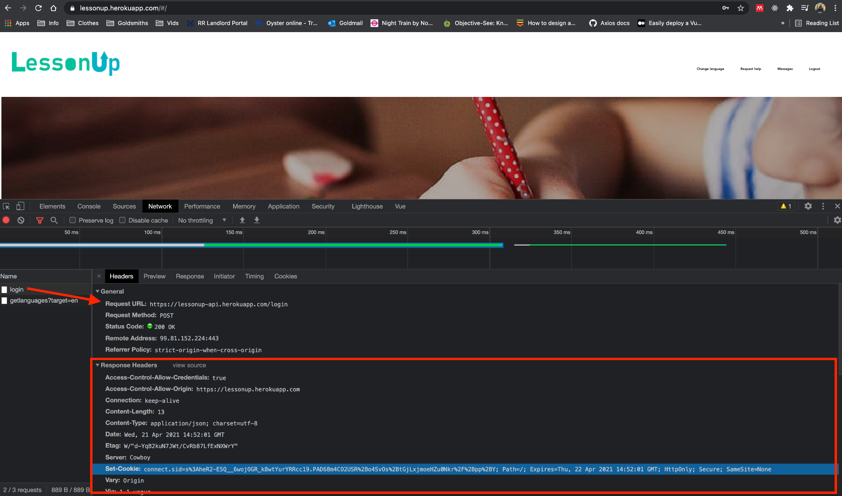

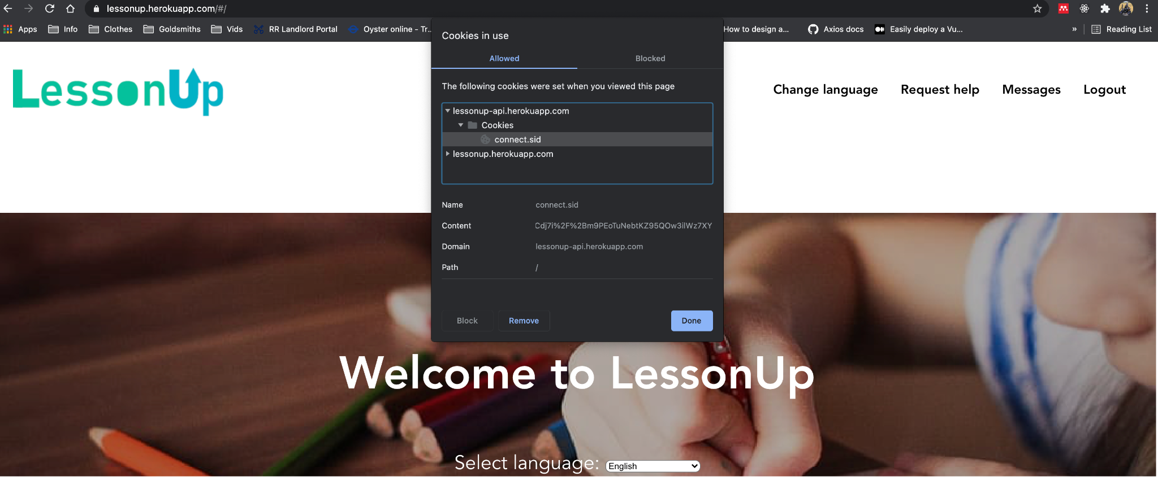

**Although, it soon transpired that Safari browser blocks cross-origin cookies by default, which is clearly an accessibility problem (explained in more detail in the section titled ‘Session management, part 3’ later in this document) for users who try to access the application through Safari:**

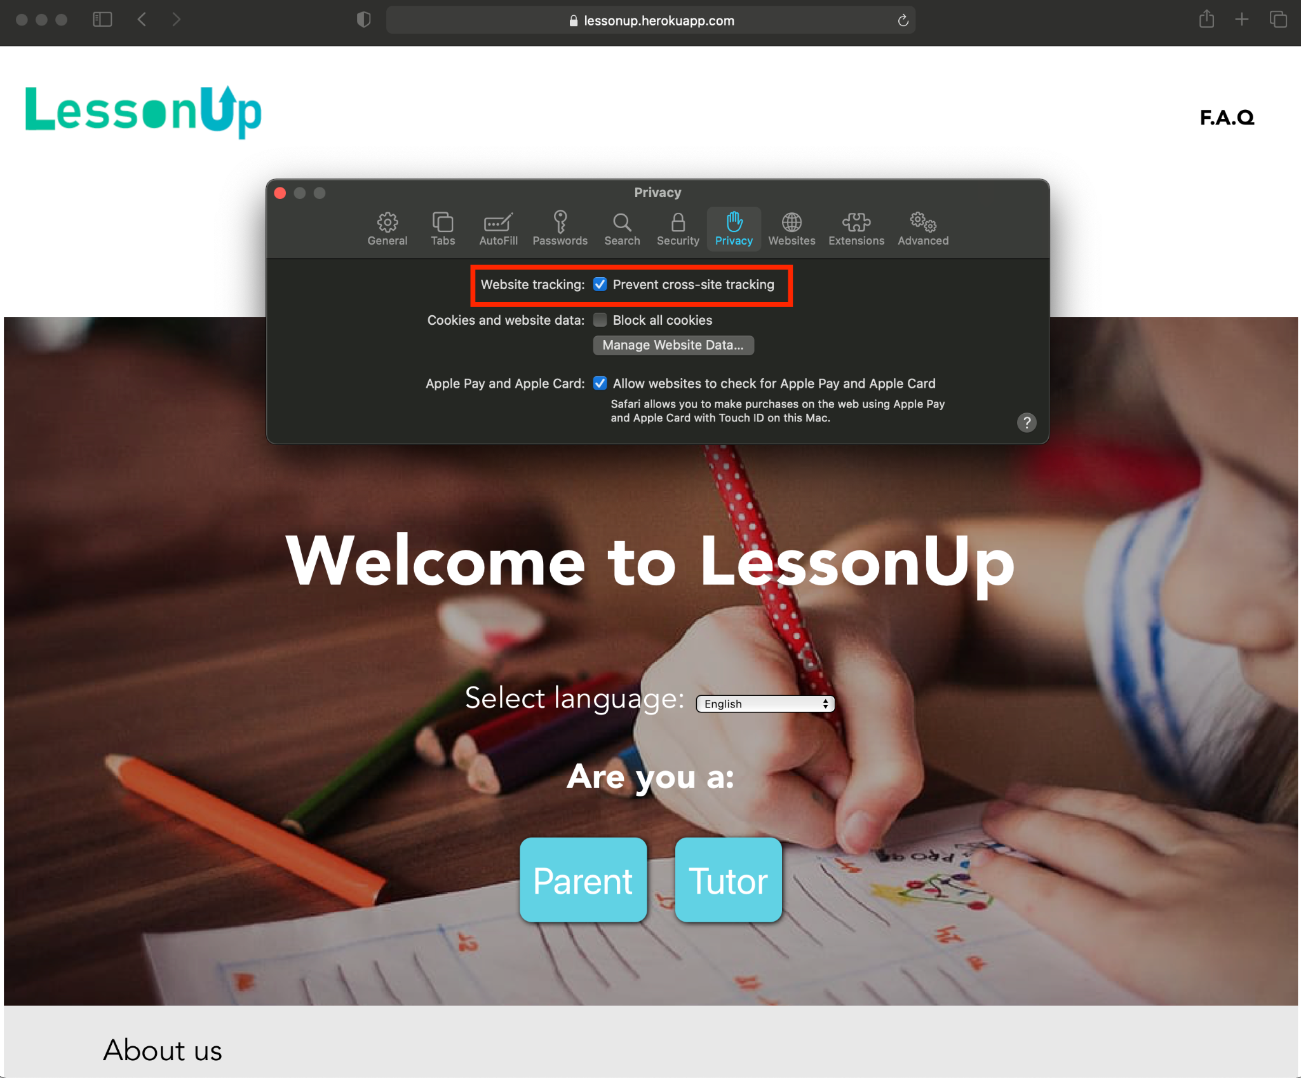

A valid cookie being sent with a HTTP request from a browser (Chrome) to our API:

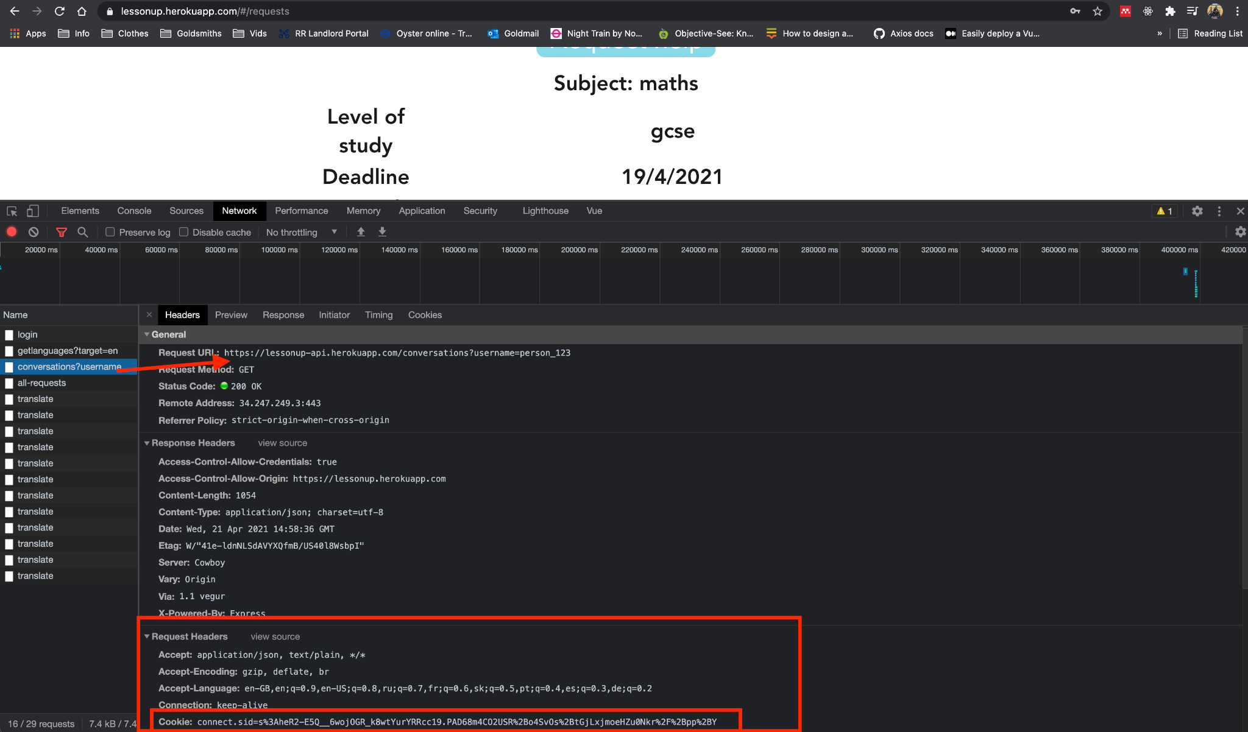

Admittedly, our UI should be informing users that the application requires cookies and asking for consent to set them. This is not something that we have got around to implementing, due to time and resource constraints. Cookie consent is something we would absolutely have to implement if this were a professional application which we intended to maintain into the future, for compliance with GDPR regulations.

## **Database**

(Session management part 3 is below the end of this section. It seemed to make sense logically to explain migrating the database from DoC to Heroku here - session management requires database access)

Whilst our backend API was hosted on a DoC virtual machine, we had installed MySQL on the virtual machine, required the Node MySQL module in our Express app.js file and created a connection to the database from there. Naturally, that meant we had first created the database and tables in the MySQL shell.

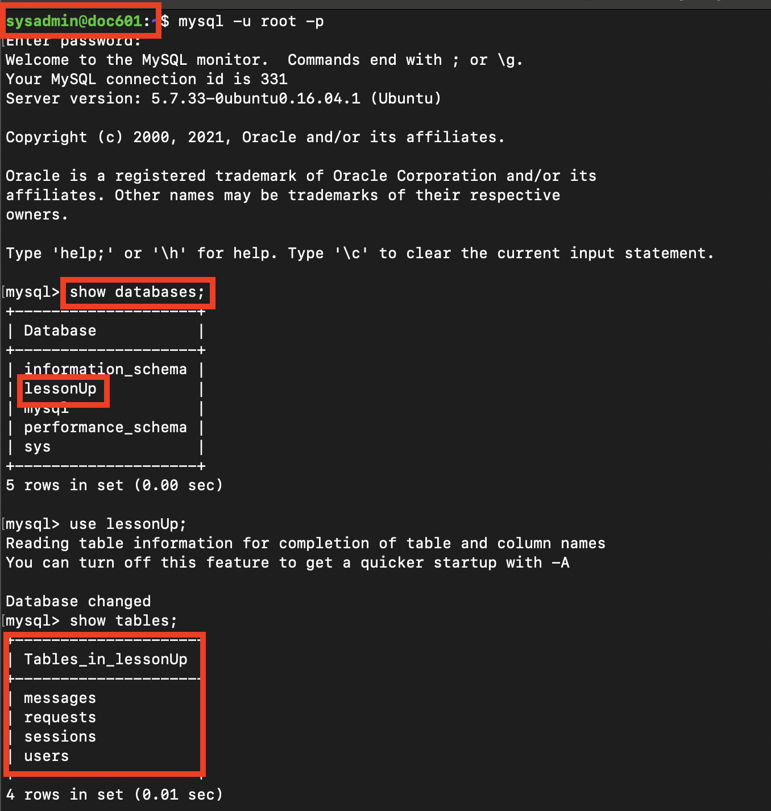



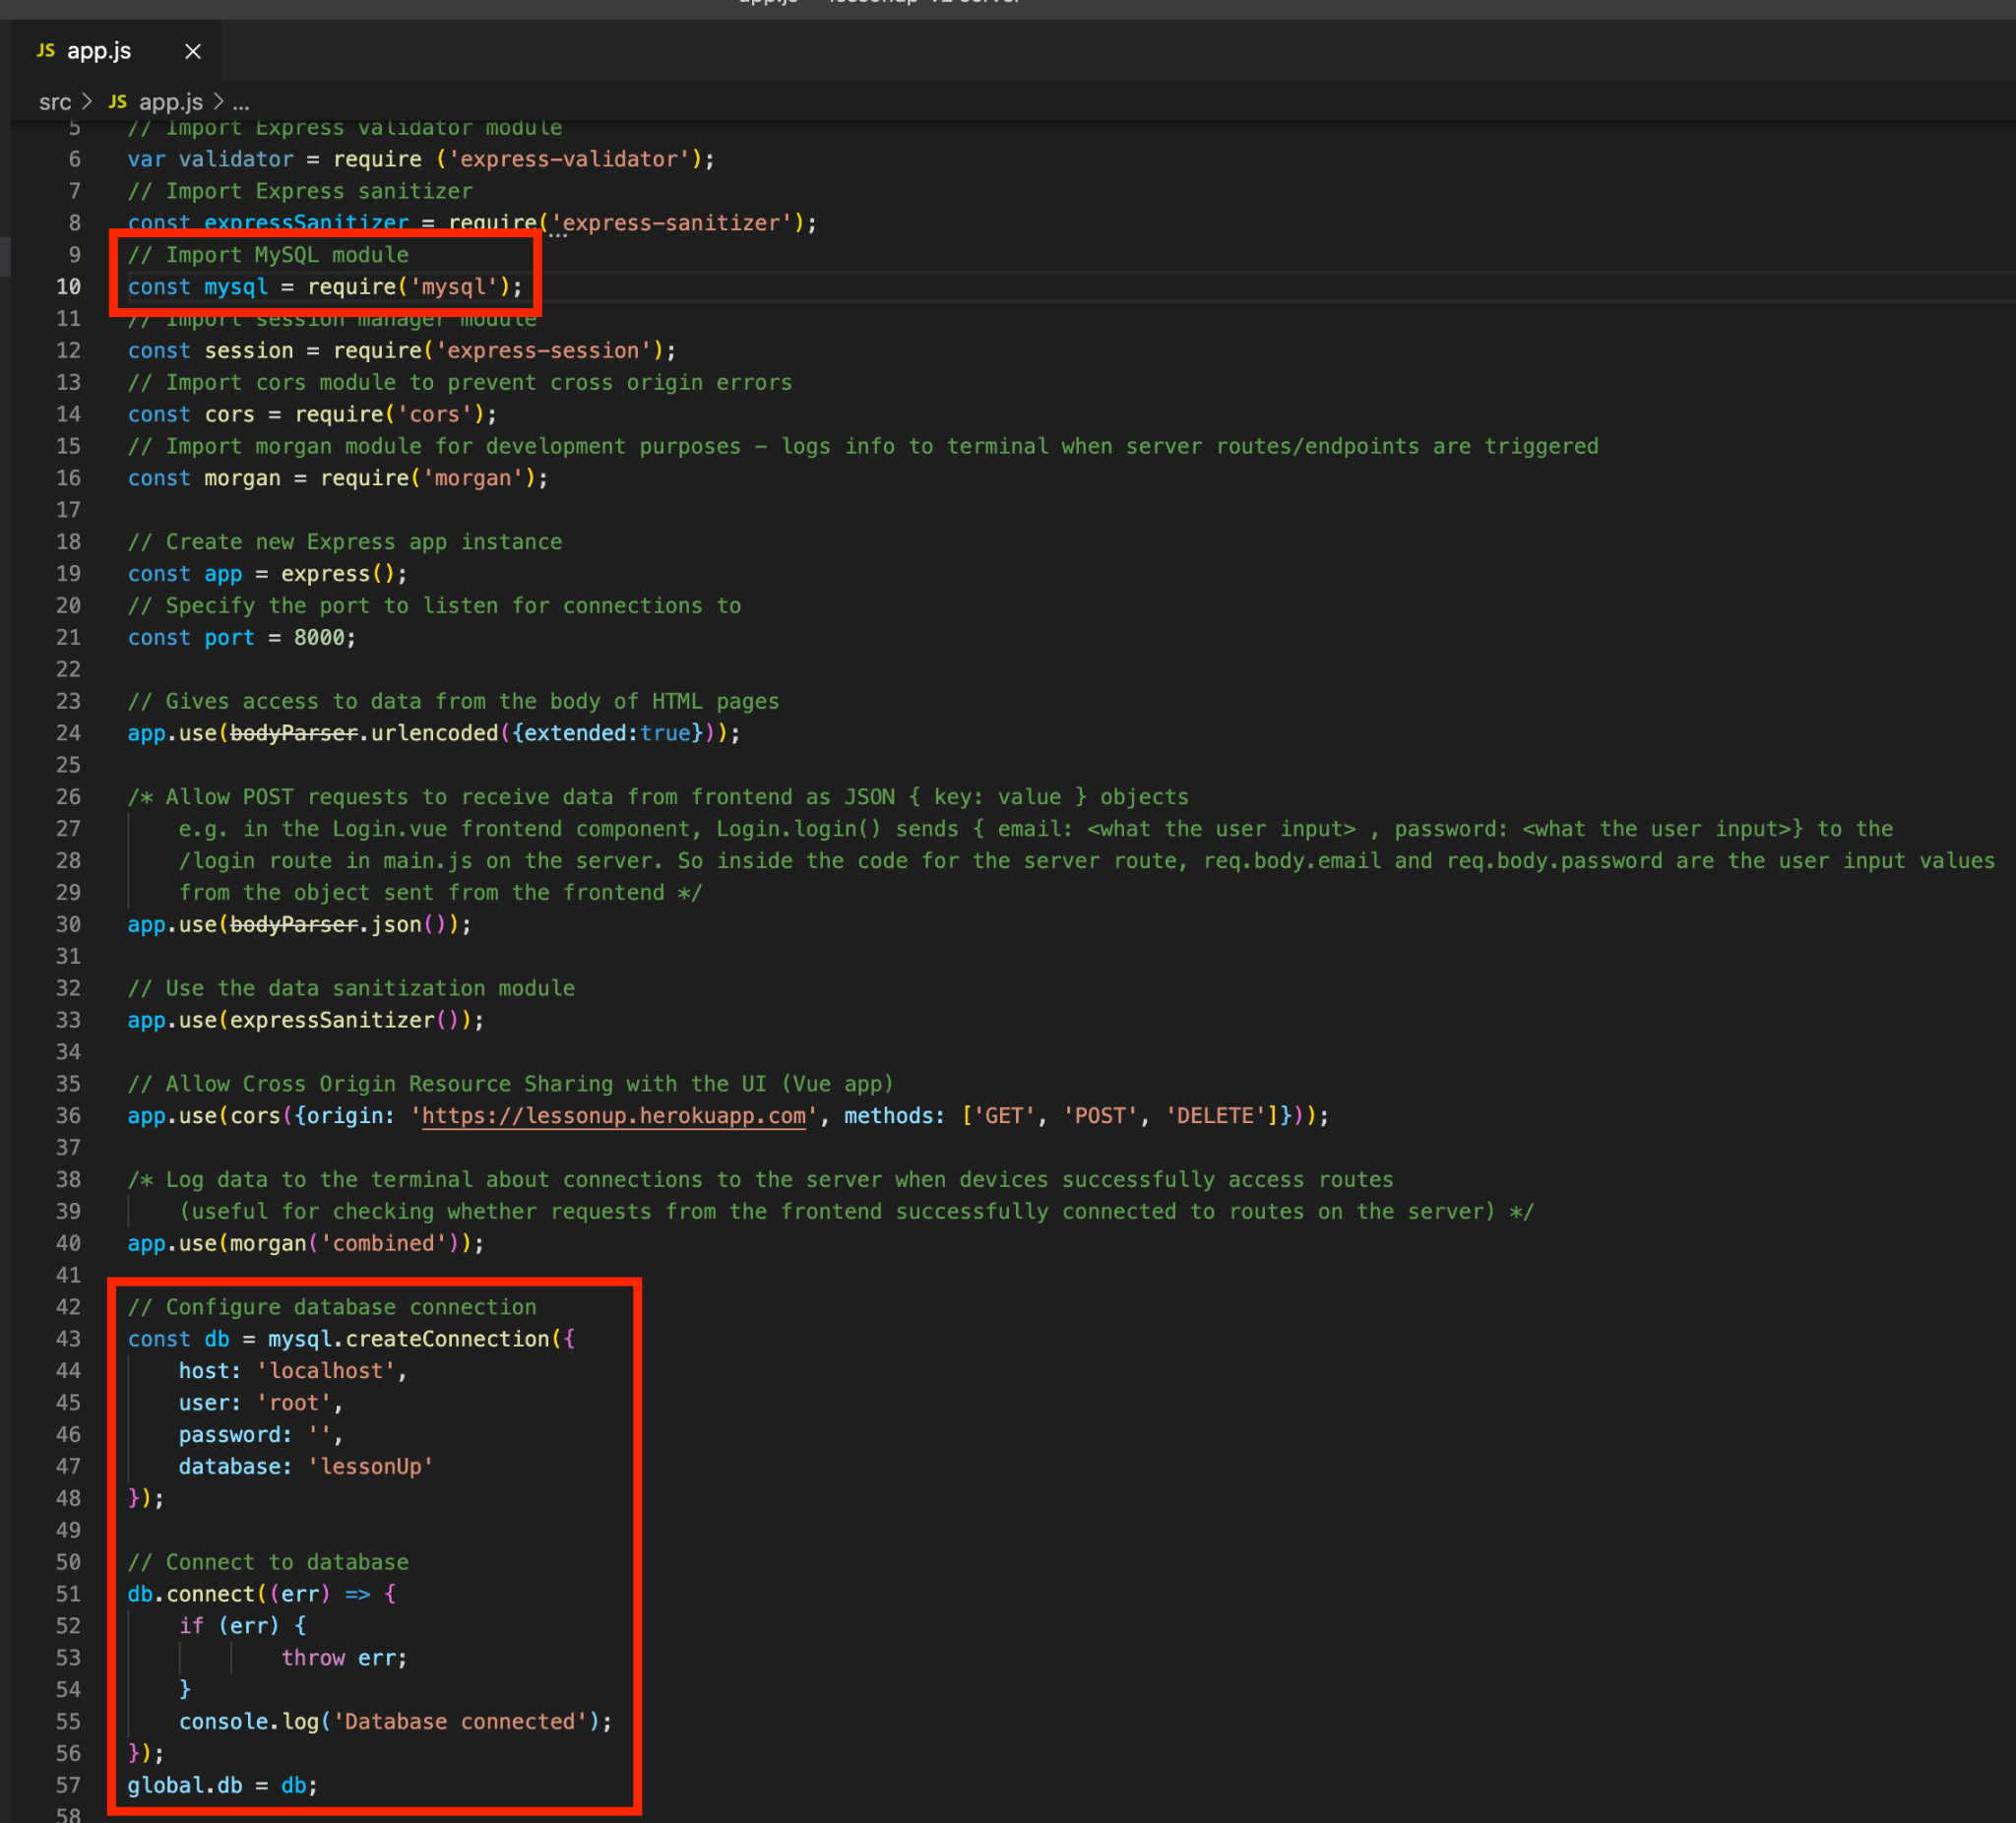

**When we moved our API to hosting on Heroku, we were unable to create and host the database on the Heroku dyno ourselves**. Heroku’s documentation includes an article titled [Preparing A Codebase for Heroku Deployment](https://devcenter.heroku.com/articles/preparing-a-codebase-for-heroku-deployment) (Heroku Dev Center, 2019a), from which the screenshot below is taken:

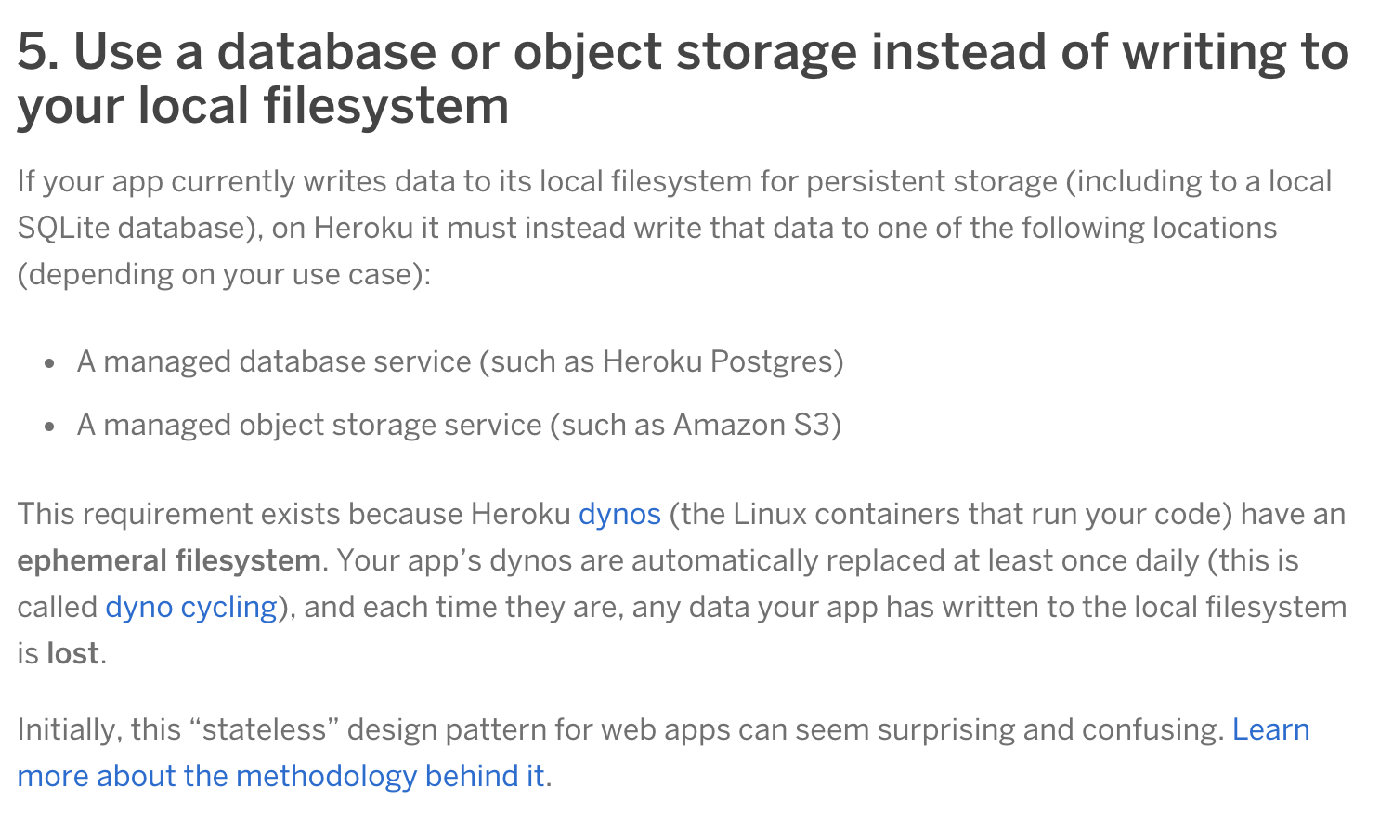

A Heroku ‘dyno’ is similar to a virtual machine, such as we had at <http://doc.gold.ac.uk/usr/601/>. However, whereas the virtual machine at the address on the DoC server is permanent (or at least has some degree of permanence), [Heroku dynos are regularly changed automatically](https://www.heroku.com/dynos/lifecycle) (*Heroku Dynos* , no date). Hence, it doesn’t make sense to install MySQL and create databases and tables on a Heroku dyno, since Heroku regularly moves applications to different dynos. That would then require the database to be setup again (on the new dyno) and any data which had been held in the database tables on the previous dyno would be lost.

Searching for ‘MySQL’ in Heroku’s ‘add-ons’ (plugins for Heroku dynos) yielded various options:

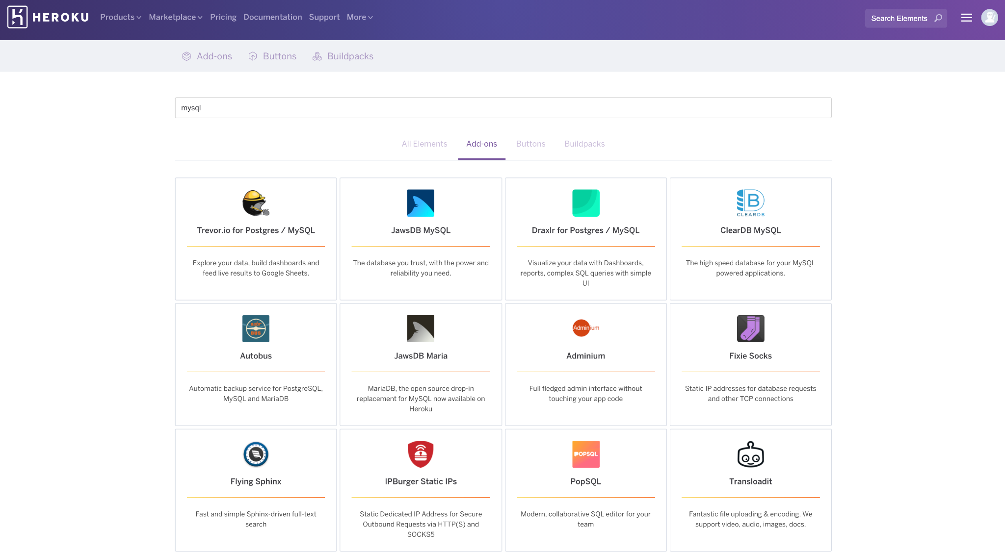

We browsed the documentation for some of these options. [ClearDB MySQL](https://elements.heroku.com/addons/cleardb) stood out as looking particularly well documented and relatively simple to configure and integrate with our API. Investigating how we might approach configuring and integrating a ClearDB MySQL database into our API, we went searching YouTube with terms such as “Heroku Cleardb mysql” and focussing on results which mentioned Node and Express in their descriptions. A YouTube video, titled [*Deploying A React, Express, MySQL Website Tutorial*](https://youtu.be/lwOsI8LtVEQ) (see 8:30 - 15:25) (Machado, 2020) guided us as we setup a ClearDB MySQL database for our lessonup-api Heroku dyno to access.

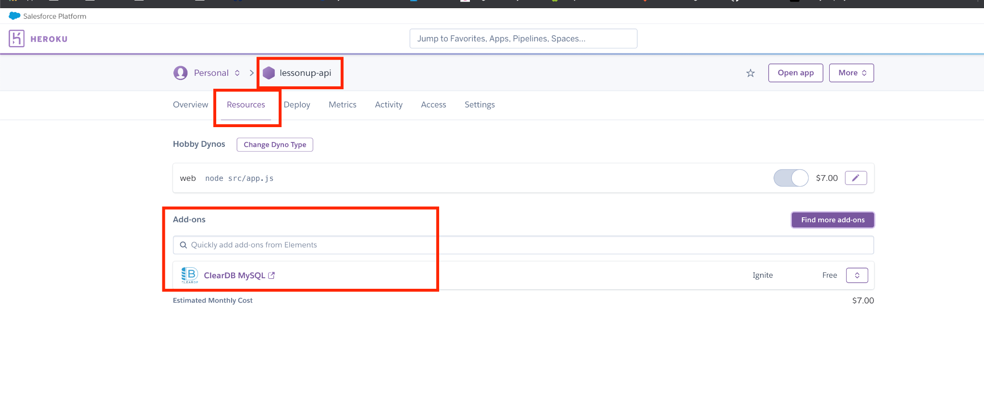

The first step was to install ClearDB MySQL as an addon, in a matter of 2-3 clicks from the resources tab of the Heroku dashboard for lessonup-api. We then have a MySQL database set up for us, which is hosted on a cloud server somewhere, by the company ClearDB:



Using the MySQL Workbench client, we connected to our ClearDB MySQL database to create the tables:

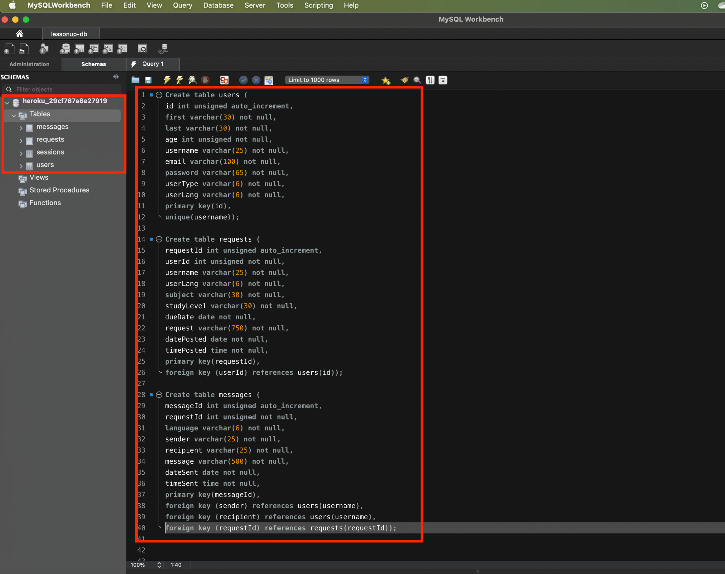

The *sessions* table is created by the express-mysql-session middleware:

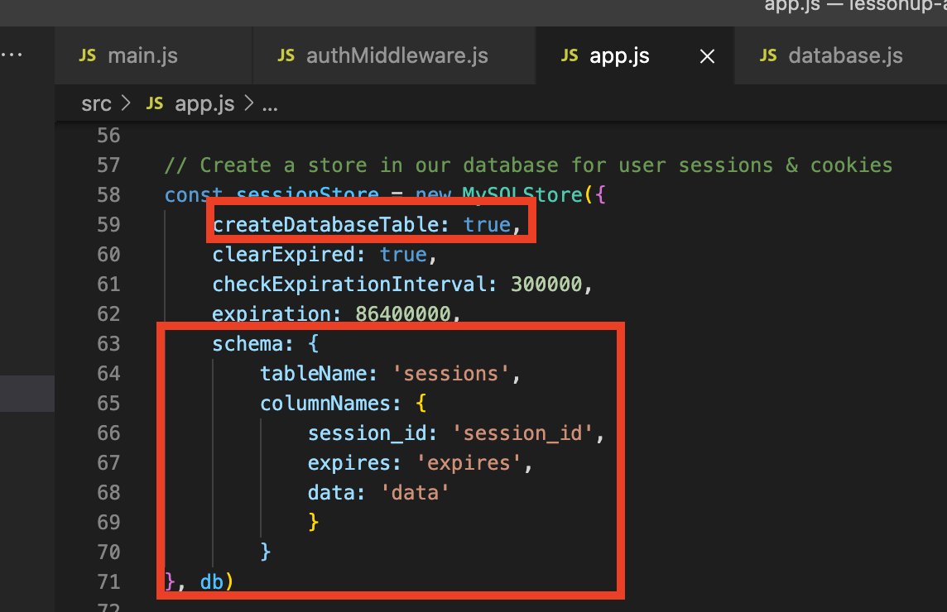

Then we could retrieve the configuration variables (host, user, password, database name) for our ClearDB database from the settings tab of the Heroku dashboard:

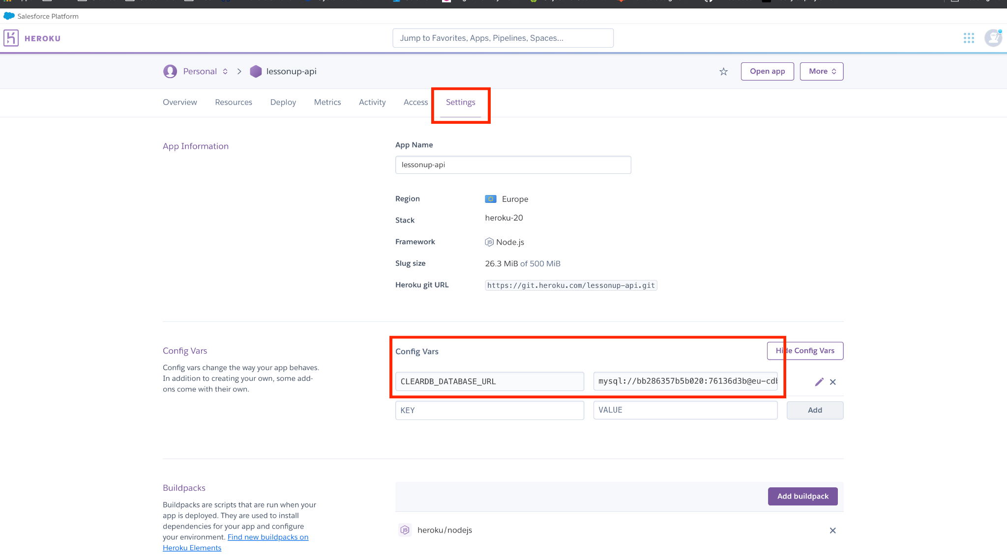

Those configuration variables are used for configuration in our database.js file in src/config:

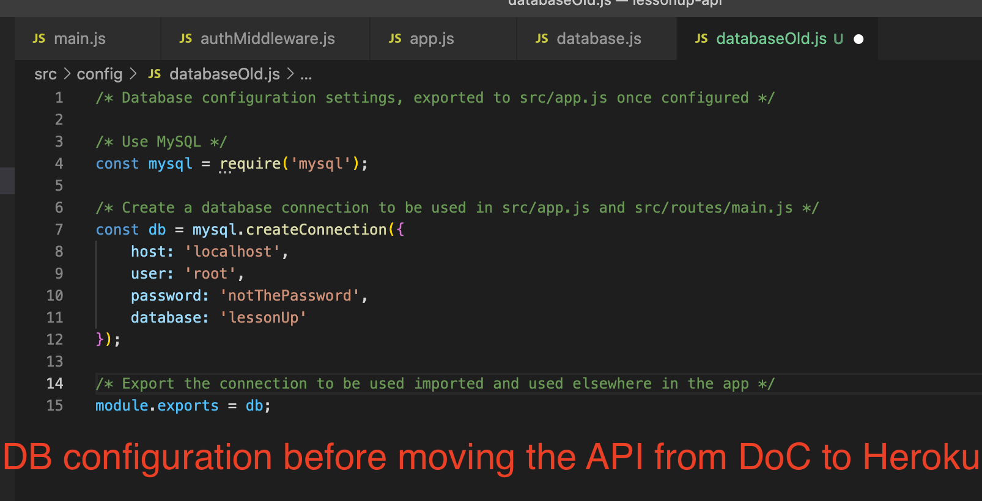

Initial configuration when we migrated the API to Heroku and ClearDB:

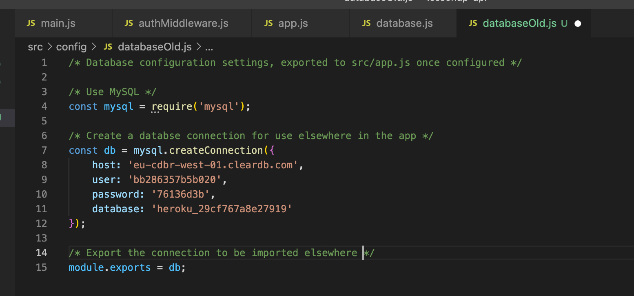

It very quickly emerged that HTTP requests to the API from the UI were causing the API to crash. There were errors in the browser console, which led us to check the Heroku logs, which showed errors trying to connect to the database. After some investigation, we realised that the ClearDB server automatically closes connections after a very short period of inactivity.

The code in the screenshot above effectively creates one single database connection when the application first runs. ClearDB server closes that connection after a short period of inactivity, with the consequence that whenever any route callback functions try to use that connection, they can’t, because it’s closed. Therefore, the UI can’t load the list of languages, get translations or messages or requests for help.

The solution to this was to create a pool of connections, instead of a single connection:

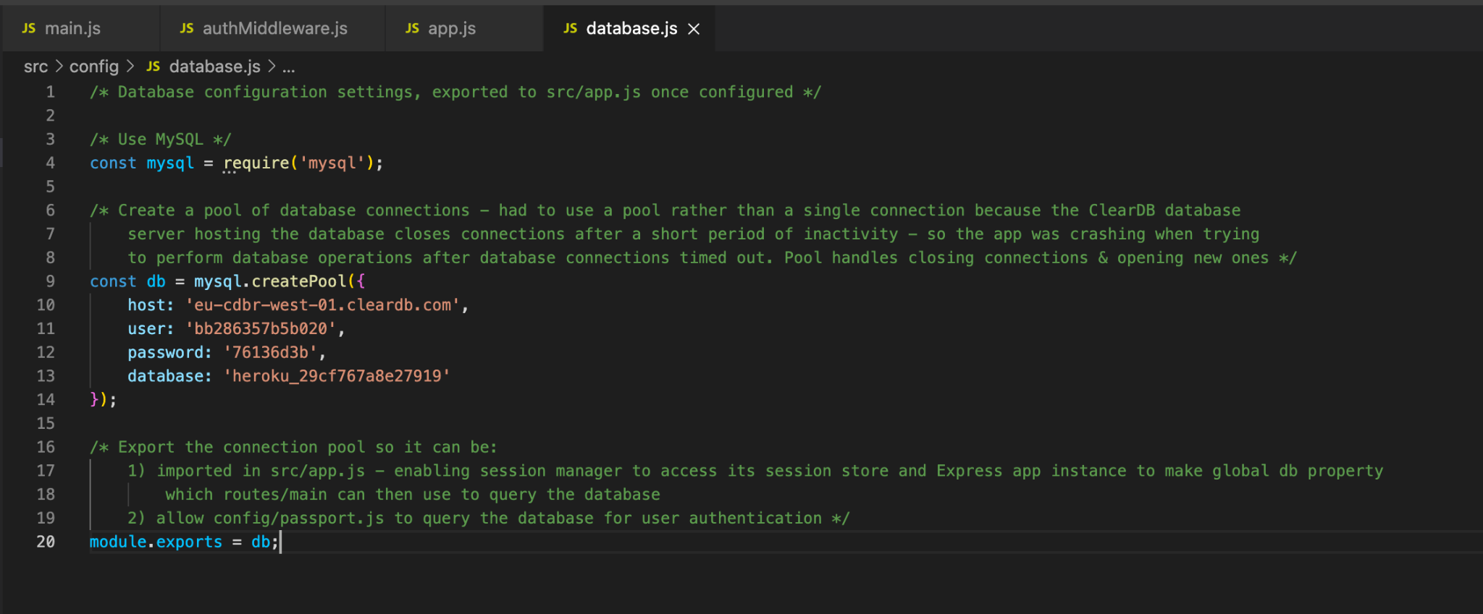

Now, when the ClearDB server closes a database connection, the MySQL Node module will create a new connection when the API needs to query the database. That’s all it took to configure and connect the database for our Express API.

Session management, part 3: Passportjs local authentication

With our API now able to set cookies in a user’s browser, we could implement a [Passportjs ‘local’ authentication strategy](http://www.passportjs.org/packages/passport-local/) (Passportjs.org, no date). This is something we were able to do by following the [fifth](https://youtu.be/xMEOT9J0IvI) and [sixth](https://youtu.be/fGrSmBk9v-4) videos in the series *Passport JS User Authentication (Node + Passport + Express + Angular)* (Gollwitzer, 2020).

Passportjs is a Nodejs middleware for user authentication. We have implemented it as access control in the route handlers for routes in our API which should only be accessible to authenticated (registered and logged in) users. The ‘local’ strategy is the most basic Passport authentication strategy; ideally we would also have attempted to implement the [Google](http://www.passportjs.org/packages/passport-google-oauth/) and [Facebook](http://www.passportjs.org/packages/passport-facebook/) strategies, so we could offer users the option to register/login through those platforms. Unfortunately we were not able to attempt those additional strategies due to the division of labour and time commitment to the project amongst our group members.

Prior to configuring and implementing Passport local authentication, it was necessary to configure and implement the Expression *session* module and *express-mysql-store* session storage manager. *Express-mysql-store* allows the Express session middleware to access our MySQL database. It will create a table in the database called *sessions*, if that table doesn’t already exist, and the *session* middleware can then perform CRUD operations on that database table. We accomplished this by following the video titled [*Your complete guide to understanding the express-session* library](https://youtu.be/J1qXK66k1y4) (Gollwitzer, 2020). It was necessary to adapt the MongoDB specific code (which he uses in the video) to their MySQL equivalents.

Express session & MySQL session store configuration:

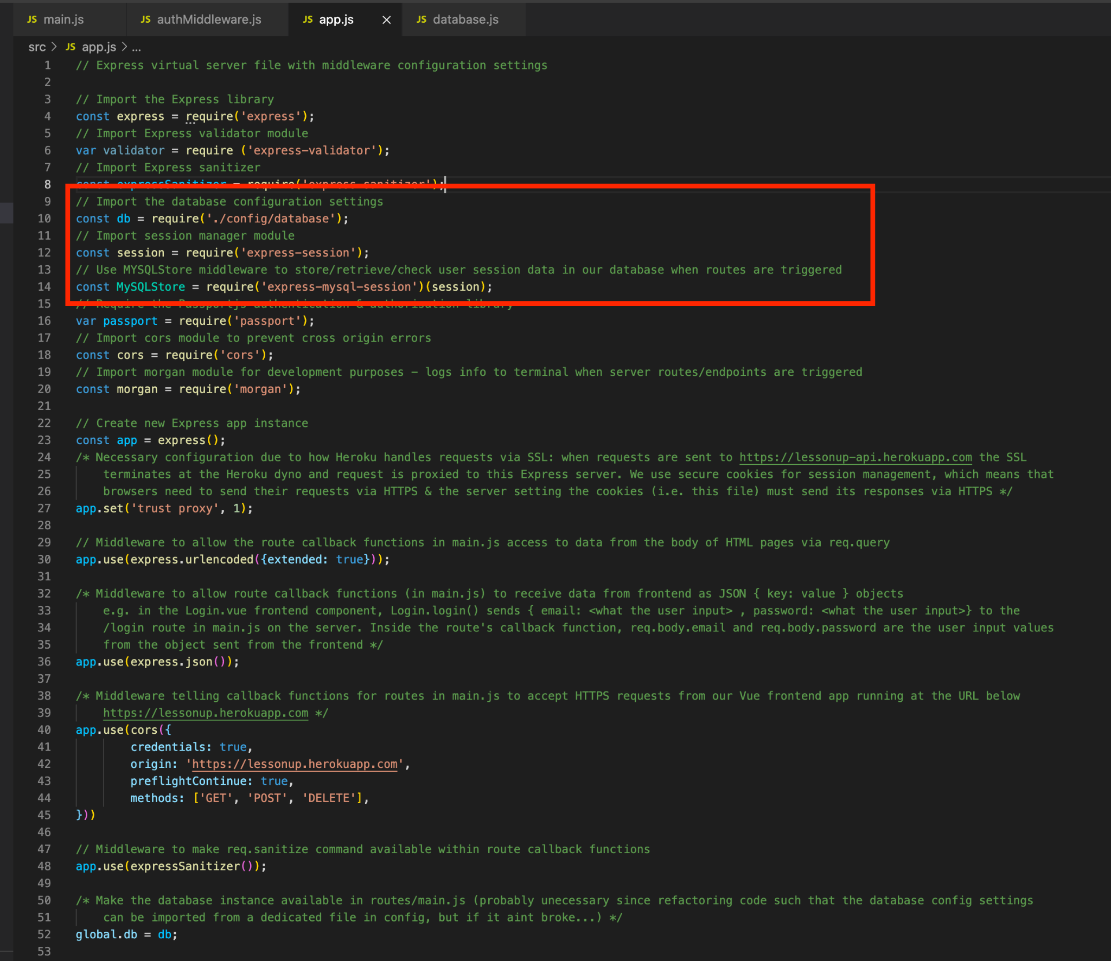

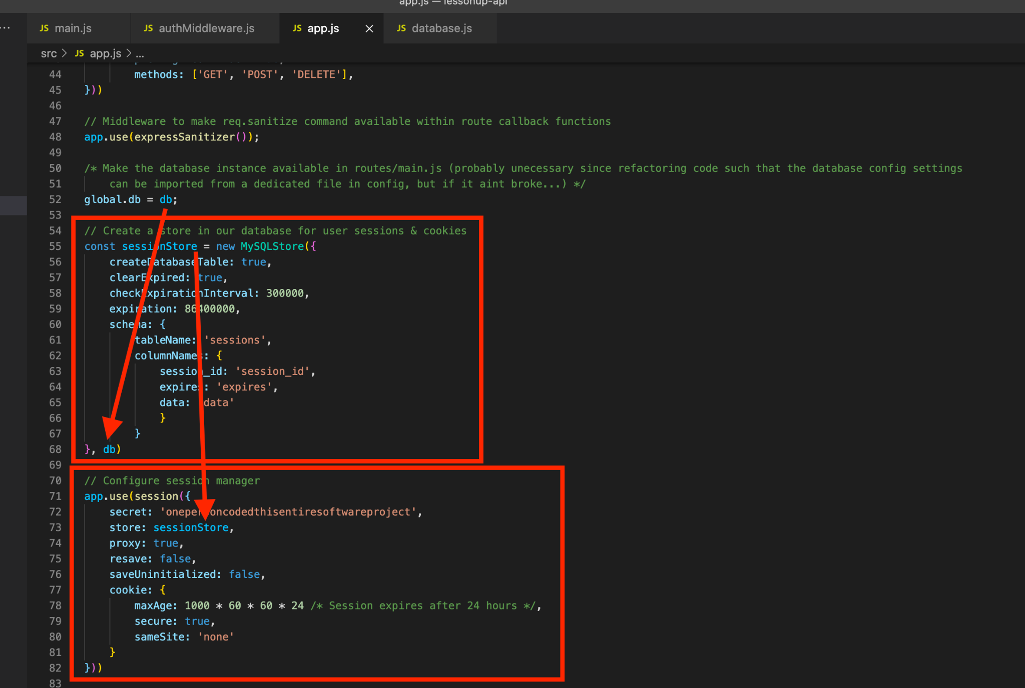

src/config/database.js:

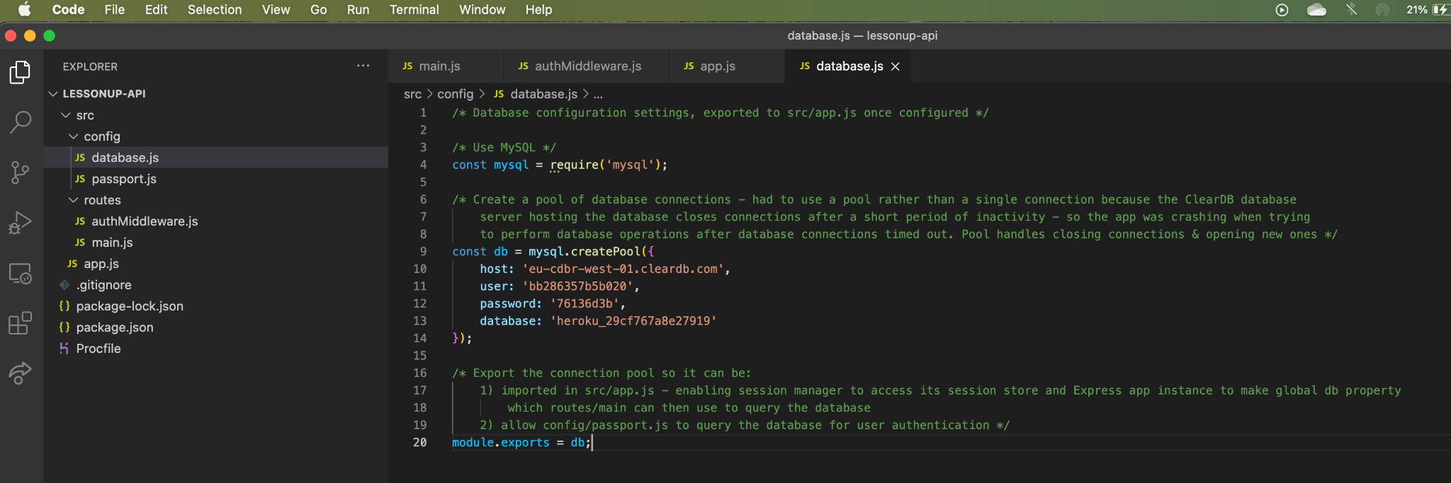

Note that the cookie set in the user’s browser contains the ‘session_id’ from their session record in the sessions table in our database:

(Populating the user’s session_id into the cookie is done by Passportjs when authentication is successful, which we will explain later.)

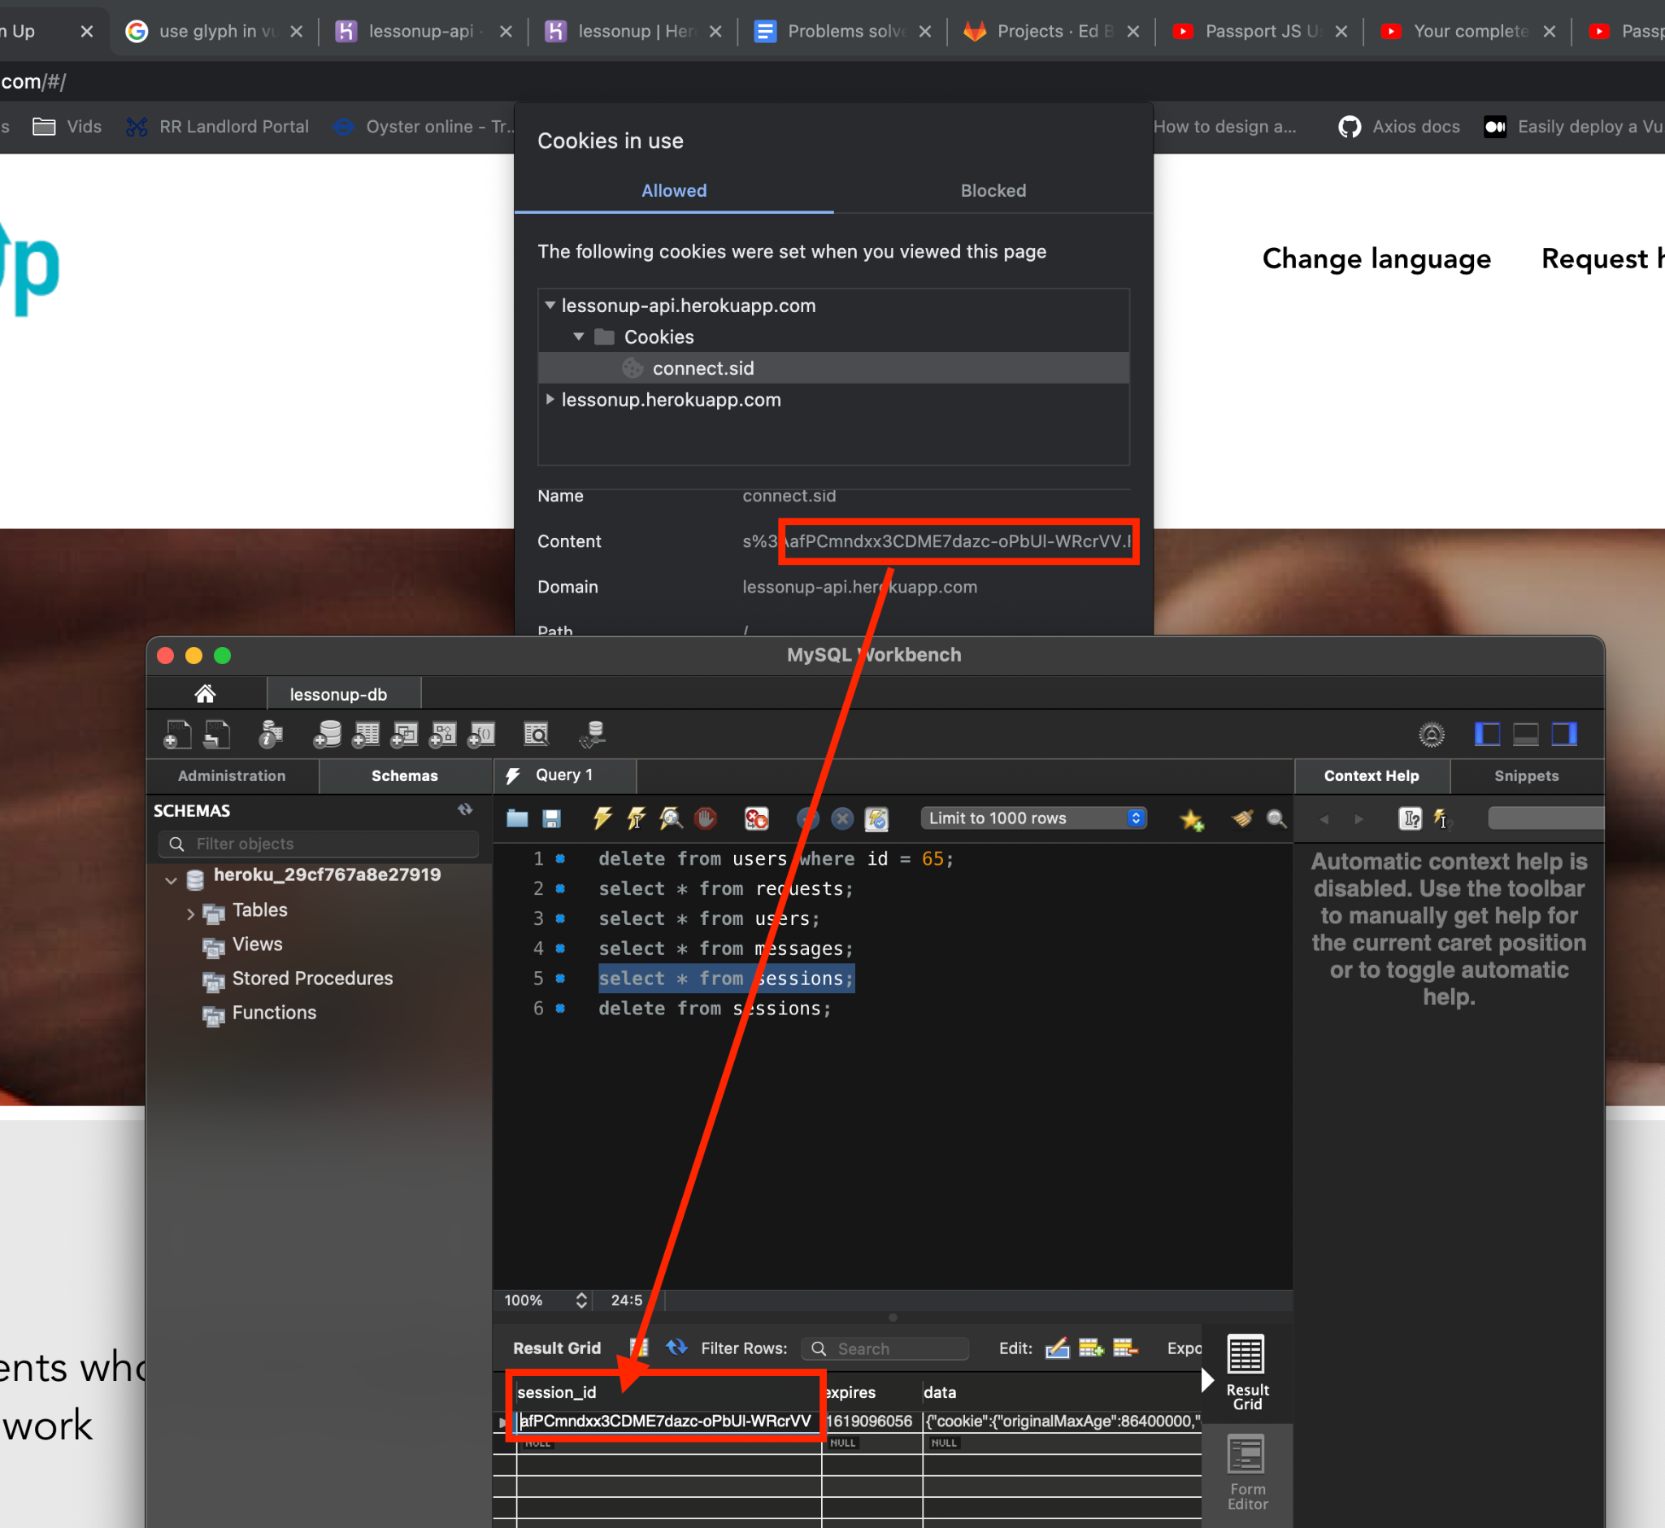

The cookie in the browser has a 24 hour expiry date/time (set on line 78 in the screenshot on the previous page):

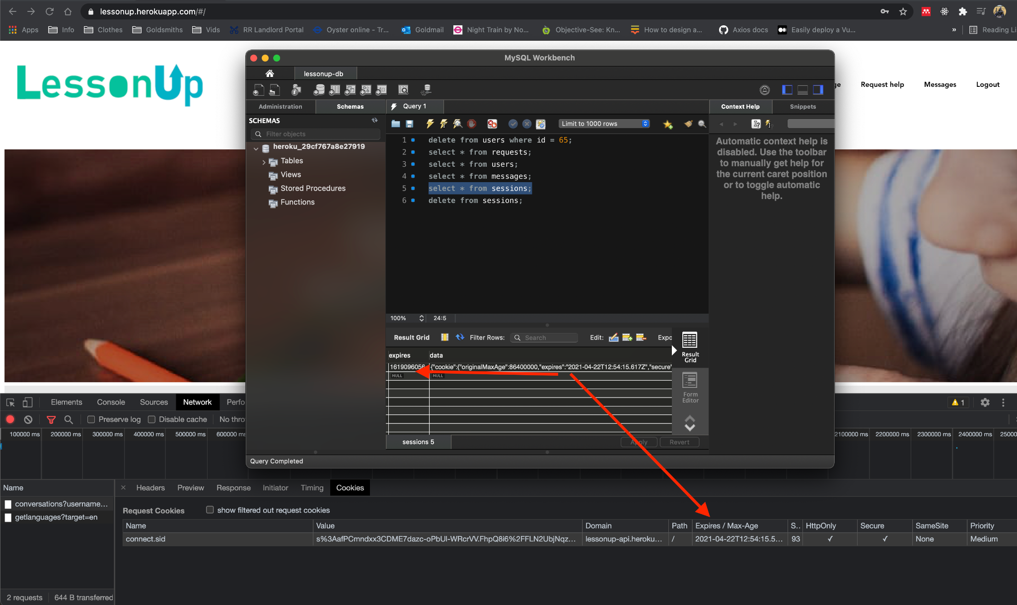

(And the value in the expires column of our database’s *sessions* table should somehow correspond to that expiry date, i.e. is presumably some encoded form of the expiry date.

The user’s browser should delete the cookie after 24 hours, so it should not be included with any requests to our API from that user’s browser after it has expired. If, somehow, it is sent with a request to the API, perhaps by ‘[cookie hijacking](https://en.wikipedia.org/wiki/Session_hijacking)’, the Express *session* middleware will check the *sessions* table in the database for a record with the *session_id* from the cookie. The store manager may already have deleted the expired session record, but if a record with that *session_id* still exists, the middleware will see that it has expired and the browser will be redirected away from protected routes. The redirection is handled by Passport middleware, which will be explained soon.)

A valid cookie being sent with a HTTP request from a browser (Chrome) to our API:



With the session store and cookies in place, we can then begin to configure Passportjs.

Firstly by requiring the module into our project, making the Express instance use it and making the Passport instance globally available (so we can apply the configuration to it within src/config/passport.js and so we can implement its methods in src/routes/main.js):

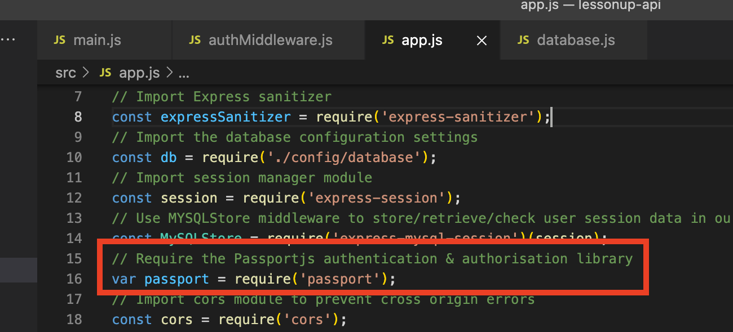

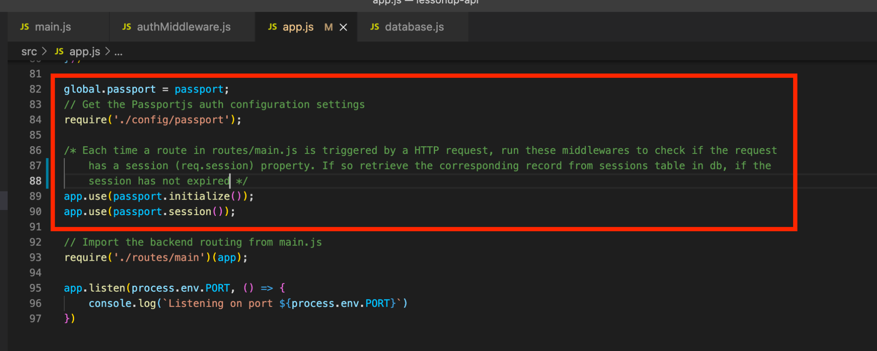

Then creating a config file in src/config/passport.js

In here we import the dependencies: Passport & its LocalStrategy library, our database connection pool and bcrypt for password checking:

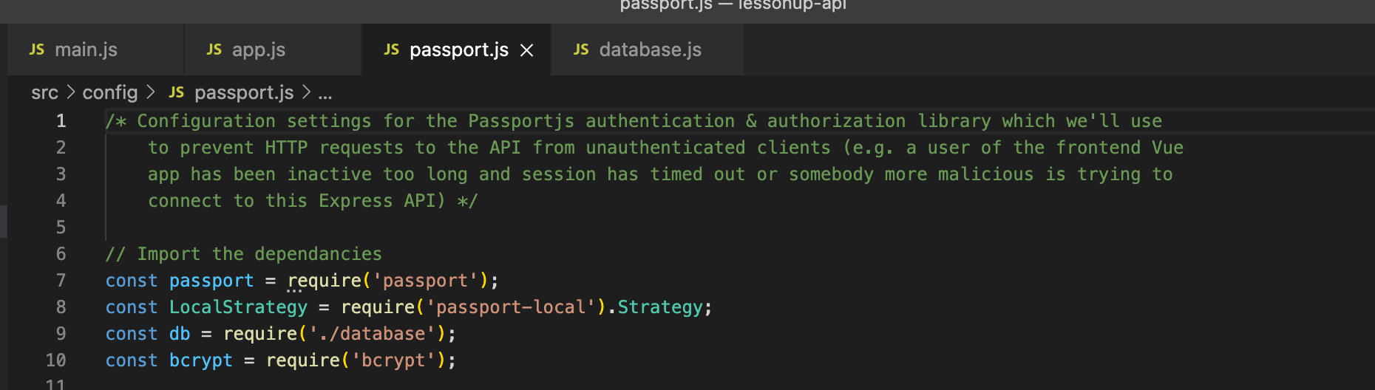

We must define a *verifyCallback* function (which will be used in our *local strategy’s* definition):

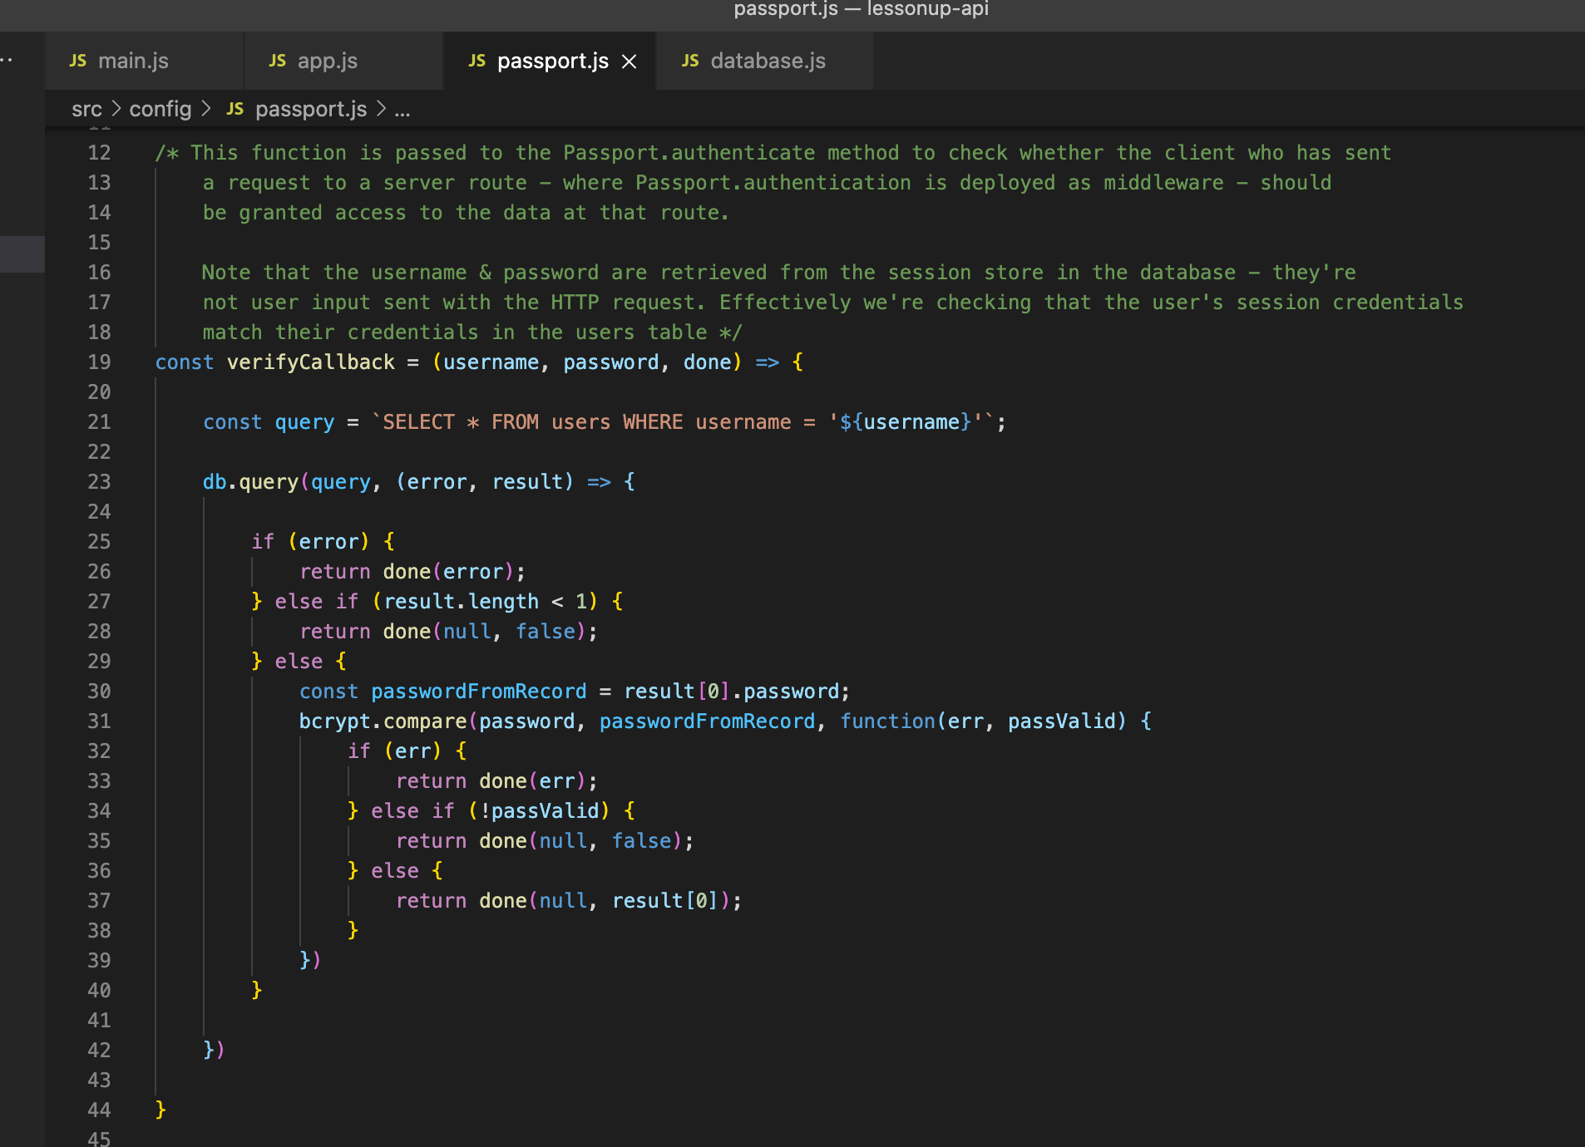

The *verifyCallback* function is passed user credentials. The *done* parameter is a callback function.

Inside the body of our *verifyCallback* function we simply retrieve a user’s record from the *users* table in the database (if a match is found for the username) and check the password in the user’s database record matches the password passed into *verifyCallback*. *verifyCallback* will be invoked anywhere that we use the *passport.authenticate(‘local’)* method, which is a method of the Passport library. *passport.authenticate(‘local’)* is the method we will use to implement access control on protected routes.

Where the *verifyCallback* returns ‘done(null, false)’, that tells the *passport.authenticate(‘local’)* method not to allow the user’s HTTP request into the route. The other potential result is ’done(null, result[0])’, which tells *passport.authenticate(‘local’)* that the user exists (is registered in the database) and is authenticated. *passport.authenticate(‘local’)* then invokes *passport.serializeUser()*. That tells Express’ *session* middleware to append a property named *passport* to the *session* object in the HTTP request (the *req* argument in the route handler is an object with a *passport* property). That *passport* property contains a property named *user*, with a value of the id from the user’s database record. This means the route’s callback function can access *req.session.passport.user*, which is the id of their database record.

We have 2 Passport methods applied as middleware to all routes, set using app.use in src/app.js:

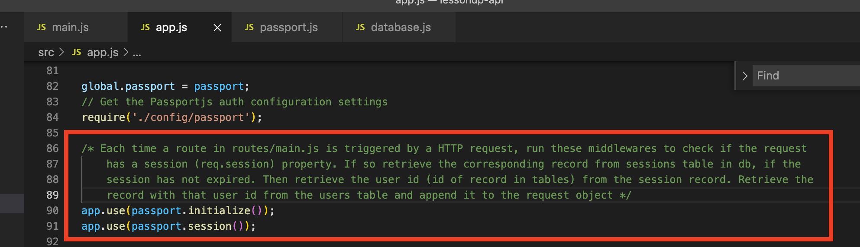

So when a route is triggered by a HTTP request, passport will check whether the *req.session* object has a *passport* property. If so, the user Id assigned to that property is used by the *passport.session* method, which invokes *passport.deserializeUser()*. *passport.deserializeUser()* retrieves the user’s whole record from the database and appends it to the HTTP request object, so *req* then has a user property, *req.user*.

For example, anywhere between line 327 and line 340 (in the screenshot of routes/main.js below), we could access *req.user*, which will have the same properties as the user’s record in the database:

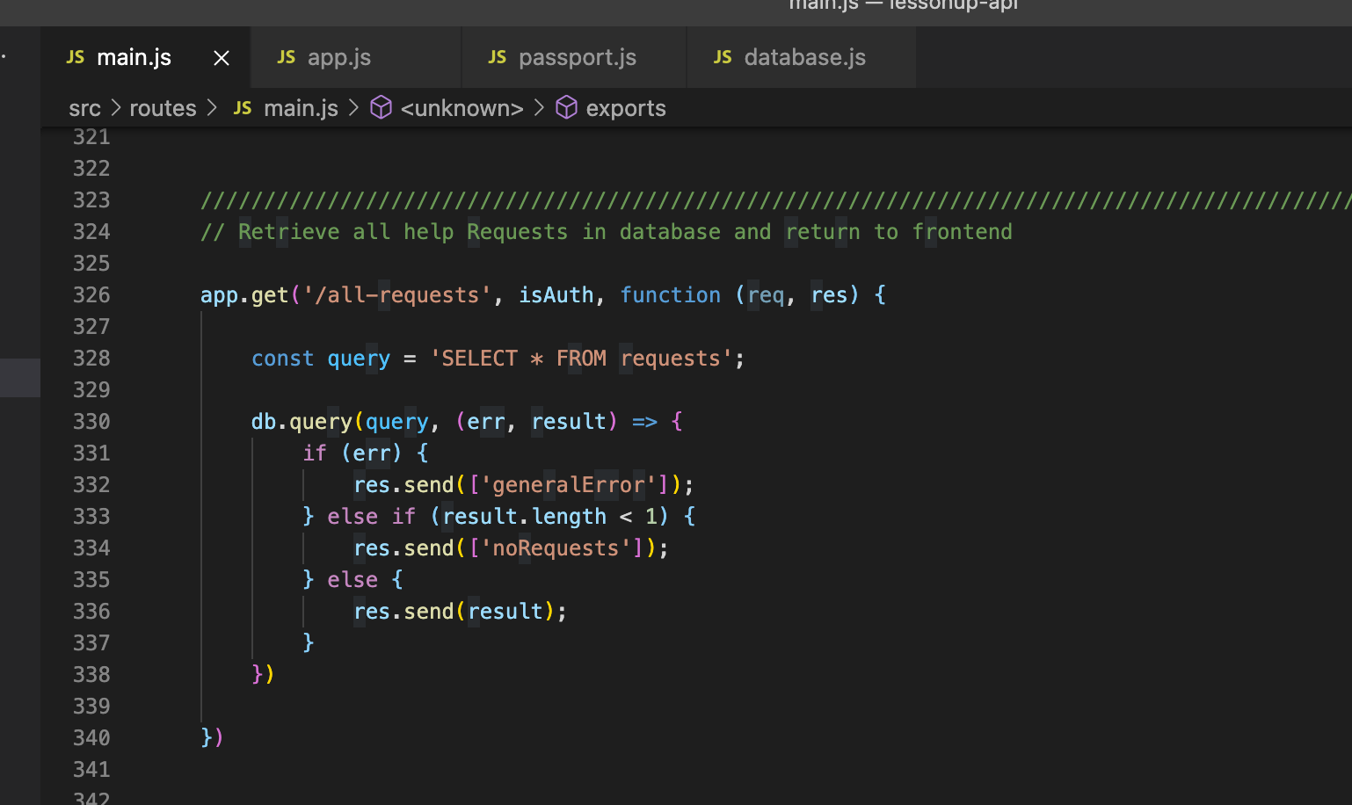

(We don’t actually need to access *req.user* in the routes, but it is used in another middleware - *isAuth* - which processes the incoming HTTP request, after the *verifyCallback* function has run.)

Having defined our *verifyCallback* function, we must then create a new Passport LocalStrategy which implements the *verifyCallback* function, and tell our Passport instance to implement this strategy:

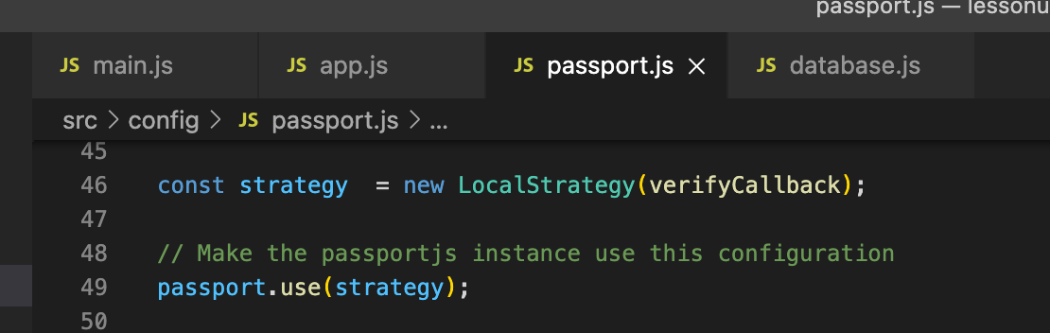

When the Passport instance has been configured, we should initialise a couple of its methods:

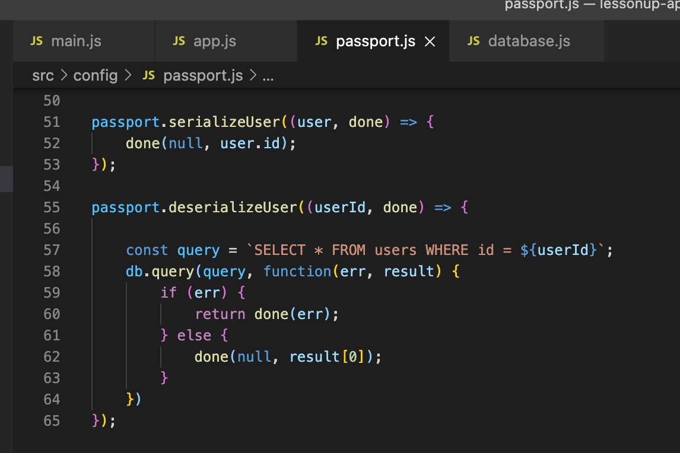

To implement the access control on our protected routes we wrote our own middleware in src/routes/authMiddleware.js:

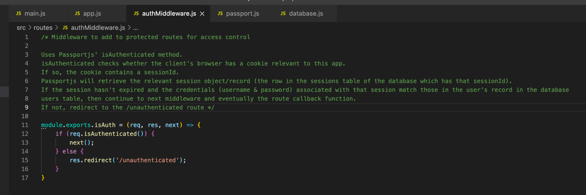

Which we imported into src/routes/main.js:

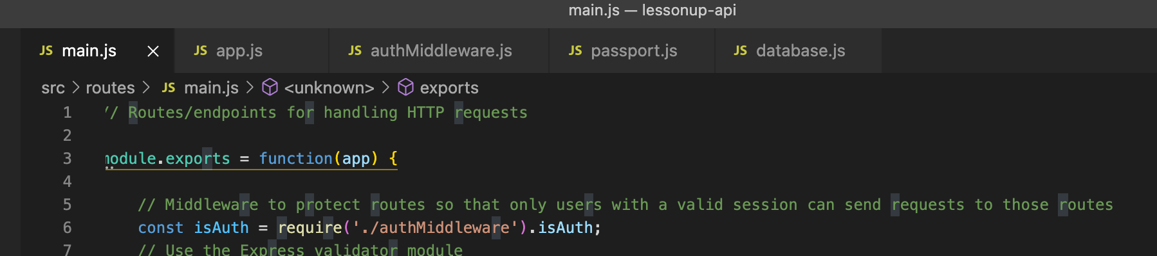

And applied to the protected routes:

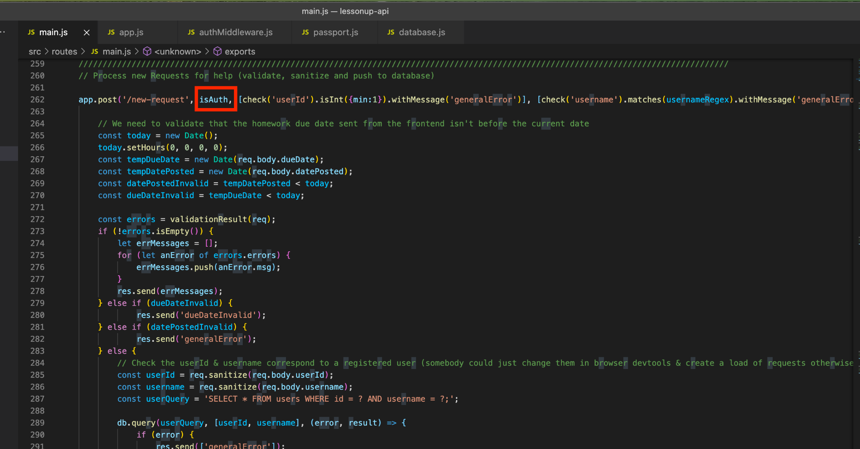

The route which requests are redirected to if not authenticated:

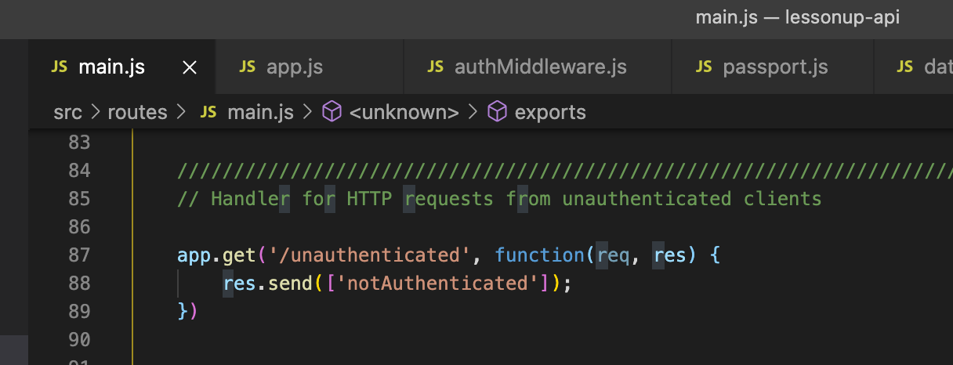

Setting a user as authenticated in our login route using *req.login*:

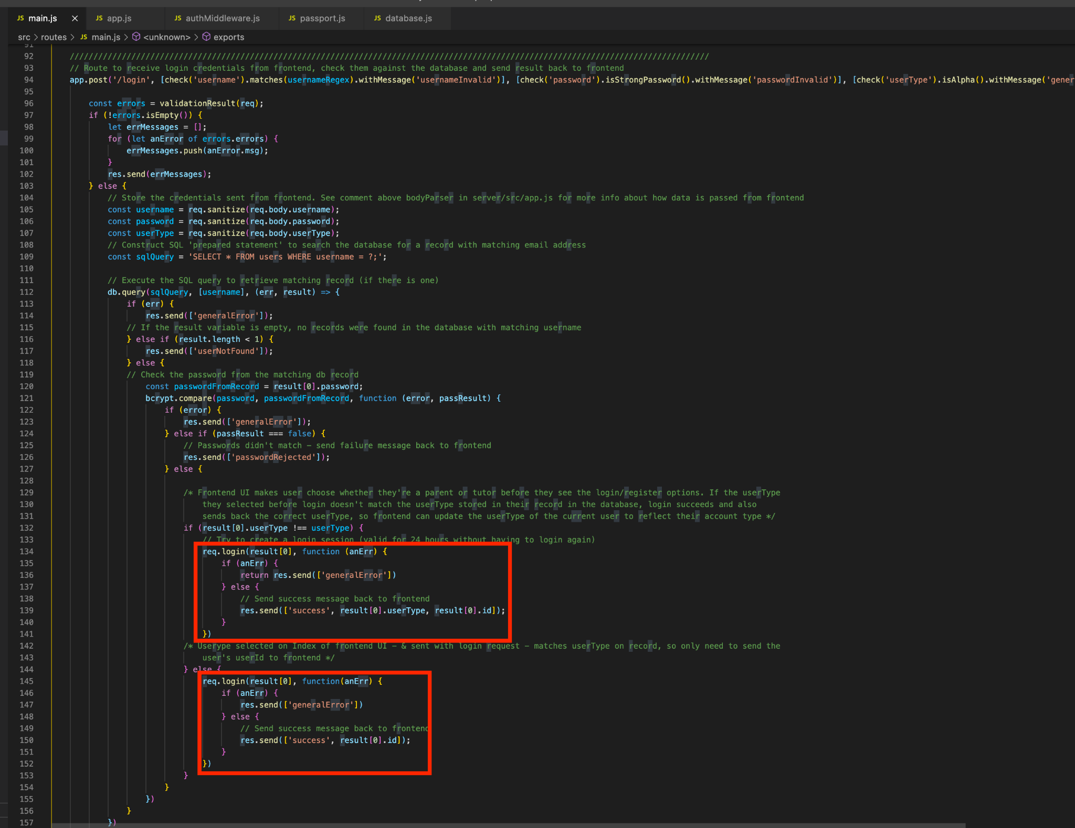

Setting a user as authenticated upon successful registration, using *req.login*:

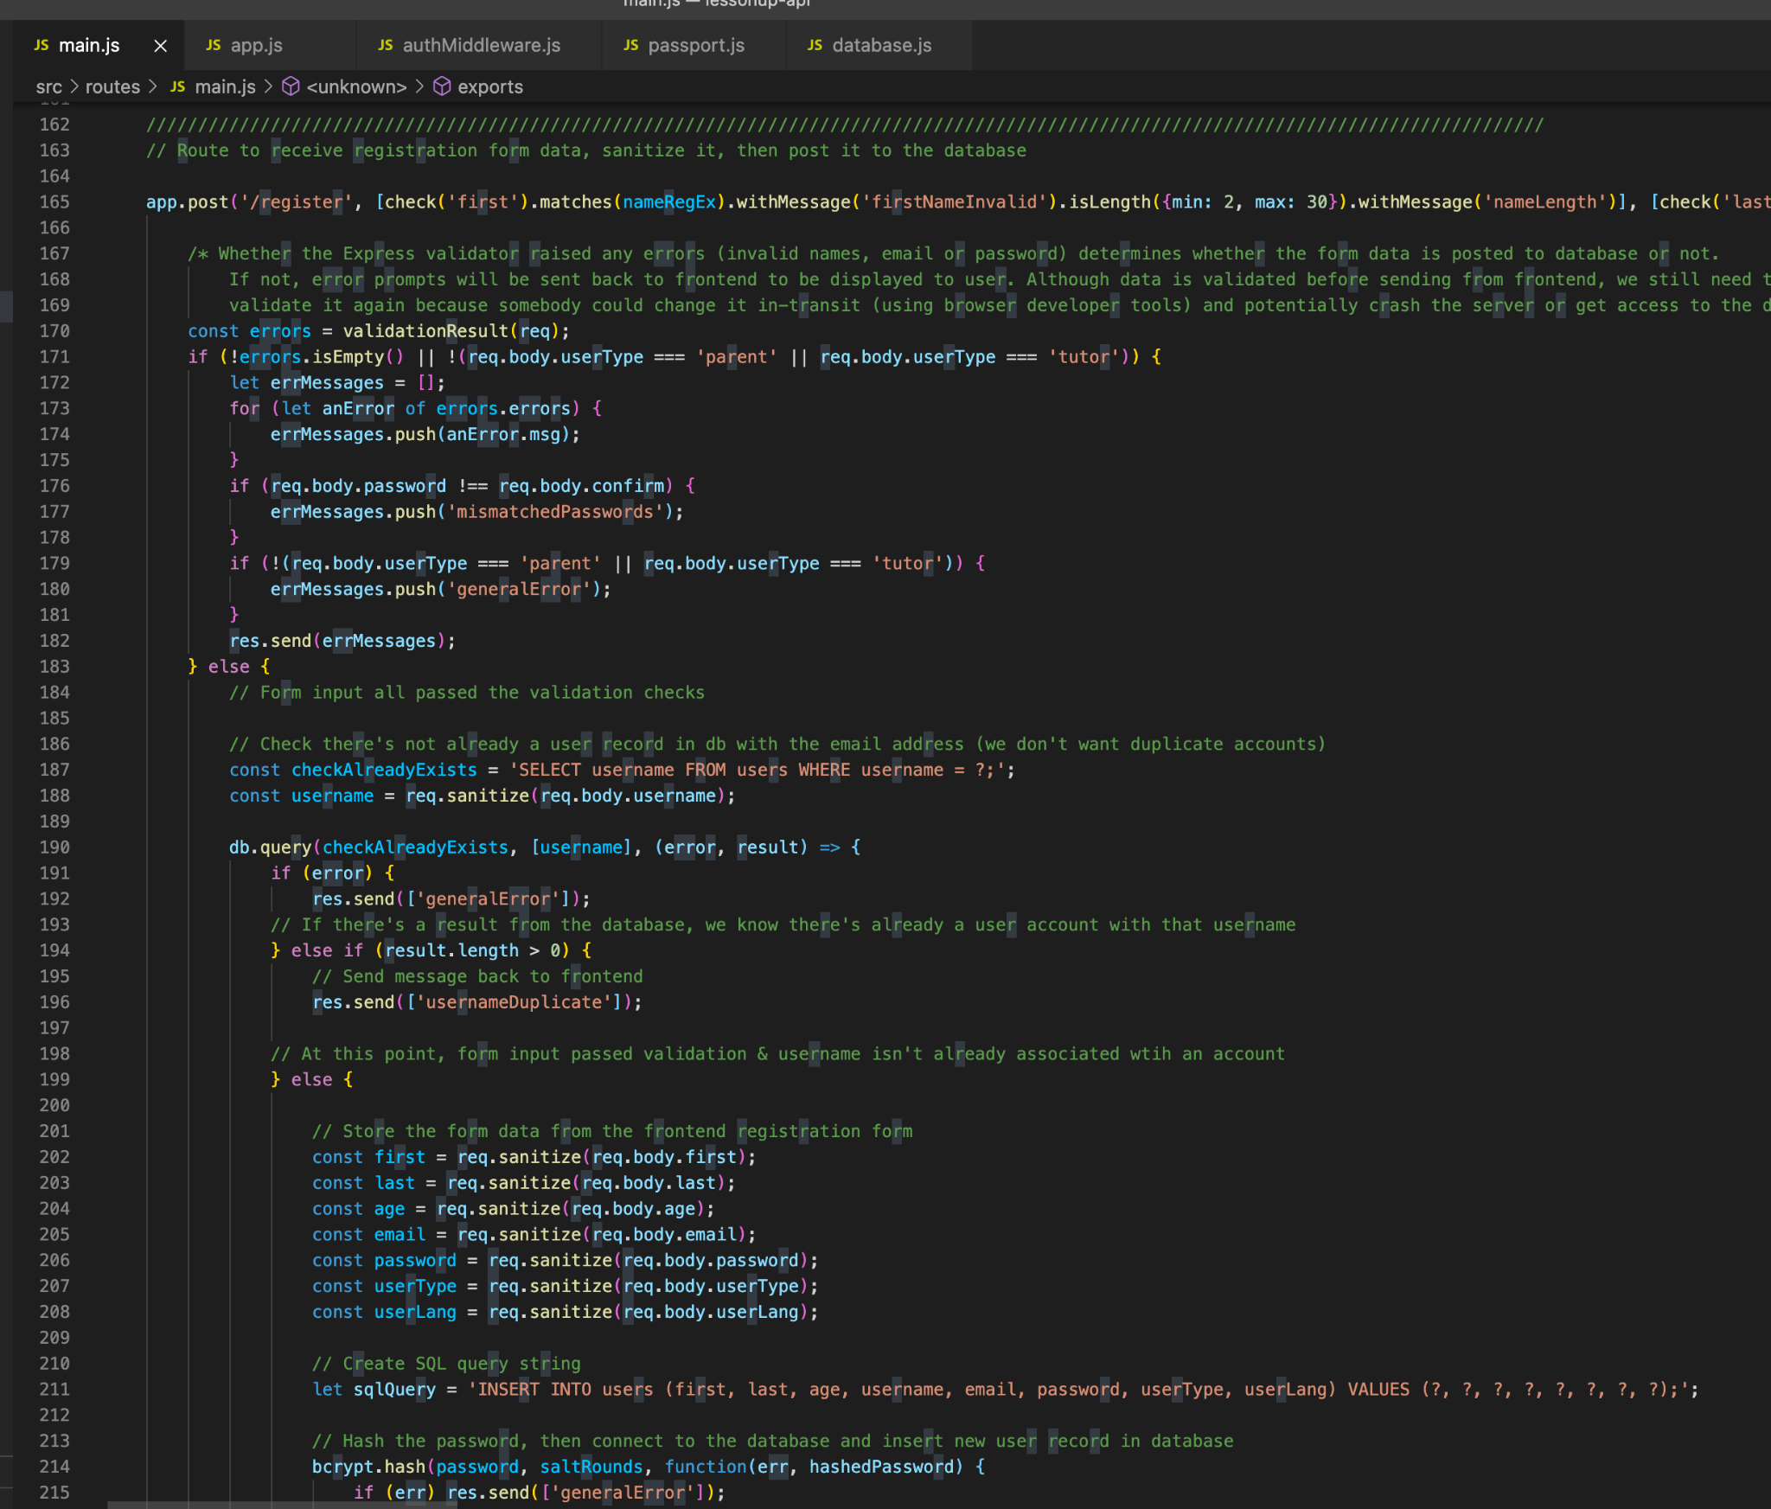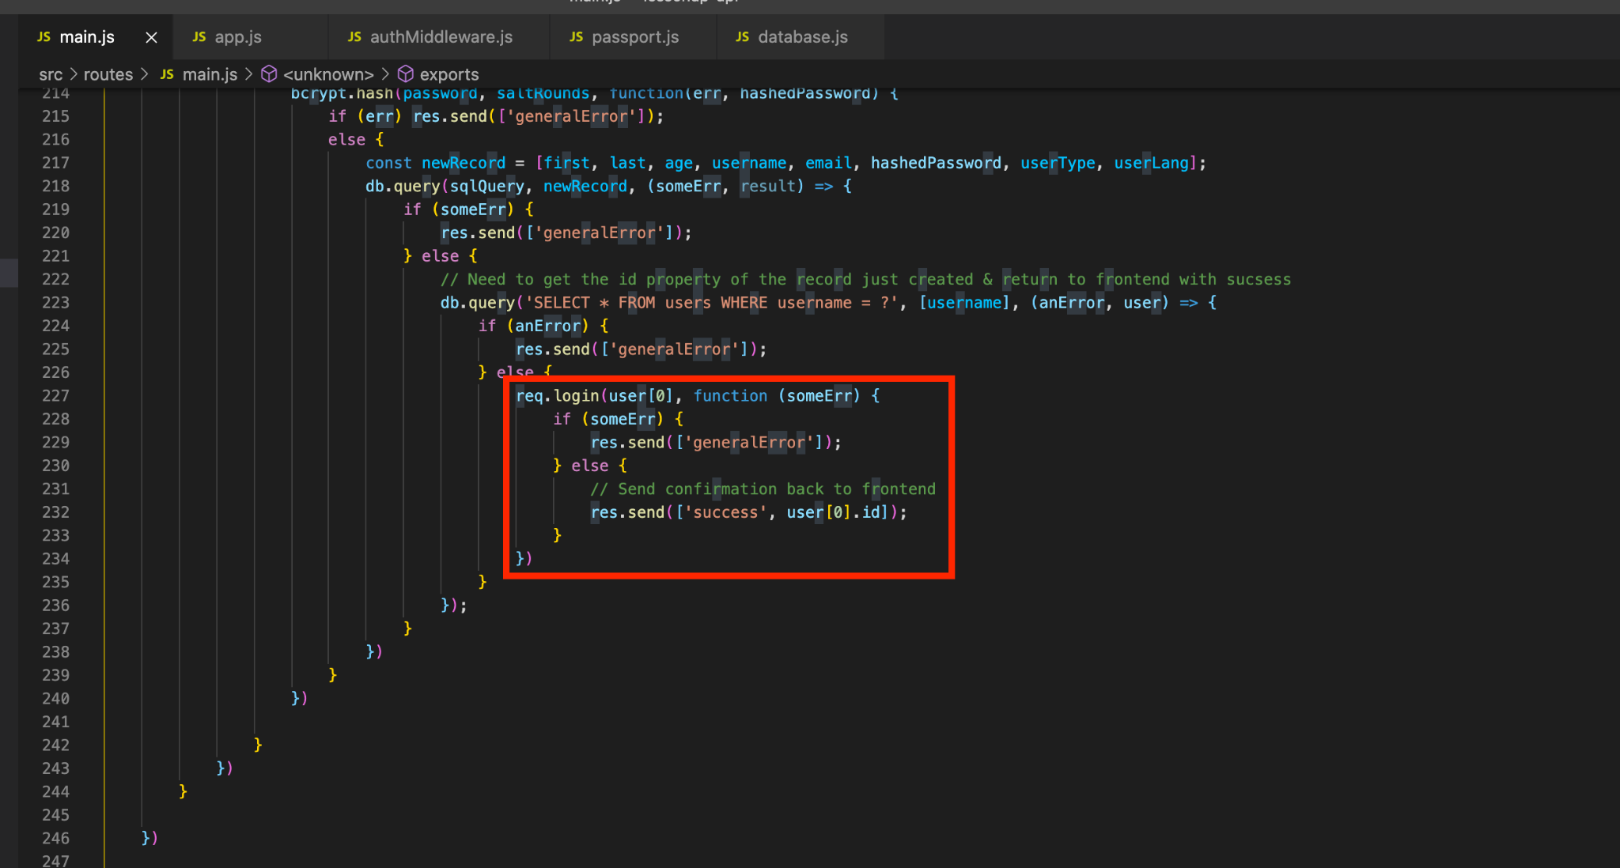

Disposing of session data on logout:

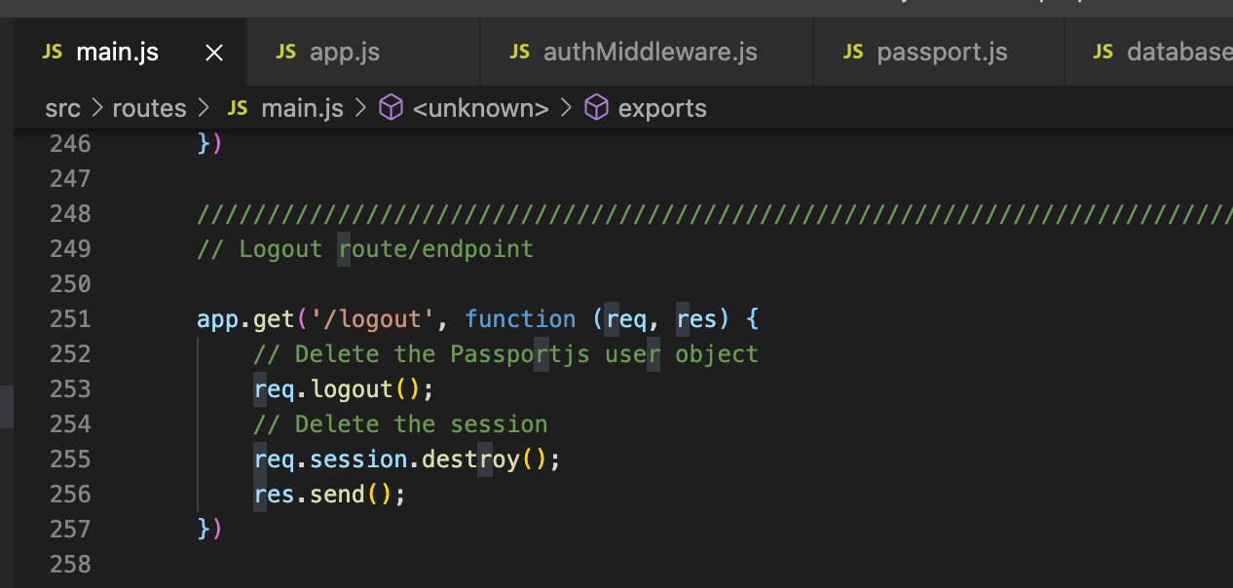

The notAuthenticated response is handled by our UI like so:

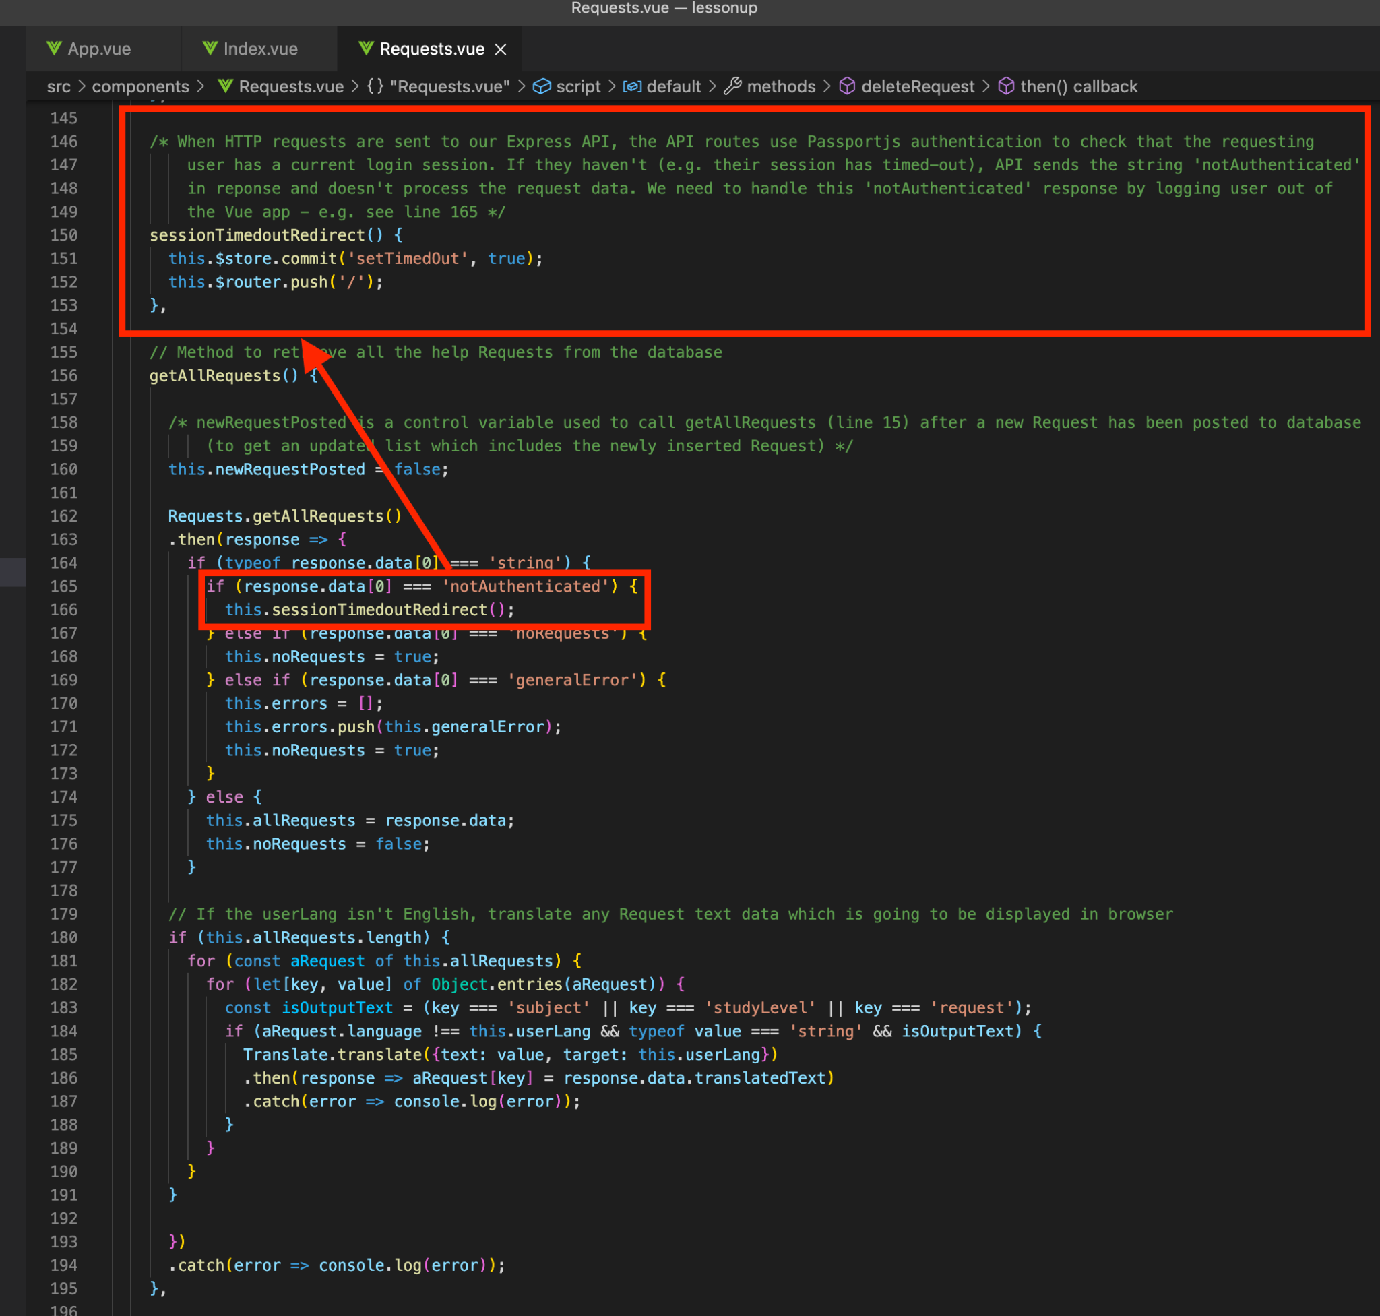

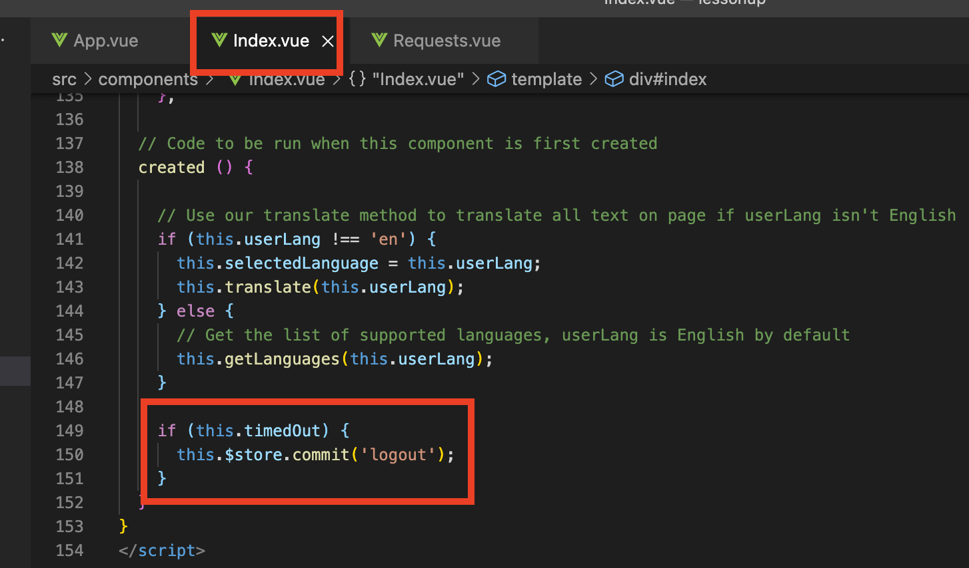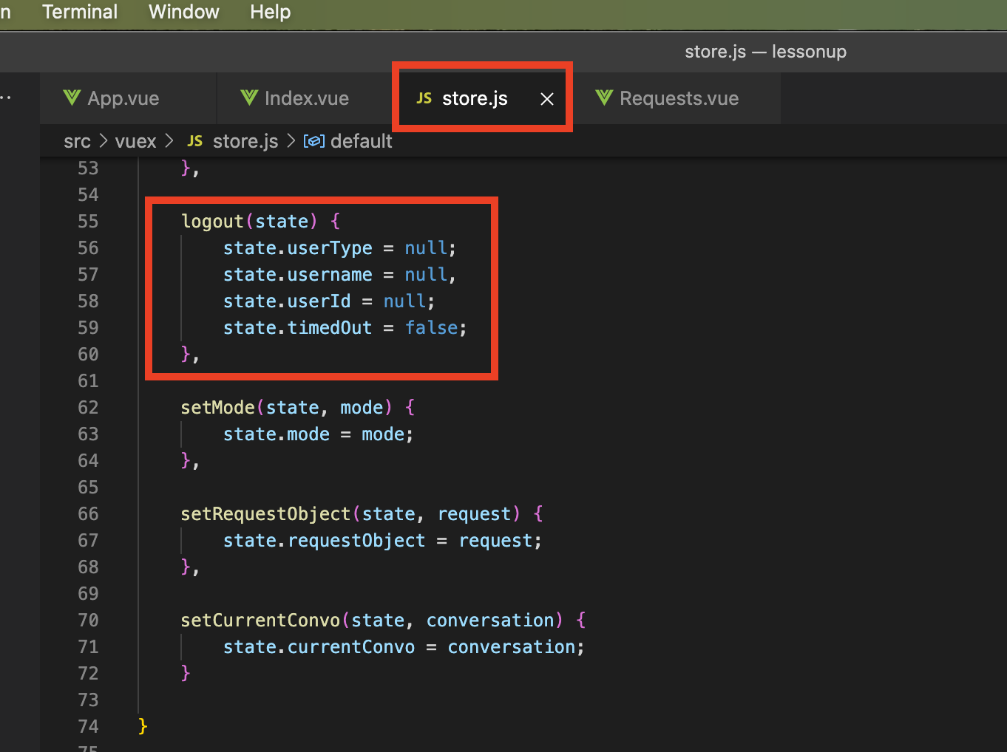

There probably should be some kind of visible feedback explaining to the user why they have just been logged out, but we haven’t got around to that.

## **A note about SQL injection attacks**

The callback functions in our API’s routes* use ‘prepared statements’ (aka parameterised queries) to pass user input with SQL queries, rather than directly inserting input into query strings using template literals or string concatenation. *Passport’s verifyCallback doesn’t need to use prepared statements because the credentials used aren’t received directly from the client.

For example, **rather than constructing our SQL queries like this**:

(where, if the user input contains an SQL escape character and an SQL query - like “; drop table users;” - it’s being inserted directly into the query that the SQL shell executes)

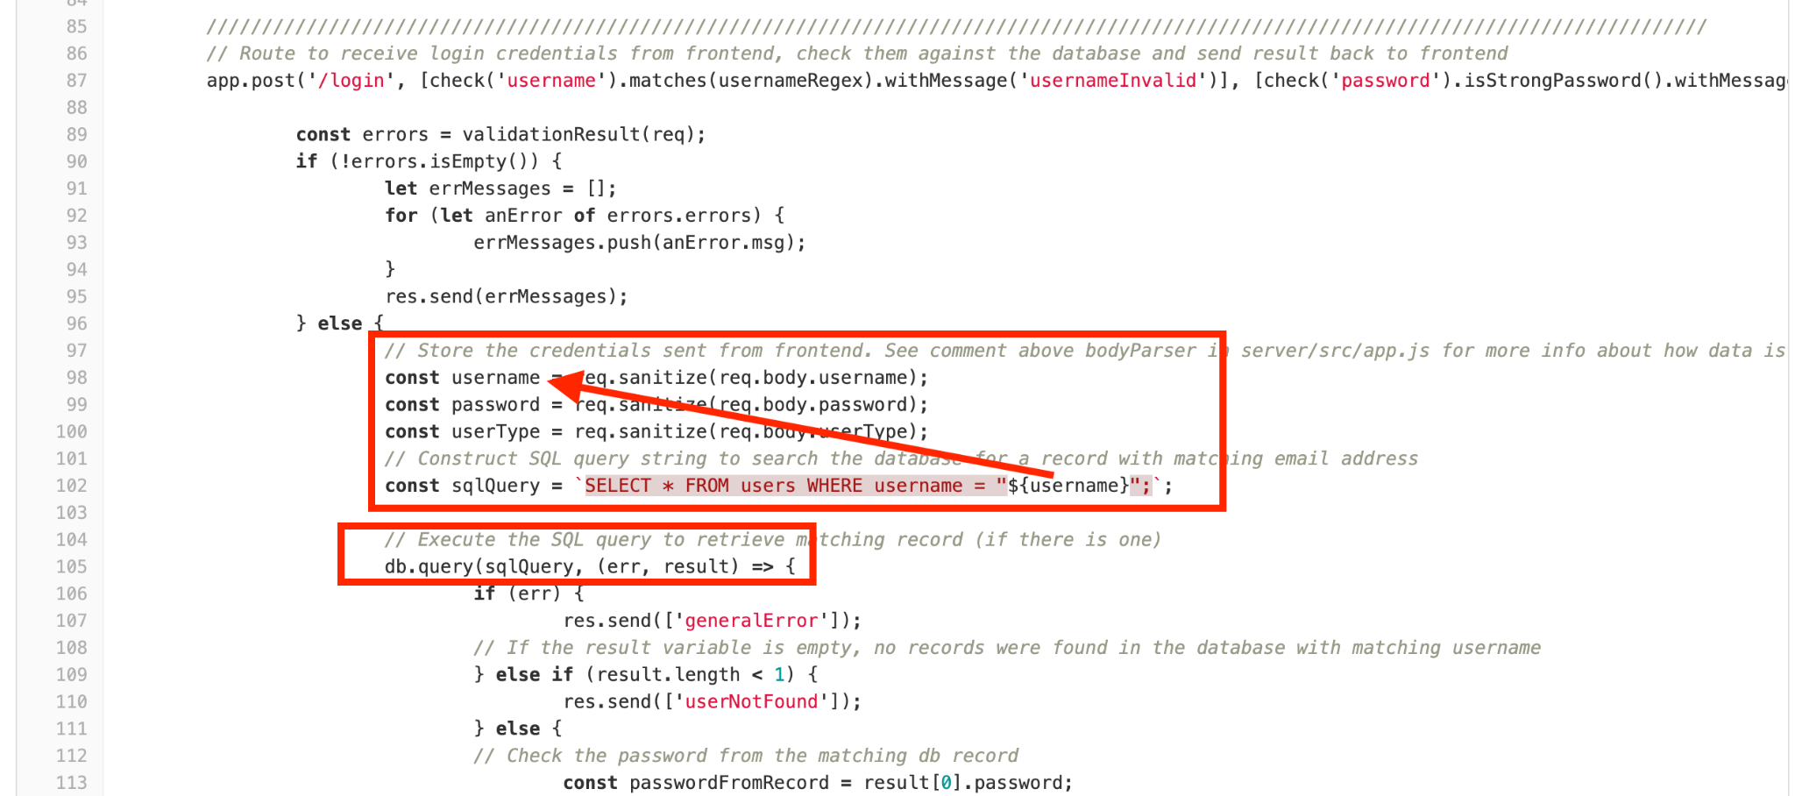

Our queries are parameterised:

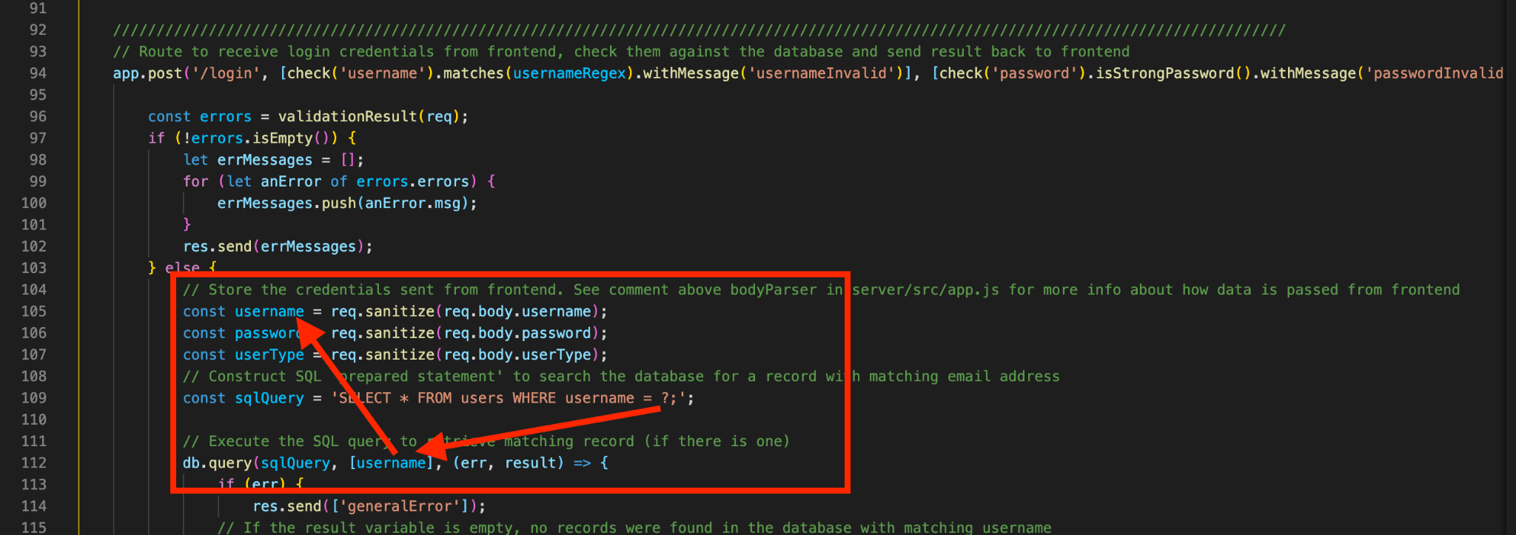

SQL processes parameterised queries/prepared statements differently than it would process a query string. This is something which frankly we do not properly understand, but have read plenty of articles and forum posts advising to use, as a preventative measure against SQL injection attacks. Examples of such [posts](https://stackoverflow.com/questions/8263371/how-can-prepared-statements-protect-from-sql-injection-attacks) and [articles](https://medium.com/@jaredablon_31568/how-to-prevent-sql-injection-vulnerabilities-how-prepared-statements-work-f492c369614f).

## **Software licencing**

Admittedly, licencing is something we have given very little thought to. Presumably, we almost definitely should have appropriately licenced some of the modules/dependencies which we have used to build this software. However, this is not something which anybody in the group has found time to research and implement.

## **Testing our software**

<https://vue-test-utils.vuejs.org/>

<https://vueschool.io/courses/learn-how-to-test-vuejs-components?friend=vuejs>

<https://youtu.be/Fbo4pttBZ9k>

<https://youtu.be/r9HdJ8P6GQI>

<https://jestjs.io/>

If only we had researched test driven development at an early stage of the project, **Jest unit and integration tests could have been very useful**. It would have saved us considerable time spent manually entering different combinations of input (or altering data in browser tools) to test the behaviour of our UI, time spent checking logs in terminals to test API endpoints and time spent checking consoles to observe responses from servers. Then, if any of us actually understood how to use Git pull requests, we could have implemented continuous integration.

Frankly, we left it until far too late a stage in the project to set up and run unit tests and integration tests. We did attempt to set up some tests with Jest and Supertest to test endpoints in our API, but were unable to understand how to correctly write the tests - Heroku logs kept showing errors after running them.

## 

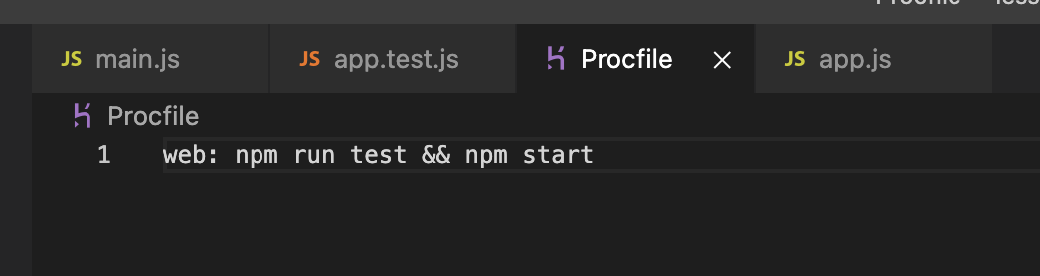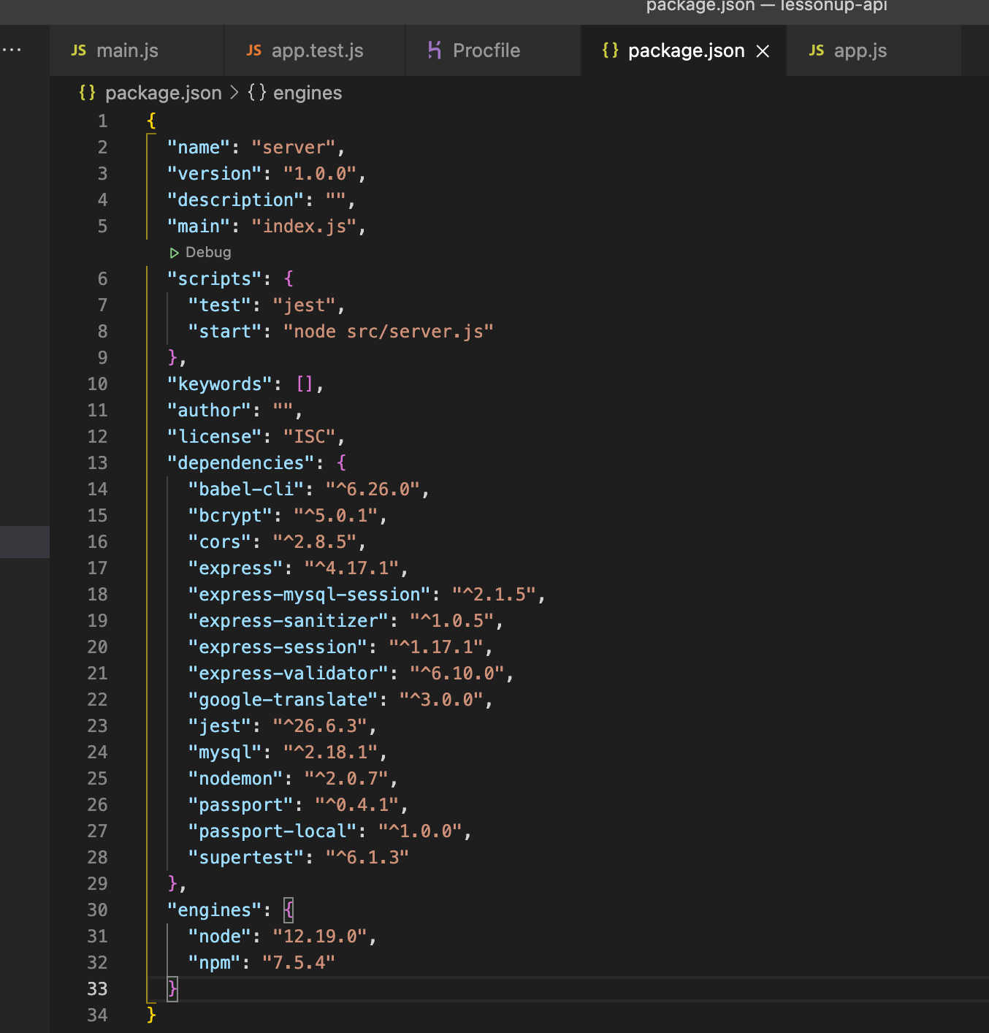

Heroku logs showing the failed (due to improper setup rather than bugs) Jest unit tests:

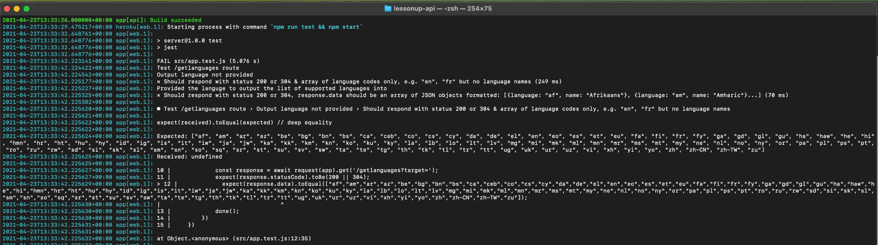

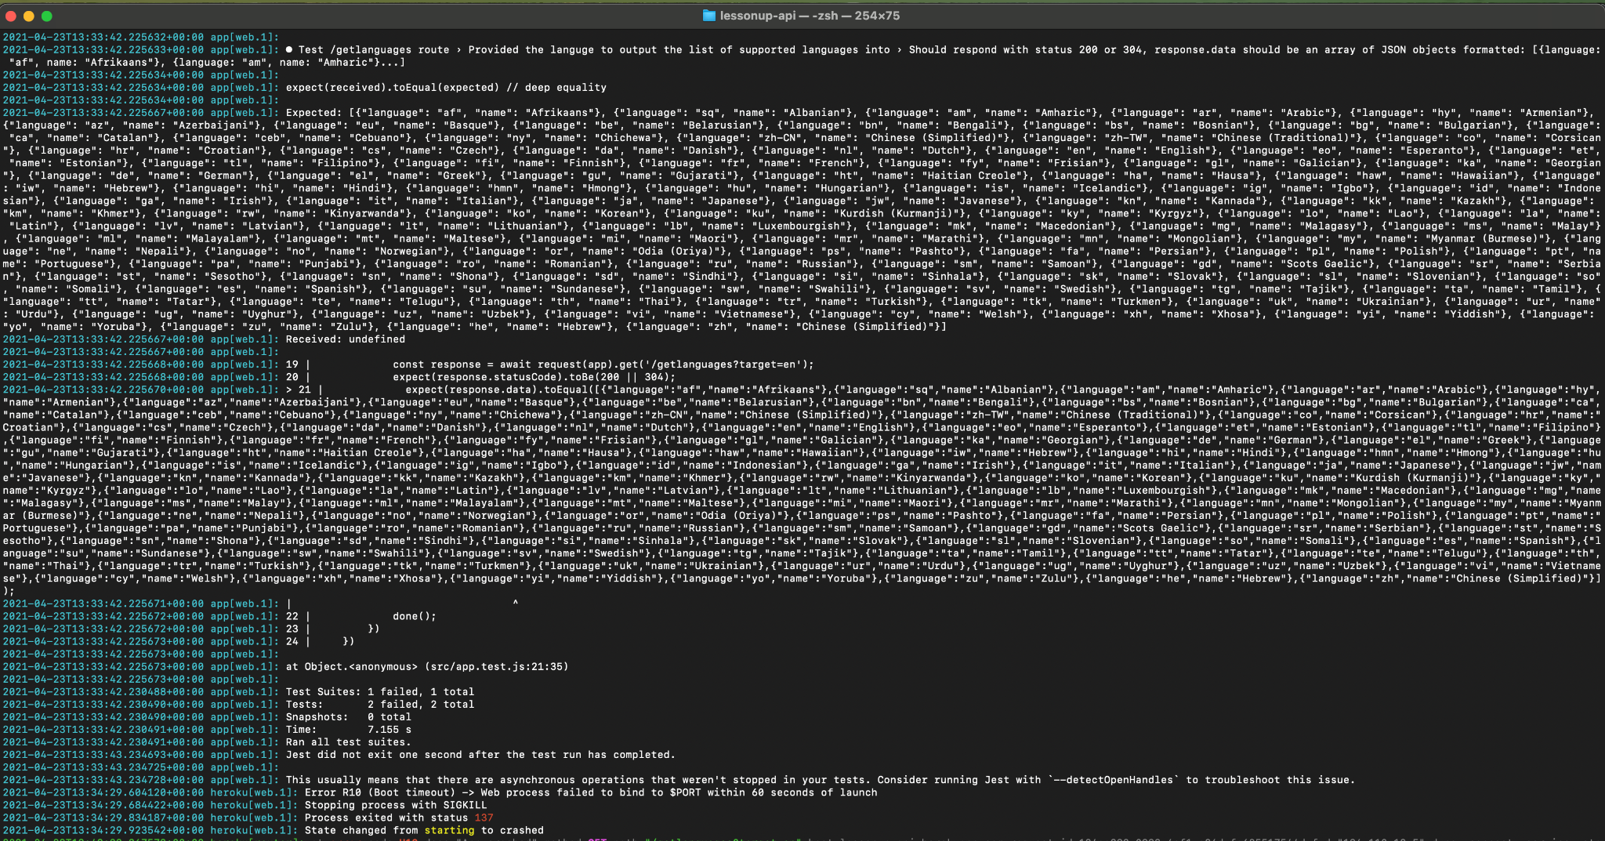

## **Known bugs**

The messaging feature does not quite function as intended or as a user might expect. We believe this is something which could be straightened out quite quickly and easily with some minor changes to the /conversations and /messages routes in our API.

If more than one tutor has replied to a particular request for help, when the parent - who posted the request - opens the messages component and selects a conversation, it contains messages from both tutors and the parent’s replies to both. We want conversations with different tutors to be separate, even if they relate to the same request for help.

The API /conversations route callback logic somehow needs to establish the username of the other party in a conversation. Then the final database query, defined with the *convoQuery* variable on line 428 in the screenshot below should be something like `SELECT * FROM messages WHERE requestId = ${requestId} AND (sender = ? OR sender = ? AND recipient = ? OR recipient = ?);`, passed with the parameter [person1, person2, person1, person2].

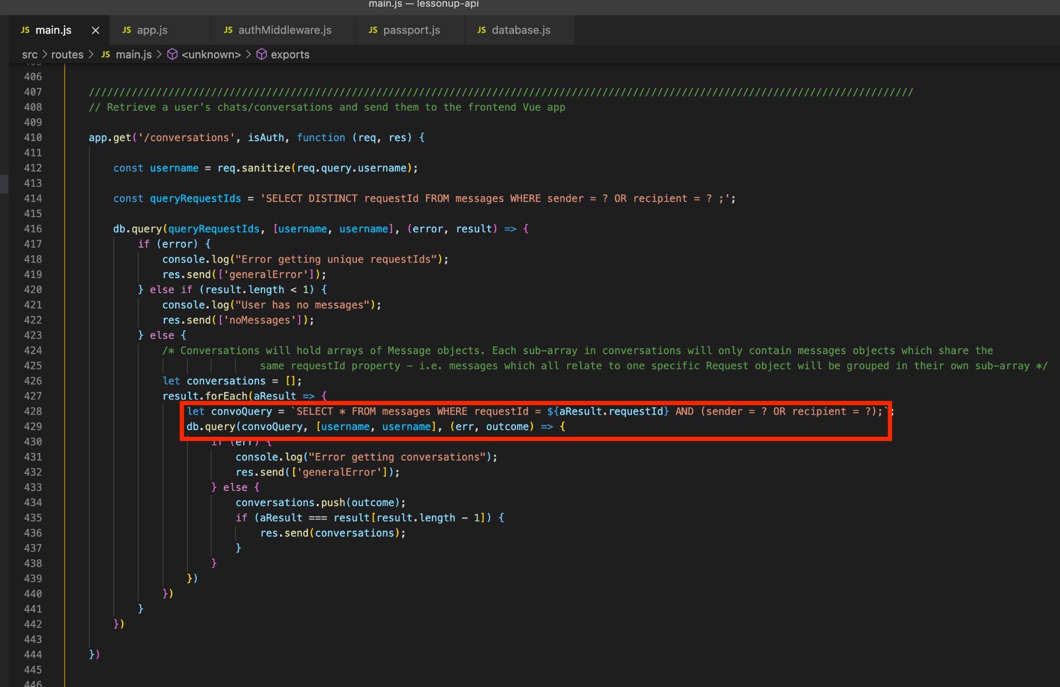

Noticed a bug on the deadline day, where we found that deleting a request for help failed due to a foreign key constraint on the request record. The HTTP response status was 200 OK, but there’s nothing in our Requests.vue method *deleteRequest* to handle this a 200 response without a message defined in our API’s response (the API also does not have any pre-prepared response for this eventuality).

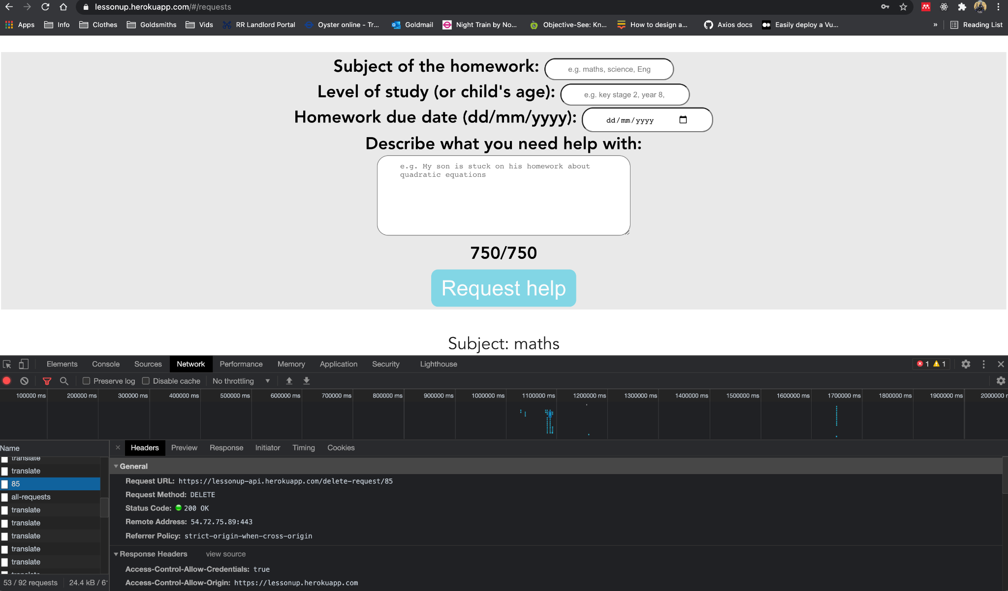

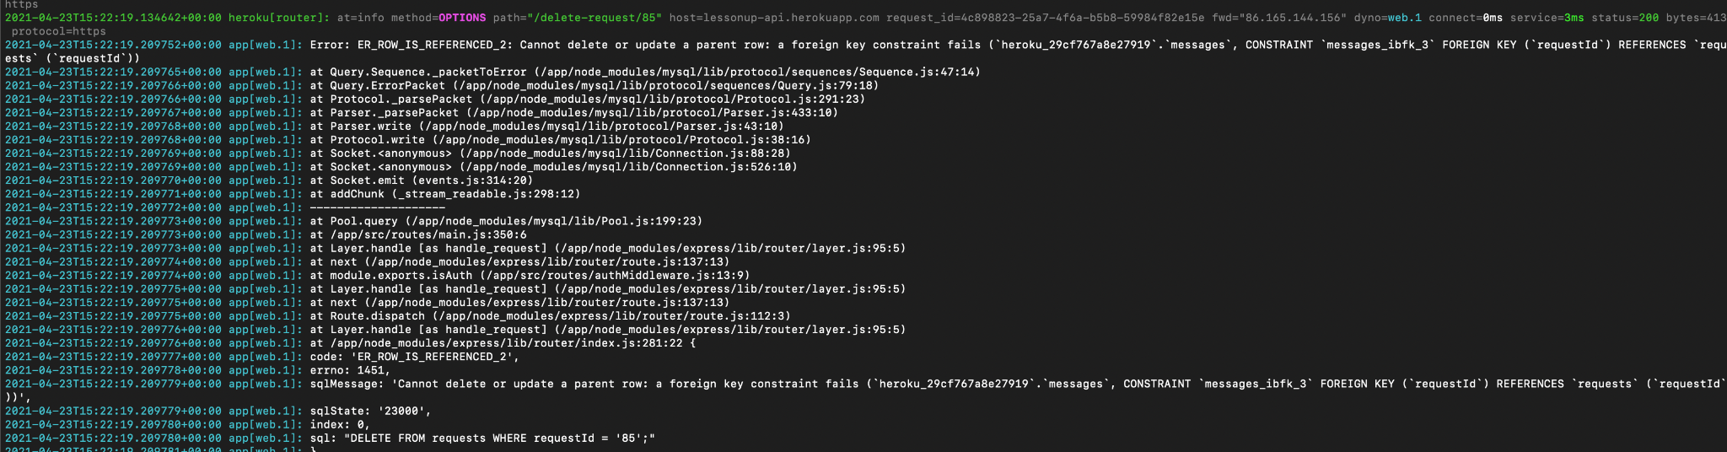

The simplest solution was to just drop the foreign key constraint from the *requests* table, since it was unnecessary anyhow. We haven’t used any junction tables.

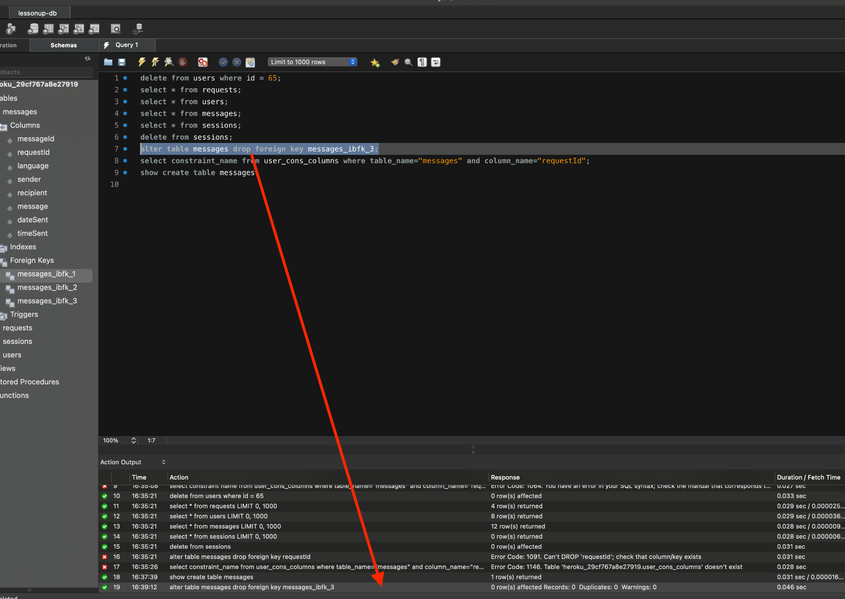

# Development Record

## **Prototype**

The prototype was created using Adobe XD. The purpose of the prototype was to elicit feedback from participants, know the strengths of our applications interactivity and what issues must be resolved. Its other purpose was to give us an idea of the right way for users to navigate the application and set up the correct routes between pages.

The prototype is mainly done in blue, yellow, and green, reflecting learning what our page is about. The prototype has many component elements that add functionality and make it more interactive.

Prototype elements are positioned using grid (both square and layout). We made sure paragraphs with more that one line of text has line spacing as a number divisible by 8 and its font size is also divisible by 8 so it is displayed correctly on many different screen sizes. Initially colors were chosen using color palette although personal preferences were also crucial in a process of choosing colouring of the page.

### **What did you learn from making and running the prototypes?**

* Accept excellent feedback after testing that will be helpful while doing some final changes; we needed to research user needs, UI, carefully chooses colours, illustrations and images.
* All was done by keeping the user in mind in the first place. We can assume users will be primarily people struggling with English; the simplicity of design, not overcomplicating and not adding too much information in one place was also a priority.

### **What problems did you encounter and how did you solve them?**

* There are few challenges like connecting all pages to make it work while having in mind there have to be two sets for tutor and parent separately. With only one homepage, the navigation bar would not work correctly.
* We planned to add animations to the prototype to make it even more interactive but unluckily, Adobe XD does not allow scrolling while having it on a page which would make it unable to use, so, unfortunately, there is no fix.

### **What can you say about the lo-fi and hi-fi prototype?**

* Lo-fi was created on paper as a sketch and probably, in our case, mainly was about planning functionality and having a general concept of what goes on which page and what we want to include on it. It has been implemented and changed a lot.
* Hi-fi was done on Adobe XD so naturally, it has illustrations, images and icons added as well as colours and meaningful text.
* There is a general concept with lo-fi and hours of planning specific positions for all of the fields on each page that make up the prototype. It is pretty much how a final website should look.
* The logo was designed and done entirely by us using Adobe Illustrator.

## **ABOUT USER TESTING OF XD PROTOTYPES**

A survey was conducted to test both functionalities of the prototype and its design side.

Over 70% of people answering the survey were not natives, and English was not their first language. This feedback is constructive because this is our most important research group. Considering the lack of English language, our application has to be proficient for all kinds of people.

Initially, the application was made with some illustrations and images. Also, keeping in mind that too many additional illustrations, images, and icons might distract and confuse users and make navigating websites a lot harder. That would also mean users would be less prone to use it in the first place or come back and use it again.

The website is done in green, yellow and blue. Green is associated as a calming colour, blue is a colour used for challenging situations, and yellow is a happy, cheerful colour that also symbolises concentration, confidence, and wisdom, which all correspond to learning the main subject of our website.

The font was easily readable for 57.1% of people, while 62.9% found the font slightly too small (38%) and way too small (4.8%). 52.4% found the text, buttons visible on different background colours and shapes. Answers 4/5 were given by 42.9%.

100% of people taking part in the survey answered that it is clear what each page asks to do.

85.7% of people agreed that all pages match each other with both colours and design. Only two people disagreed on this.

One person liked green and blue together but suggested changing the yellow to pink. However, because we considered more than just the visual aspect of the page and the psychological effect the colour has on users, we decided to stay with yellow having in mind that most people liked it.

95.2% answered that the prototype meets their standards. Only one person answered “No”.

Question specific to navigation bars asked about font size and font visibility on the image. 95.2% said it is visible and in a good size, while there was one answer saying that it is visible although too small.

A more specific answer about font asked if people would prefer it bigger or smaller. 47.6% answered that it is good, while the same amount of people wanted the font bigger to match previous answers. On the contrary, one person thought it was too big.

All of the respondents agreed that icons and illustrations help navigate and understand what they are asked to do.

61.9% of people thought there are already enough illustrations, icons and images. 14.3% would add more illustrations, 4.8% people would add more images, and 19.1% would add all 3 of them. Five people reported that the mail section has too few parts, and the section, about” on the home page, language list, and posted request has a small font.

85.7% of people agreed that it is clear from the start what our page intends. When asked about things that need improving, there were some valuable answers with feedback including:

* Different fonts and font sizes for prototype and adding more images to sign in and register.
* The home page and login page need a little more improvement in general.

95.2% of people liked the page's colour theme while only one person would change the yellow colour as mentioned previously.

When asked about which page is looking the best, 33.3 % thought all pages look equally good, 33.3% answered the home page, 14.3% thought the FAQ page is best looking, 9.5% answered the register page, and the request page was chosen by 4.8% of participants. One person created their answer and thought both register and FAQ are looking the best.

**People asked about specific thing they liked about prototype answered:**

* Colours and icons.
* FAQ page.
* It is clear and readable -request page (because it has more colours)
* Easy to find everything and navigate -design
* It is aesthetic. There were also a lot of answers that liked all aspects of the prototype.
* 100% did not find anything unnecessary that they would delete.
* 95.2% thought navigating through the prototype was good. Only one person had some problems.

However, the testing stage was difficult due to the lack of participants responding to our survey initially. During this time, COVID-19 was a big issue and forced us to conduct surveys by sending them to participants via email. This made it difficult to get results initially because we were not sure of the flexibility and availability of the people we send the surveys to. For example, the participants might be too busy with their work, either school, college, university, jobs or other duties they must attend. As a result, it took us a long time to get a decent number of responses.

We have over 20/30 responses so far, but if we had been able to conduct surveys in person, we might have obtained more responses and a more comprehensive range of data to look at. Furthermore, this survey and the prototype was meant to be aimed at non-native speakers, so we wanted to test it on both groups, but mainly participants whose first language is not English. Due to being unable to look for people to answer our survey in person, it became harder and time-consuming to look for these specific participants.

Due to time constraints, our options for other forms of testing we could have conducted to ensure the app and the prototype are perfectly functioning. Also, our attempt to add an FB group failed because our post was not accepted.

Overall, based on the survey, our prototype seemed successful as we had obtained plenty of positive feedback despite Covid-19. In the end, we obtained a sufficient amount of data regarding the strengths of our prototype and its weaknesses, thus providing us with enough data on what we could improve.

Furthermore, as stated above, 70% of our participants’ first language is not English. They were our most important research group, making the results of this survey and testing helpful and relevant for this app’s primary purpose despite previous interference from the pandemic. Also, the feedback provided made it easier to decide the right way to code our app.

# DESIGN RESOURCES

Hi-fi prototypes

Adobe XD

using following additional plugins:

Icons 4 Design (for icons);

UI Faces and User Profile (user profile avatars);

uilogos (for flags).

For the official app icons and images were downloaded from prototype and saved in assets folder in app directory.

ILLUSTRATION USED ON HOME PAGE:

Source:Freepik deigned by iconicbestiary

<https://www.freepik.com/free-vector/teacher-home-tutor-studying-with-her-girl-pupil_1311391.htm>

SLIDESHOW IMAGE 2

Source: Pixabay

https://cdn.pixabay.com/photo/2015/12/15/06/42/kids-1093758__340.jpg

SLIDESHOW IMAGE 3

Source: Pixabay

http://www.freeimageslive.co.uk/files/images008/math_learning.jpg

SLIDESHOW IMAGE 1

Source: Piqsels

https://p0.piqsels.com/preview/265/849/245/toys.jpg

MAIN IMAGE HOMEPAGE

Source: Piqsels

https://p0.piqsels.com/preview/227/656/989/blur-child-classroom-close-up.jpg

FAQ PAGE IMAGE

Source: Pixabay

https://cdn.pixabay.com/photo/2020/09/03/12/25/school-supplies-5541099_1280.jpg

Help with CSS and HTML

https://www.w3schools.com/

IMAGE MODIFICATION

Adobe Photoshop

LOGO

Adobe Illustrator

About colors

https://www.sobrietystones.com/meaning-of-colors/meaning_color_green.htm

https://www.huffingtonpost.ca/carole-kanchier/what-colour-to-wear_b_1556811.html

https://99designs.com/blog/tips/color-meanings/

https://en.m.wikipedia.org/wiki/Color_symbolism

# APPENDICES

Appendices, including Git logs, Heroku logs & Xd prototypes can be found at:

<https://gitlab.doc.gold.ac.uk/ebrad005/lessonup>

# BIBLIOGRAPHY

Anumadu, M. (2020) *A complete guide to mapping in Vuex*, *LogRocket*. Available at: https://blog.logrocket.com/a-complete-guide-to-mapping-in-vuex/ (Accessed: 23 April 2021).

Arul, M. (no date) *How to Install the latest OpenSSL version from Source on Linux*, *HowtoForge*. Available at: https://www.howtoforge.com/tutorial/how-to-install-openssl-from-source-on-linux/ (Accessed: 23 April 2021).

Eschweiler, S. (2017) *Vue.js 2 State Management With Vuex — Introduction*, *Medium.com*. Available at: https://medium.com/codingthesmartway-com-blog/vue-js-2-state-management-with-vuex-introduction-db26cb495113 (Accessed: 23 April 2021).

Freed, T. (2016) *What is Virtual Dom*, *Medium.com*. Available at: https://medium.com/@tony_freed/what-is-virtual-dom-c0ec6d6a925c (Accessed: 23 April 2021).

Gollwitzer, Z. (2020) *Course: Passport JS User Authentication - YouTube*, *YouTube.com*. Available at: https://www.youtube.com/playlist?list=PLYQSCk-qyTW2ewJ05f_GKHtTIzjynDgjK (Accessed: 23 April 2021).

Heroku Dev Center (2019a) *Preparing a Codebase for Heroku Deployment*, *Heroku Dev Center*. Available at: https://devcenter.heroku.com/articles/preparing-a-codebase-for-heroku-deployment (Accessed: 23 April 2021).

Heroku Dev Center (2019b) *Understanding SSL on Heroku*, *Heroku Dev Center*. Available at: https://devcenter.heroku.com/articles/understanding-ssl-on-heroku (Accessed: 23 April 2021).

Heroku Dev Center (2020a) *Dynos and the Dyno Manager*, *Heroku Dev Center*. Available at: https://devcenter.heroku.com/articles/dynos (Accessed: 23 April 2021).

Heroku Dev Center (2020b) *HTTP Routing*, *Heroku Dev Center*. Available at: https://devcenter.heroku.com/articles/http-routing (Accessed: 23 April 2021).

Heroku Dev Center (2021a) *Automated Certificate Management*, *Heroku Dev Center*. Available at: https://devcenter.heroku.com/articles/automated-certificate-management (Accessed: 23 April 2021).

Heroku Dev Center (2021b) *Heroku SSL*, *Heroku Dev Center*. Available at: https://devcenter.heroku.com/articles/ssl (Accessed: 23 April 2021).

*Heroku Dynos*  (no date) *Heroku*. Available at: https://www.heroku.com/dynos/lifecycle (Accessed: 23 April 2021).

Machado, P. (2020) *Deploying A React, Express, MySQL Website Tutorial*, *PedroTech on YouTube*. Canada: YouTube. Available at: https://www.youtube.com/watch?v=lwOsI8LtVEQ (Accessed: 23 April 2021).

Maniatis, K. (2018) *Learn the differences between Shadow DOM and Virtual DOM*, *VueJSFeed*. Available at: https://vuejsfeed.com/blog/learn-the-differences-between-shadow-dom-and-virtual-dom (Accessed: 23 April 2021).

Manning, N. (2017) *Easily deploy a Vue + Webpack App to Heroku in 5 Steps [tutorial]*, *Medium.com*. Available at: https://medium.com/netscape/deploying-a-vue-js-2-x-app-to-heroku-in-5-steps-tutorial-a69845ace489 (Accessed: 23 April 2021).

Mozilla Developer Network (no date) *Cross-Origin Resource Sharing (CORS) - HTTP*, *Mozilla Developer Network*. Available at: https://developer.mozilla.org/en-US/docs/Web/HTTP/CORS (Accessed: 23 April 2021).

Passportjs.org (no date) *passport-local*, *Passportjs.org*. Available at: http://www.passportjs.org/packages/passport-local/ (Accessed: 23 April 2021).

Purkaystha, S. (2019) *Top 10 Best Translation APIs*, *Rakuten Rapid API*. Available at: https://blog.api.rakuten.net/top-10-best-translation-apis-google-translate-microsoft-translator-and-others/ (Accessed: 23 April 2021).

Seibert, C. (2017) *Full Stack Web App using Vue.js & Express.js: Part 1 - Intro*. FreeCodeCamp on YouTube. Available at: https://www.youtube.com/watch?v=Fa4cRMaTDUI (Accessed: 23 April 2021).

*Top 9 Best Translation APIs (2021) [23+ Reviewed]* (2021) *Last Call: The RapidAPI Blog*. Available at: https://rapidapi.com/blog/best-translation-api/ (Accessed: 23 April 2021).

Wikipedia (no date) *Cross-origin resource sharing*, *Wikipedia*. Available at: https://en.wikipedia.org/wiki/Cross-origin_resource_sharing (Accessed: 23 April 2021).